AN IMPORTANT TECHNIQUE - USE OF THE MICROSCOPE

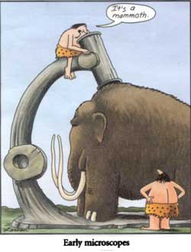

Name:_________
Contents
Page/s | Content
2-9 and 11-14 | Introductory Practical Skills
9-11 | Notes on Measuring field diameters, estimating size and calculating scale
14 | Appendix 1: Setting up microscope and Obtaining a focus
16 | Appendix 2: Cleaning slides and coverslips
16-17 | Appendix 3: Biological Drawings
17-18 | Appendix 4: Estimating Size and Scale

AN IMPORTANT TECHNIQUE - USE OF THE MICROSCOPE
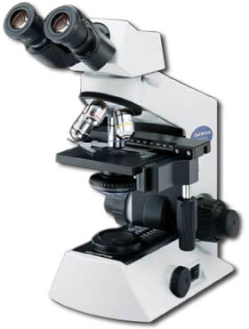

PURPOSE:

a) To learn the parts of the light microscope and to understand their functions.
b) To learn how to use the light microscope.
c) To learn how to make slides for use with the microscope.
d) To learn how to estimate the size of microscopic objects.
e) To learn the conventions for recording microscope observations in the form of clear diagrams.

INTRODUCTION:

Because so much that is studied in biological work is too small to be seen with the naked eye; the various types of microscope are essential tools of the biologists.

A microscope has two functions:

- To resolve fine details
- To magnify the image so that it is large enough for the detail to be seen easily.

Magnification without resolving power is of little value. Many cheap microscopes provide high magnification but the image is indistinct- it lacks clarity, and fine details are not visible. A good quality light microscope, used well, can provide a clear, sharp image at magnifications up to 1000 times the diameter of the object being examined.

Resolution

Lenses don't produce perfect images of objects. If an object contains much fine detail, the lens may not reproduce all this detail in the image. The ability of a lens to reproduce fine detail is called RESOLVING POWER or RESOLUTION. For example, take 2 lines i.e. . With less resolution they are seen as ONE line and with more resolution they are TWO DISTINCT LINES. If the resolving power of the microscope only allows us to see them as one line, we cannot see two lines by increasing the magnification. If we increase the magnification we well see a larger single line that is blurred, not two distinct lines. The objective lens is responsible for the resolution of the light microscope.

MATERIALS and EQIPMENT:

- CX21 Olympus Binocular Microscope
- eye dropper
- lens tissue
- fine forceps
- a mini grid
- a prepared slide of cheek cells
- a length of paper toweling about 40 cm in length

- Mini grid
- microscope slides
- coverslips
- piece of newspaper with letter ("e")
- scissors
- dissecting needle

PROCEDURE:

PART A FAMILIARISATION

Familiarise yourself with the following components and controls: eye piece (ocular), objective lenses (your microscope has three), specimen holder, specimen holder Y-axis adjustment knob, specimen holder X-axis adjustment knob, coarse adjustment knob, fine adjustment knob, condenser, condenser adjustment knob, aperture iris diaphragm ring, main switch, light intensity adjustment, globe
Complete the names of the parts of the microscope on the diagram below.

Binocular observation tube
Microscope frame
1.
3.
4.
8.
9.
16.
15.
14.
13.
11.
10.
6.
5.
2.
7.
17.

DO NOT adjust either of these knobs.

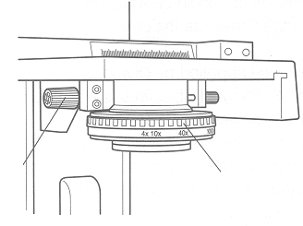
10.
12.
11.

Components of the Binocular Light Microscope and their Functions

Number | Name | Function
1 | Eye piece (ocular) | To magnify the image
2 | Binocular observation tube | To hold the ocular and objective lenses in the correct position in relation to each other
3 | Objective lens  (three different magnifications) | To magnify and resolve
4 | Revolving nose piece (Turret) | To support the objective lenses and allow easy change of magnification
5 | Specimen holder | To hold slide in place on the stage
6 | Stage | Supports the slide and allows light to pass onto the slide
7 | Microscope frame | To support the other components of the microscope
8 | Coarse adjustment knob | To move the body tube rapidly to allow focussing using the scanning and low power magnification.
9 | Fine adjustment knob | To move the body tube slowly to allow focussing under High Power magnification.
10 | Aperture iris diaphragm ring | To adjust the size of the diaphragm and thus to control the amount of light passing through the slide. Allows for the control of contrast.
11 | Condenser | Focuses light from source onto slide to improve resolution
12 | Condenser adjustment knob | Rotate to lower or raise the condenser. The condenser is usually used in the highest position. DO NOT alter the condenser position unless it has been lowered. For the work we are doing it should be at the highest position.
13 | Specimen holder Y axis adjustment knob | Controls the vertical movement of the specimen holder. In conjunction with the X-axis adjustment knob, enables you to easily reposition the specimen on the stage
14 | Specimen holder X axis adjustment knob | Controls the horizontal movement of the specimen holder. In conjunction with the Y-axis adjustment knob, enables you to easily reposition the specimen on the stage
15 | Light intensity adjustment knob | Adjust the brightness of the light. Rotating clockwise increases the brightness and anticlockwise decreases the brightness.
16 | Main switch | Switches the light on. “|”=(ON)
17 | lamp | Provides light to illuminate specimen

PART B: PREPARING THE MICROSCOPE FOR USE

- Holding the microscope by the frame and supporting the base, take the microscope out of the cupboard and carefully remove its cover.
- Collect a power cord from the storage tub.
Position of dot to the side of this plate enables interpupillary distance value to be read
- Place the microscope on the bench so that the microscope frame faces away from you and plug in the power cord.
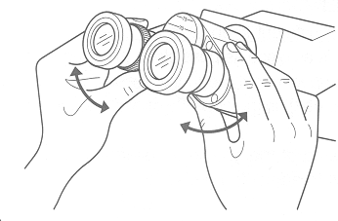
- Click the scanning (x4) objective into position.
- Ensure that the condenser is at the top of is movement. It should already be in this position and should be not adjusted by you.
- If necessary adjust the aperture iris diaphragm ring (10) so that the X4x10 setting is facing forward. (This setting will need to be readjusted if you click the x40 objective into place)
Fig 1.
- Flick the main switch on.
- Adjust the interpupillary distance.
- The interpupillary distance adjustment consists of regulating the two eyepieces according to your eyes so that you can observe a single microscope image through two eyepieces. This greatly helps to reduce fatigue during observation.
- While looking through the eyepieces, move both eyepieces until the left and right fields of view coincide completely. At this point the two separate circular fields overlap and appear as one.
- The position of the index dot indicates the interpupillary distance value.
(Note the interpupillary distance so that it can be quickly duplicated in future)

My Interpupillary distance: L:_________ R:_________

- The microscope is now ready to use.

C. MAKING A WET MOUNT OF A “SPECIMEN” FOR EXAMINATION

- Place the rest of the materials and equipment in an orderly arrangement on the length of paper towelling.
- Obtain one letter ‘e’ from newpaper.
It is important to use a lower case ‘e’ since it has clear orientation. You can clearly tell top from bottom and left from right.
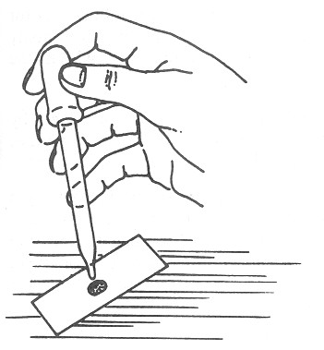
Fig. 2
- Using an eyedropper put 2 or 3 drops of water on a clean slide. (fig. 2) Using fine forceps, place the piece of newspaper in the centre of the water drop, printed side up. Push it down into the water with dissecting needle until it is saturated with water and fully immersed.
- Hold the coverslip at an angle of about 45° to the slide; then bring the coverslip down to the slide until the lower edge touches the drop of water. (fig.3)

Using the dissecting needle, slowly lower the outer edge of the coverslip until it is parallel to the surface of the slide. (fig.4) Even when this is done carefully, air bubbles will occasionally be trapped in the mount. You have now prepared a wet mount of the letter e.

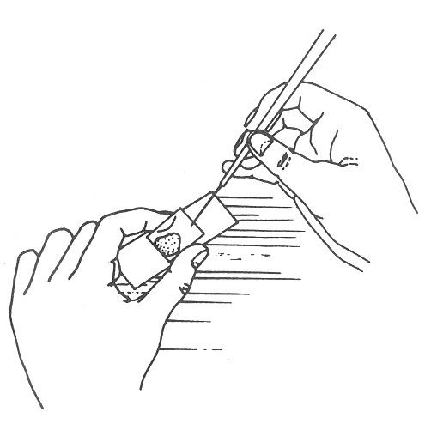
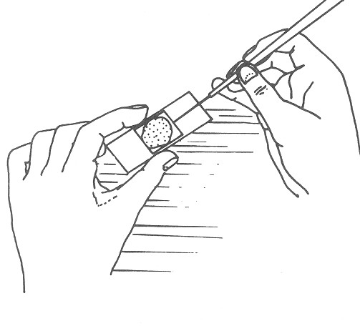

Fig. 4

Fig. 3

D. USING THE MICROSCOPE TO EXAMINE A SPECIMEN

Placing the Slide

- Turn the power on.
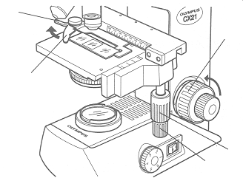
5b
- Rotate the coarse adjustment knob (8) in an anticlockwise direction to fully lower the stage.
8

- Open the bow shaped lever of the specimen holder (5a) outwards and place your prepared slide by gliding the glass slide on the stage from the front to the rear. Gently return the bow shaped lever (5b).
5a.

- Rotate the upper knob (13), the Y-axis adjustment knob, and the lower knob (14), the X-axis adjustment knob, to move the specimen holder so that the letter “e” sits centrally over the opening in the microscope stage.
13
14
Fig. 5

Focusing Procedure
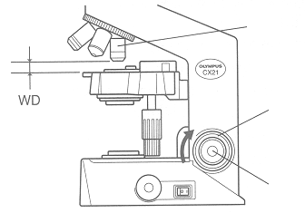
3.
- Make sure that the scanning (x4) objective (3) is in place.
- Look from the side and rotate the coarse adjustment knob (8) in a clockwise direction so that the objective lens is as close to the specimen as possible. (Our microscopes have an automatic stop which should prevent you from accidentally hitting the coverslip with the objective lens however you still need to take care in case this device fails)
8.
9.
- While observing the specimen through the eyepieces, slowly rotate the course adjustment knob (8) in an anticlockwise direction (towards you) to lower the stage.
15.
Fig. 6

- When coarse focusing of the specimen is obtained rotate the fine adjustment knob (9) to adjust to a fine focus if required.
- Use the light intensity adjustment knob(15) to adjust brightness if required.
- You should now have a clear sharp image.

Working distance:

The Working distance (WD) refers to the distance between each objective lens and the specimen when precise focus of the specimen is obtained.
The table below indicates the working distance for each objective lens. Note that the higher the magnification of the objective lens, the small the working distance. This means that when using the high power objective lens, the tip of the lens will be very close to the specimen.

Objective Magnification | 4x | 10x | 40x
WD (mm) | 22.0 | 10.5 | .56

- The brightness of the light should be adjusted so that the image you see is just brighter than the level of lighting in the room. Use the light intensity adjustment knob (15) to alter the light intensity.

- Try the effect of adjusting the iris diaphragm to alternative magnification settings (x10, x40) as you look at the letter ‘e’. This alters the size of the aperture (opening) through which light passes.

This procedure has two very useful effects. One is to increase the depth of field. "Depth of field" refers to the thickness of the plane of focus. With a broad depth of field, parts of a specimen in different planes can be in focused at the same time. With a narrower depth of field, only parts of the specimen in one narrow plane can be focused at one time, everything else will be out of focus. Increasing depth of field means that you can view several “planes” of a thick specimen fairly effectively simultaneously. This is very useful when viewing unicellular organisms, which are quite large, or samples that are quite thick.

(1) What is the other useful effect of closing the iris diaphragm?

The image below illustrates the effect of partially closing the iris diaphragm
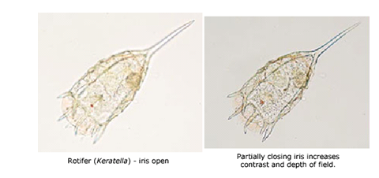

- Find an air bubble in your own or another student's preparation and examine it under the microscope, focusing up and down as you do so.

(2) What happens to the appearance of an air bubble when you focus up and down?

(3) Draw the orientation of the ‘e’ as it appears on the slide and when viewed through the microscope.
(don’t worry about size difference or the details of the image. Just record the orientation)

e as it appears on the actual Slide | e as it is seen when viewing it through the microscope

- Compare the position of the image of the letter "e" in the ocular with the position of the actual printed "e" on the slide.

(4) Describe the change in its orientation.

Moving the slide:

(5) While looking into the ocular, use the x-axis adjustment knob to slowly move the slide from right to left. Which way does the image move?

(6) While looking into the ocular, use the y-axis adjustment knob to slowly move the slide
away from you. Which way does the image move?

(7) Predict the direction in which you would have to move the slide to make the image move to the bottom left of the field of view.

- Test your prediction be moving the slide as you suggested.

The image seen under the microscope:

- Turn the rotating nosepiece to bring the low power (x10) objective lens into place.
(Ensure that you feel it click into place. If it doesn’t you will not be able to see anything when you look down the microscope.)

- View the specimen and sharpen using the fine focus if required
Look at the image of the ‘e’ closely. Besides its orientation, think about how it looks different to the ‘e’ view with the unaided eye.

(8) What PROPERTY of the microscope (apart from the magnification) is illustrated by the image? Explain briefly.

Fine focusing:
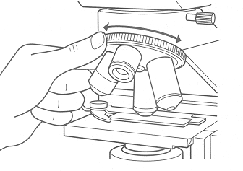
4.
Obtaining a focus under High Power

- Centre the ‘e’ in the low power field of view, refocus under low power if required, and then rotate the revolving nosepiece (4) so that the high-power (longer) objective is in line with the ocular. You should feel it 'click' into position. In doing this, make sure that the lower end of the objective does not touch the coverslip.
Fig. 7

(NOTE: When the high-power objective is in correct focus its lower end will be very close to the slide. There is only a very small working distance and this is why you need to be careful)

- Use fine focus to sharpen the image if necessary

- Adjust the aperture iris diaphragm ring(10) so that the X40 setting is facing forward. This opens the diaphragm slightly so that the brightness of the high-power image is about the same as when low power is used.
Fig. 8

- Microscopes which remain in focus, or very nearly so, when the nosepiece is rotated, are said to be 'parfocal'

(9) Is your microscope parfocal? Explain

___________________________________________________________________________

(10) Why must you be careful when rotating the nosepiece to bring the high power objective into place?

THEORY: USING THE MINIGRID AND MEASURING SIZE AND SCALE
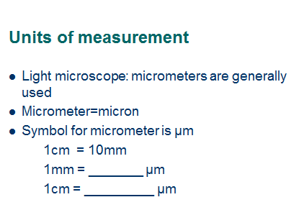 | 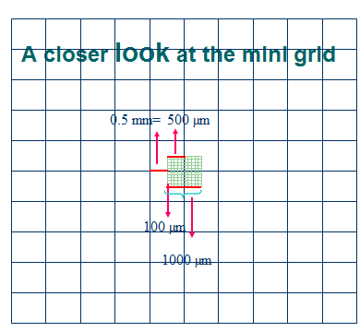
Field Of View  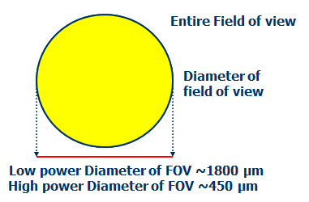 | 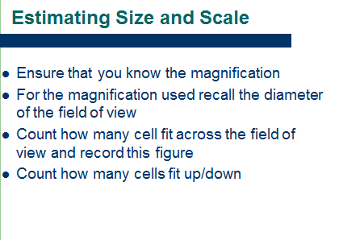
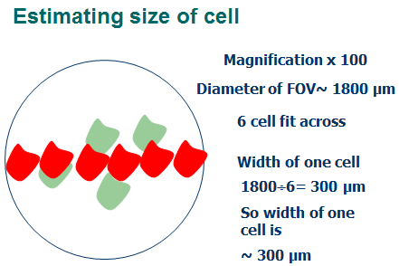 | 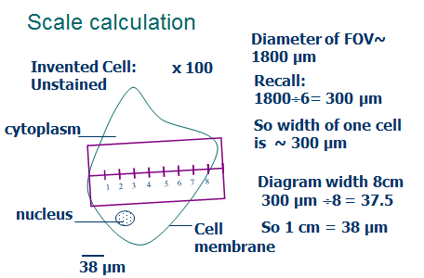
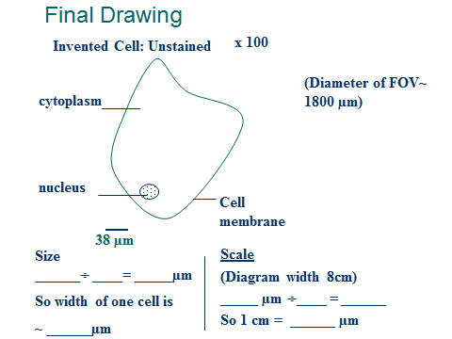
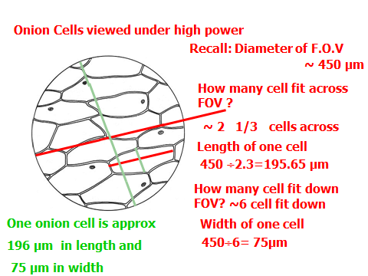 | 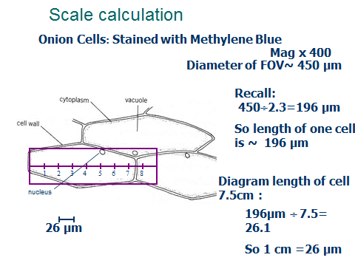
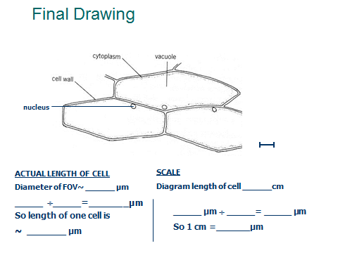

E. MEASURMENT WITH THE MICROSCOPE

Because objects observed with the microscope are usually quite small, biologist find it convenient to use units of length smaller than centimetres or millimetres for microscopic measurement. One such unit commonly used is the micrometre (micron) for which the symbol is 'μm'. One micrometer is equivalent to one thousandth of a millimetre. (1μm=0.001mm AND 1000 μm = 1 mm)

We can estimate the size of a microscopic object by comparing it with the size of the circular field of view. Details are show in the preceding slides and are summarized in APPENDIX 4.

Field diameters

The standard field diameter or various magnifications of the school binocular microscopes are given in the table below:

MICROSCOPE NUMBER:________

Power used | X10 Eyepiece with ………..  Objective lens | Magnifications | Field Diameters |  | Verify field diameter(tick) Or record the field diameter if it varied from expected value
Power used | X10 Eyepiece with ………..  Objective lens | Magnifications | mm | Micrometres/ microns  (μm)
scanning | X4 |  | 4.5mm
Low power | X10 |  | 1.8mm | 1800 μm
High power | X40 |  | .450mm

Calculate the field diameter in micrometres for the scanning objective and high power objective and record these in the table above.

Check the field diameter for your microscope at low power using a mini-grid and either verify its measurement or record its measurement if it varies to what was expected.

To measure the diameter of the low power (x100) field of view:
- Place the 10x objective in position. The eyepiece lenses have a magnification of 10x. The eyepiece lens and the objective lens together produce a magnification of X100. (ie. 10x10) (This is called "low power" magnification”). RECORD this in the table above.
- Now place a mini-grid on the stage and obtain focus using previously outlined technique. It will be necessary to move the mini grid on the stage until a measurement is possible. Your teacher will assist you if necessary.

Determine the total magnification and check the field diameters for the scanning and high power objectives.

(11)
a) Compare the diameter of the field of view under high and low power magnifications.

b) Explain why this is the case by referring to the magnification achieved by each objective lens.

Remember always to obtain focus under low power before attempting to focus under high power. Always observe the procedures set out above. Now you have these skills, proceed to use the microscope as a tool for making observations of organisms.

For additional information about microscopes and to play with the virtual scanning microscope go to the following website: http://micro.magnet.fsu.edu/primer/java/electronmicroscopy/magnify1/index.html

F. USING THE MICROSCOPE TO VIEW A PREPARED SLIDE

- Ensure that the microscope is ready for use. Check APPENDIX 1 for a summary of the necessary steps.
- Collect one of the prepared cheek slides and place it cover slip side up on the stage.
- Obtain focus using first the scanning objective and then using the low power and then the high power objective. APPENDIX 1 lists the necessary steps.
- Read APPENDIX 3 in order to become familiar with the conventions for drawing biological diagrams.
- In the space below draw a representative sample of the cells that you see using the high power objective. This may mean 2 or 3 cheek epithelium cells or one single celled organism.

- Complete your diagram by including a title, magnification, scale and labels as outlined in APPENDIX 3 and 4. Refer to “Final Drawing” slides on pages 11 and 12 to see how to set it out.
- Skills practise 2: Use Biological drawing conventions to make a high power drawing of a human white blood cell.(leukocyte)

APPENDIX 1

HOW TO SET UP AND USE A MICROSCOPE
A SUMMARY
SETTING UP

- Holding the microscope by the frame and supporting the base, take the microscope out of the cupboard and carefully remove its cover. Leave its cover on the teacher’s bench at the front of the classroom. The laboratory staff will replace these later.
- Collect a power cord from the storage tub.
- Place the microscope on the bench so that the microscope frame faces away from you and plug in the power cord.
- Click the low power (x4) objective into position.
- Adjust aperture iris diaphragm ring so that the X4x10 setting is facing forward.
- Check that the condenser is at the top of its movement.
- Switch the main switch on.
- Set the interpupillary distance to suit your eyes.
- The microscope is now ready to use.

HOW TO OBTAIN AN IMAGE IN FOCUS USING THE MICROSCOPE

- Make sure the microscope is set up correctly as described above.
- Rotate the coarse adjustment knob in an anticlockwise direction to fully lower the stage.
- Open the bow shaped lever of the specimen holder outwards and place your prepared slide on the stage. (The cover slip must face up!) Make sure that the specimen on the slide is over the opening of the stage.
- Use the x-axis and y-axis adjustment knobs to move the slide on the stage until you find the portion of the specimen that you wish to view. Ensure that this portion of the slide is in the centre of your field of view.
- Click the scanning objective (the scanning objective is the shortest of the three objectives) into position and ensure that the x4x10 magnification is facing forward on the aperture iris diaphragm ring.
- Look from the side and rotate the coarse adjustment knob in clockwise direction so that the objective lens is as close to the specimen as possible.
- While observing the specimen through the eyepieces, slowly rotate the course adjustment knob (8) in an anticlockwise direction (away from you) to lower the stage.
- When coarse focusing of the specimen is obtained rotate the fine adjustment knob (9) to adjust to a fine focus. You should now have a clear sharp image.
- To increase the magnification, click the low power objective into position. The microscope is parfocal and you should be able to see an image.
- Adjust the focus using either the coarse or fine adjustment knob. At this stage, you can either focus up or down as the low power objective has an automatic stop; you should only have to alter the working distance a small amount. Again, centre the image if you want to view the slide using high power magnification.
- Carefully rotate the high power objective into position. Adjust the aperture iris diaphragm ring so that the x40 magnification is facing forward.
- The image should appear. The focus should be adjusted using the fine focus only. (You will need to ensure that the objective does not hit the slide) Again, it may be necessary to centre the image. Adjusting the light intensity and the fine focus may enhance the quality of the image. Slight alteration of the aperture iris diaphragm ring may assist with obtaining maximum contrast in your specimen.

APPENDIX 2 : CLEANING SLIDES AND COVER SLIPS

Materials to be studied are placed on a piece of glass of standard size called a microscope slide. In most cases the material is covered with a small, thin piece of glass, the coverslip. Both slide and coverslip should be as clean as possible before use.

- To clean glass slides, hold them by the edges, between finger and thumb, and dip in water. Wipe them clean and dry use paper towel.
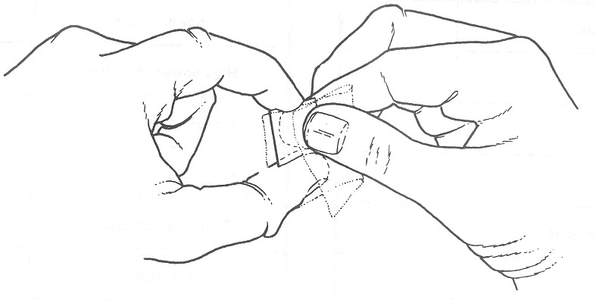
- Cover slips are much more fragile than slides. Hold them carefully, by the edges, using a finger and thumb of one hand, and dip into water. Lens tissue should then be folded and held between the finger and thumb of the other hand. Next, insert the wet coverslip in the fold and gently wipe both surfaces at the same time by bringing thumb and finger together (fig 2). A gently circular wiping motion is most effective. Avoid touching the flat surfaces of slides and coverslips with your fingers. Always handle them by the edge.
Fig. 9

APPENDIX 3

BIOLOGICAL DRAWINGS

1. Drawing materials:
- A sharp HB pencil. Do not use pen or coloured pencils.
- Good quality unlined paper.

2. Positioning:
- Centre the diagram on the page. This leaves space for titles, labels and annotations to be added.
- Do not put the diagram in a corner of a page.

3. Size:
- The diagram should be large enough to represent all the details in the specimen without crowding them.
- The minimum size is about 1/3 of a page. Rarely is a diagram too large.

- Accuracy: Your diagram should:
- Be accurate and demonstrate your understanding of what you have observed
- Be representative of what you see. You do not have to draw the entire field of view but rather you should draw enough to show the detail of the specimen and the relationships of the various parts of the specimen to each other.
- If asked to draw ONE cell, make it a representative cell of those viewed, don’t pick out an unusual cell.
- Sometimes it is necessary to draw the entire field of view but usually your teacher would indicate this.
- You will often be asked to draw a sufficient number to show their arrangement. You may have to use your judgement here, but usually up to four cells is sufficient.
- Show accurate proportions of the specimen

- Technique:
- Lines should be simple, narrow, sharp and firm.
- When lines indicate an outline then the ends of the line should meet.
- Represent depth only when necessary by stippling(dots). Do not use shading or colour.

- Labels:
- Leave plenty of margin for labels. (NB. You were asked to centre the diagram on the page)
- Label lines must be ruled and they should not have arrow heads on the end.
- Label lines should sit ON the structure they are indicating, not beside it.
- The labels should appear at the end of the label line, they should not sit on the line.
- As far as possible labels should be parallel and horizontal and vertical.
- Names of structures must he horizontal.

- Title, Size and Scale conventions
Microscope drawings should include the following (unless told otherwise):
- A title, which should identify the material (organism, tissues or cell/s) and if appropriate the stain that was used in preparation. Singular/plural forms of words matter here since the title should indicate precisely what the viewer is seeing. For example if one cell is drawn and the title says cells, then this will confuse the viewer who will be trying to make out where the cells are.
- The magnification under which it was observed.
- A scale to indicate the size of the object. (see APPENDIX 4 for instructions how to calculate scale)
- In the case of living materials, a brief description of any movement that was observed
- Other annotations neatly made beside the drawing that communicate observations made.

APPENDIX 4

ESTIMATING SIZE AND SCALE

- Estimate the actual size of the cell you are viewing using known field diameters.
The field diameter when using the x10 ocular and the x10 objective is approximately 1800µm. A hypothetical x100 field of view is shown below. (Note that you are not required to draw the entire field of view in your diagram.)Estimate the number of cells that can fit across the field of view.
Field of view

cells

In the above case approximately three cells can fit lengthways across the field diameter
The length of the cell can thus be estimated as 1800µm÷3=600µm
The width of the cell can be estimated in a similar manner.
This method can also be applied to the high power and scanning magnification using the appropriate field diameters.

- Draw your diagram using the appropriate conventions as described previously.

- Measure the actual size of your diagram.

In this case, the diagram is 4.75 cm long.

- Calculate the scale: To calculate the scale, divide the estimated length of the cell by the length of the diagram. In this case, 600÷4.75= 126 µm (Round off 126.3. You can approximate as using decimals would imply an accuracy that we cannot claim)
You are in fact performing an exercise in direct proportion and saying, “ If 4.75 cm represents 600µm then 1cm represents 126µm”

- Indicate the scale on your diagram: Draw a 1cm line near your diagram and below it write the length that the line represents
Magnification x100

126µm

6. Finish your diagram: Remember to include a title and labels as described in APPENDIX 3.

- Magnification must not be confused with scale; both need to be included in your diagrams.
- The size of the specimen does not change with magnification. In a diagram made using low power, 1cm will represents a greater distance than in a diagram made using high power magnification.

ADDITIONAL FUNCTIONS

Specimen Holder Scales

These scales allow the position (coordinates) being observed on the specimen to be identified. Even after the specimen is moved it can be returned easily to the original position. (assuming that the specimen has not move on the slide)
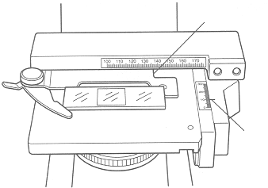
A

- The horizontal coordinate can be read at position (A) on the specimen holder
- The vertical coordinate can be read at the position of the index line (B)
B

