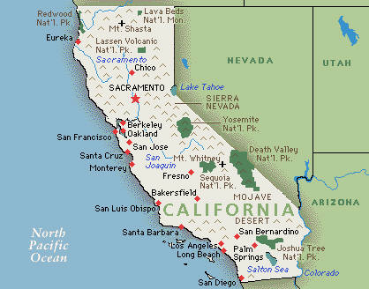
Fortune Cookie History

The Mysterious Origin of the Fortune Cookie
Much to most American’s surprise, the fortune cookie is not a Chinese invention.
Fortune Cookies Actually Originated in California!
Fortune cookies are an American invention originating in California. There are many theories, and much speculation surrounding the mysterious origin of the fortune cookie. People wonder where the fortune cookie originated and who invented it, whether Chinese-American, Japanese-American or 14th century revolutionists, there has been much debate. In 1983, there was even a mock trial held in San Francisco's pseudo-legal Court of Historical Review to determine the origins of the fortune cookie.

Legendary History of the Fortune Cookie #1 The Chinese immigrant, David Jung, founded the Hong Kong Noodle Company while living in Los Angeles, invented the cookie in 1918. Concerned about the poor he saw wandering near his shop, he created the cookie and passed them out free on the streets. Each cookie contained a strip of paper with an inspirational Bible scripture on it, written for Jung by a Presbyterian minister.

Legendary History of the Fortune Cookie #2 Some claim a Japanese immigrant, Makoto Hagiwara, invented the fortune cookie in San Francisco. Hagiwara designer of the famous Japanese Tea Garden in Golden Gate Park was an avid gardener until an anti-Japanese mayor fired him from his job around the turn of the century. Later a new mayor did reinstate him. In 1914, to show his deep appreciation to friends who had stood by him during his time of hardship, Hagiwara made a cookie and placed a thank you note inside. After passing them out to those who had helped him, he began serving them regularly at the Japanese Tea Garden. In 1915, they were displayed at the Panama-Pacific Exhibition, San Francisco's world fair.

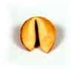
Legendary History of the Fortune Cookie #3 The Original Idea
In the early 1900’s a plan was hatched to transform San Francisco’s Chinatown from a ghetto into a cute tourist attraction. San Francisco’s Chinatown promised tourist a real Oriental experience. The city promoted Chinese decorations, pageantry and architecture. Supposedly, increased tourism led to the invention of the fortune cookie to fill the void of a dessert item. To fill the tourists demands for a dessert, a worker in San Francisco’s Kay Heong Noodle Factory invented a plain flat cookie in the 1930s. This plain flat cookie, while still warm, was folded around a little piece of paper on which a hand-written prediction or piece of Chinese wisdom would be found.

Legendary History of the Fortune Cookie #4 During the 13th and 14th centuries, China was occupied by Mongols. The story goes that the Mongols had no taste for Lotus Nut Paste. So, the Chinese people hid sayings inscribed with the date of their revolution inside the Moon Cakes where the yolk would typically reside. Under the disguise of a Taoist priest, patriotic revolutionary Chu Yuan Chang, entered occupied walled cities to hand out Moon Cakes to other revolutionaries. These instructions coordinated the uprising that successfully allowed the Chinese people to form the basis of the Ming Dynasty.
Moon Festival became regularly celebrated. Part of that tradition was the passing out of cakes with sayings inside them.It is thought that this legend is what inspired the Chinese 49'ers working on the construction of American Railways through the Sierra Nevada to California. When Moon Festival rolled around, they did not have any traditional moon cakes. So out of necessity they improvised with hard biscuits and the Fortune Cookie was born

Today’s Fortune Cookie Fortune cookies became common in Chinese restaurants after World War II. While not traditionally part of Chinese cuisine, American customers expected desserts. So out of necessity the fortune cookies thus offered Americans something familiar with an exotic flair while still being economical for the Chinese vendors.
Although there have been a few cases reported of individuals actually liking the texture and flavor of fortune cookies, most consider the fortune to be the essence of the cookie. Early fortunes featured Biblical sayings, or aphorisms from Confucius, Aesop, or Ben Franklin. Later, fortunes included recommended lottery numbers, smiley faces, jokes, and sage, if hackneyed, advice. Politicians have used them in campaigns, and fortunes have been customized for weddings and birthday parties.

