Microsoft Excel

Beyond the Numbers!

**PROJECTS:**

* WAV (Written, Audio and Visual)
* Pictograph
* Timeline

**\*\*You will create your own project using one or more of the formats\*\***

**STEPS**

**Organization**

1. Create a New Folder and name it “Excel Projects”
2. Create two Sub-Folders
   1. Pictures - collect pictures for your project(s) from Google images.
   2. Audio – find audio-video files and/or links from the internet.

**Creation**

***WAV Project***

1. **Open** an Excel blank worksheet. **Save** as “**Beyond the Numbers Projects**”
2. Go to the “view” tab and select “normal”

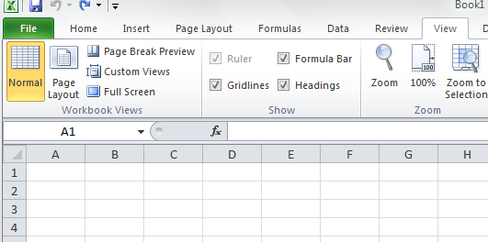

1. Select the “zoom” option and enter/select “150”
2. Select the upper left corner of the worksheet (above 1/left of A)



1. WITHOUT clicking anywhere on the worksheet, SELECT the line between columns A and B to control the width



1. Drag the line to the left (there will be a dark/thin plus sign) to make the column 2:00 or 19 pixels and release. The entire worksheet will look like graph paper.

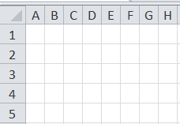

1. Go to the “Page Layout” tab and select the “background” icon.

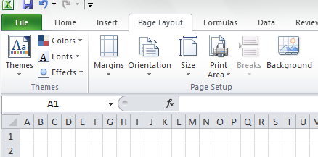

1. Insert the picture/collage of pictures for this project.
   1. The picture will appear multiple times in the background.
   2. In order of only one picture to appear, you will WHITE OUT the other pictures
      1. Select the columns to the right of the picture (about 20 or so – enough to disappear from the screen)

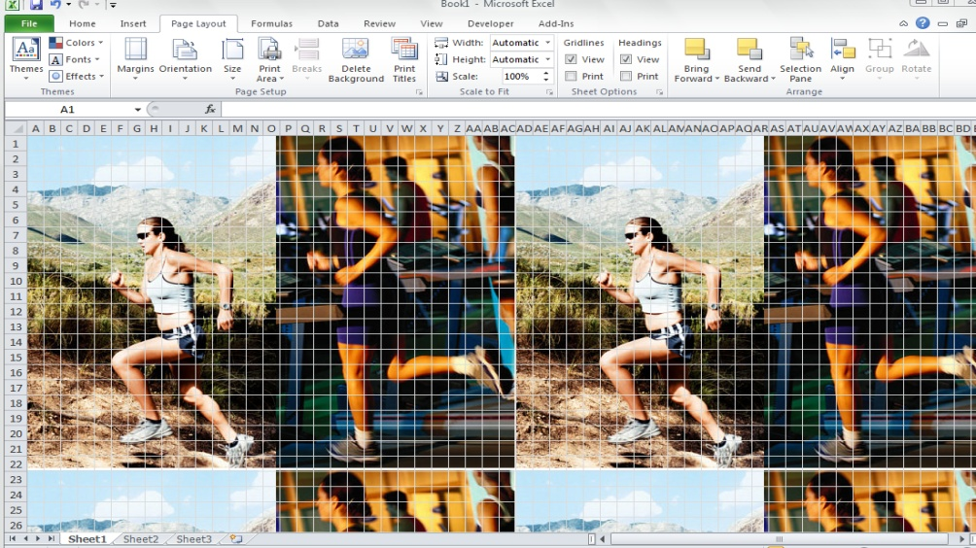

* + 1. Go to the “home” tab and select the “color bucket” (this will fill the select area and hid the images)

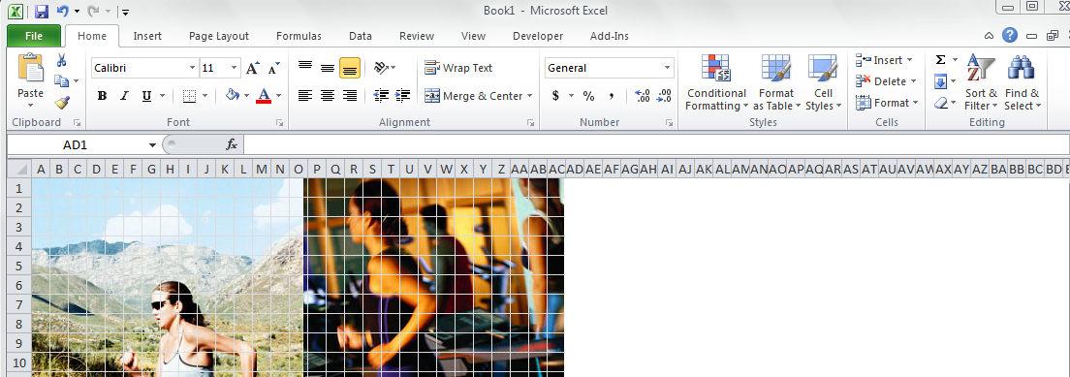

* + 1. Sele
    2. Select the rows below the image (30 or so)
    3. Click on the “color bucket” again to hide the pictures. SAVE

1. Select the **cell** where you would like to enter your comment.
2. Select the “Review” tab and click on “new comment”

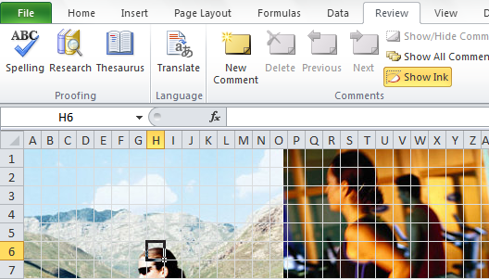

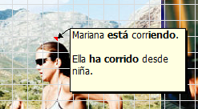

1. Type your comment and click outside the comment box.
   1. The comment will disappear
   2. To read the comment scroll over the cell
   3. TO EDIT COMMENT
      1. Right click and select “edit comment”
      2. SAVE
2. To add the recording
   1. **Open** Garage Band
   2. Create a new “voice file”
   3. Select a “voice track” (male or female)
   4. Press the red “record” button at the bottom of the screen.
   5. DO NOT SAVE FILE --- SHARE IT
      1. Select the “share tab”
      2. Click on “burn cd”
      3. Change the “encoder” to “MP3”
      4. Choose the “excel file” you created at the beginning

YOU MAY SAVE A link to a sound bite or a video and link to it from your worksheet.

* 1. **Back** to Excel
     1. **Select** the cell where you would like the sound to play.
     2. **Type** a number or enter a symbol (you need the number/symbol to hyperlink) click outside the cell and back on it.

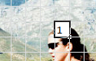

* + 1. **Right click on the cell with** the number or symbol OR select the “insert” tab and
       1. 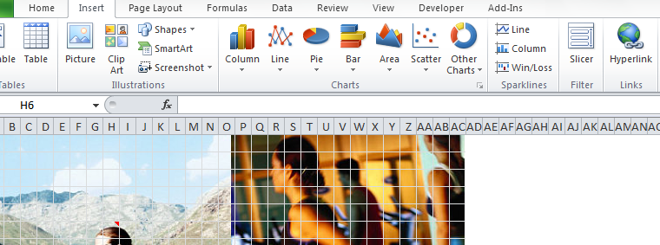Click the “**hyperlink**” option
       2. Link to your sound/video file or web link.

1. **REPEAT** steps 9-12 as many times as needed until you complete the task.
   * 1. SAVE
2. Remove the Gridlines
   1. Select the “View” tab and DESELECT the “gridlines” option

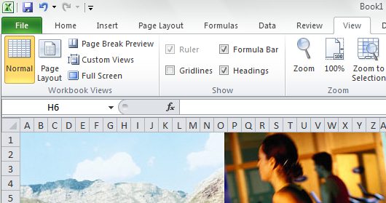

1. Double click on the “Sheet 1” tab at the bottom left of your document. Type “WAV”
   1. You may “right click” and change the TAB color.
2. SAVE.

***PICTOGRAPH***

* + - 1. Make sure you have collected all the necessary data and theme/appropriate images.
      2. Select the “sheet2” tab at the bottom left of your document. Double click and name the worksheet “Pictograph”

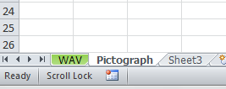

* + - 1. Enter Table title and label columns.
      2. Enter the collected data into the worksheet. SAVE



* + - 1. Highlight (select) the information entered.
      2. Select the “Insert” tab and click on the “column graph”

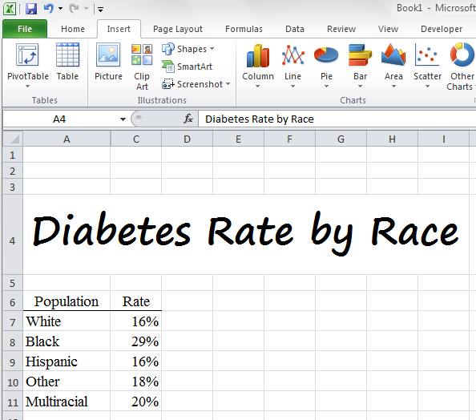

* + - 1. Double click on one of the bars making sure that ONLY ONE bar is selected.

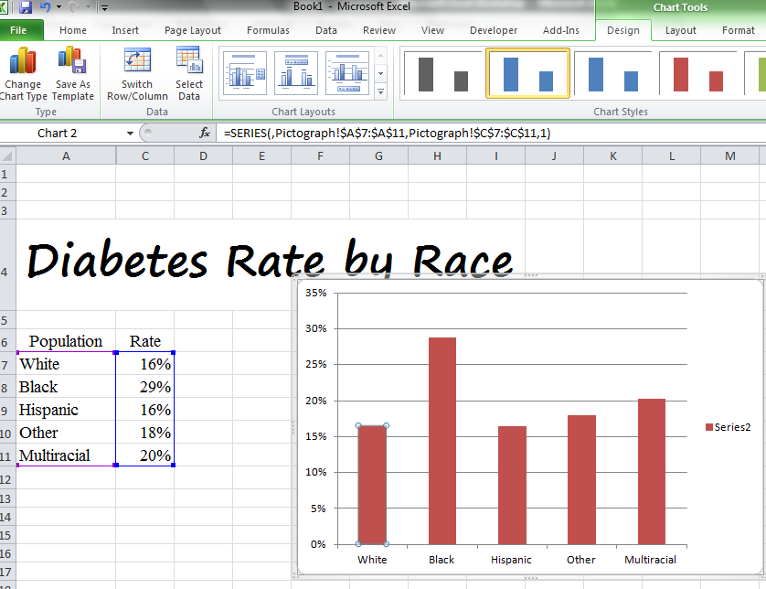

* + - 1. Select the “Format” tab under the “chart tools” and click on “Format Selection”

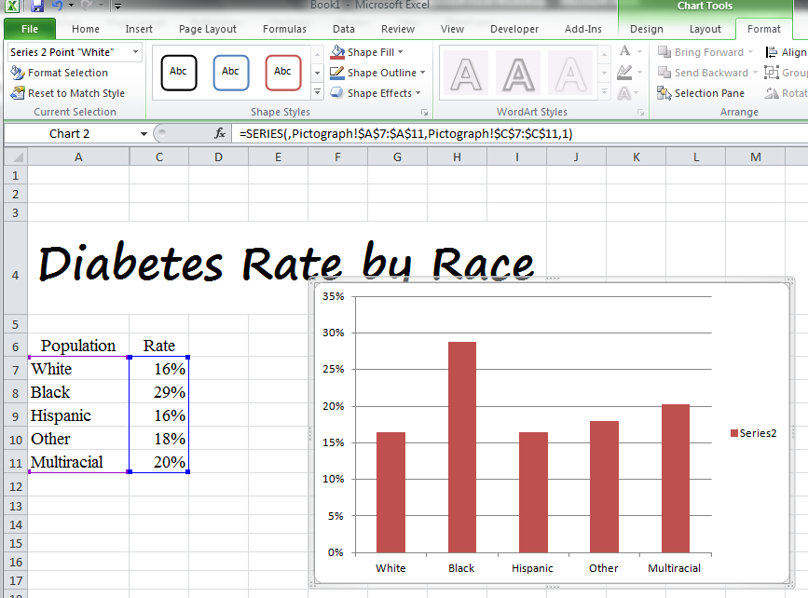

* + - 1. 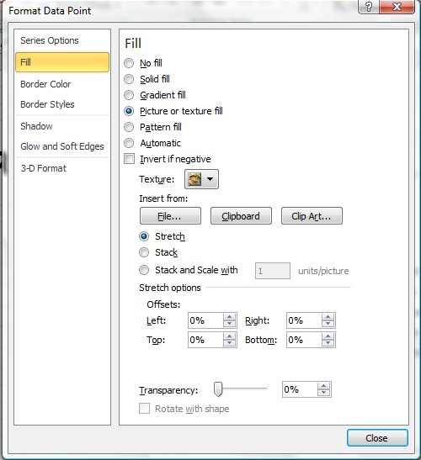Click on “fill”. Select the “Picture or Texture fill” option and then
         1. Click the “file” button and find the appropriate image.
      2. Before closing the window, select the “stack” option and “close” the window.

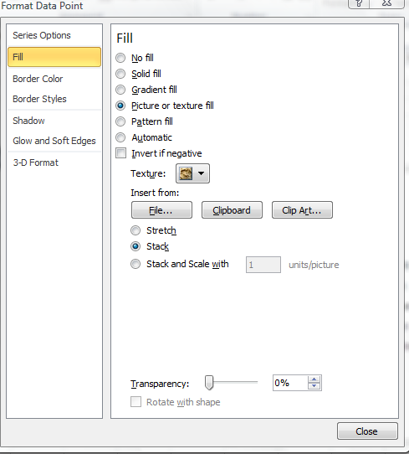

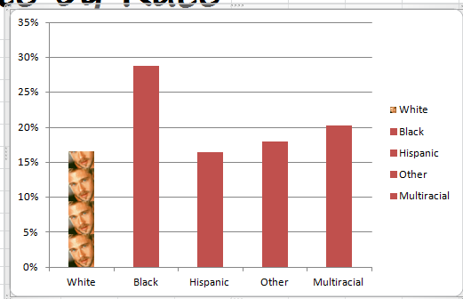

* + - 1. 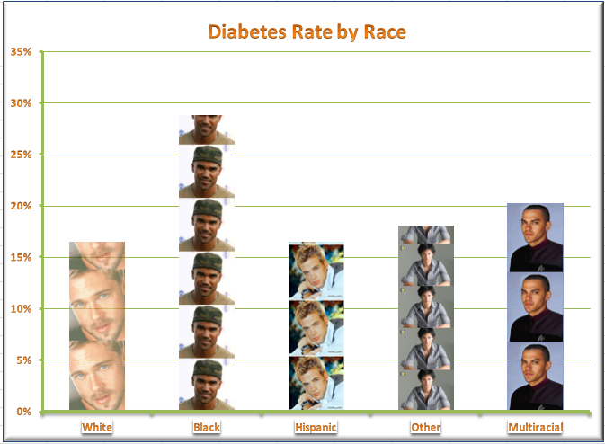 Repeat STEPs 7-10 as necessary. SAVE

*Timeline*

1. Make sure you have collected all the necessary data and theme/appropriate images.
2. Select the “sheet3” tab at the bottom left of your document. Double click and name the worksheet “Timeline”

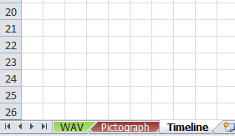

1. Re-size the column width to approx. 3.00 or 26 pixels.
2. Select the “insert” tab. Click on the “SmartArt” option. Choose “Process”

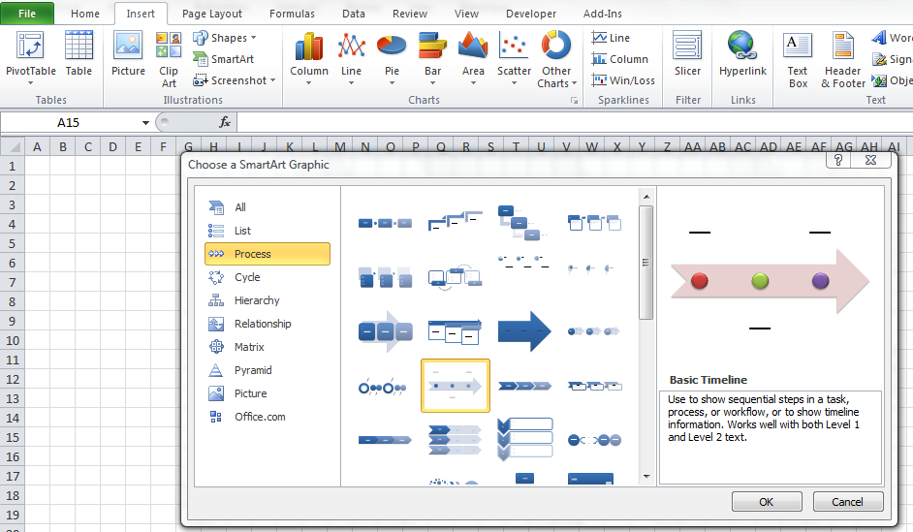

1. Choose the “Basic Timeline.”
2. Label the specific areas. If the textbox does not open click on the side of the timeline box to open it.

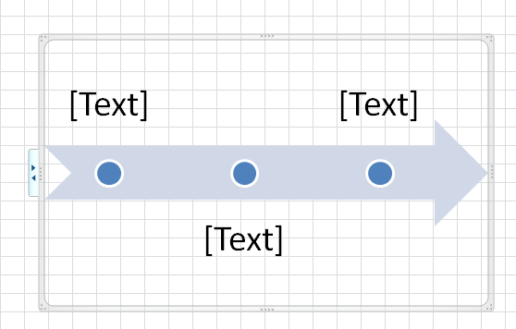

**Click *here* to open textbox**

1. Enter as many events as you need. The bar will adjust automatically and you may manually adjust it after you enter the events.

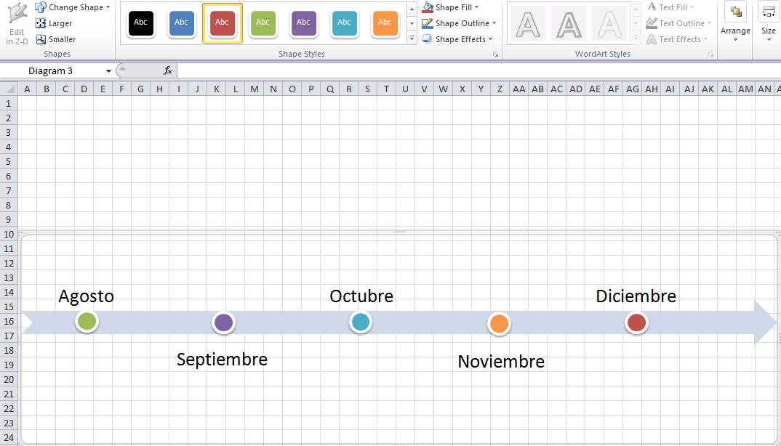

1. You may change the color of the event “mark” by clicking on it and selecting a different color.
2. Enter the Timeline Title and center it across columns. SAVE

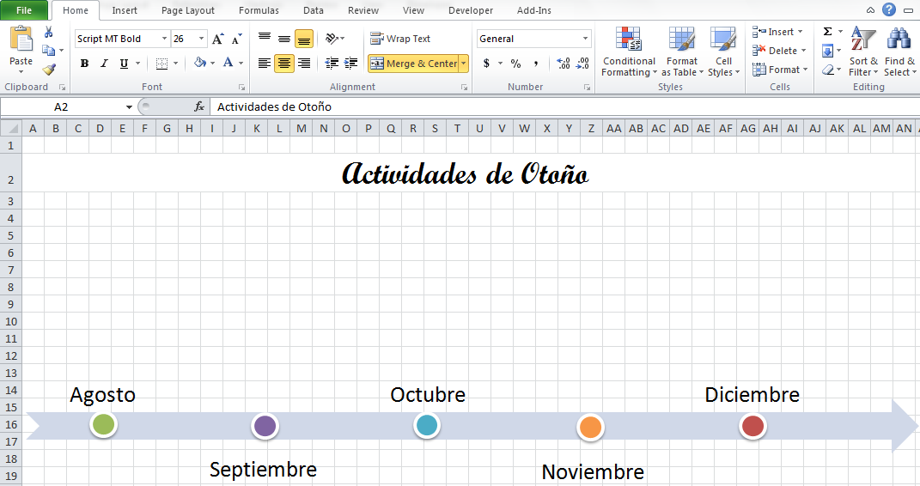

1. Insert Pictures and position along timeline.
2. Enter information above each of the events.
3. Add sound if desired: record and hyperlink OR hyperlink to a website or other file.
   1. Insert/hyperlink
4. Add comments if desired: Review/New Comment
5. Remove Gridlines: Page Layout/deselect gridlines

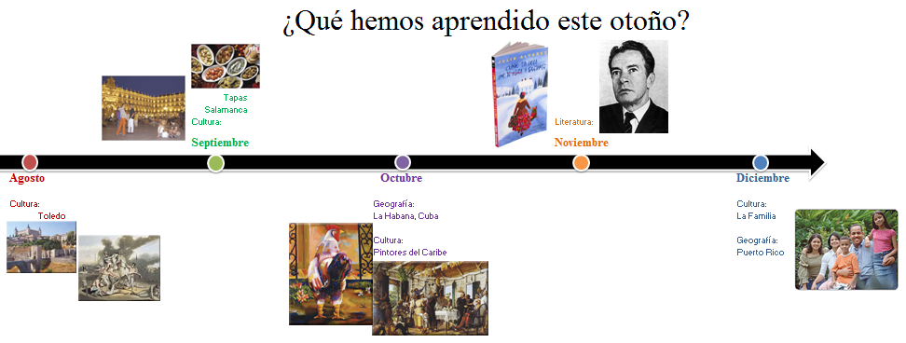

1. SAVE