
This assignment will be to create a minimum of five panels as a cartoon strip for a local newspaper. The formal definition of a cartoon strip is: A comic strip is a sequence of drawings arranged in interrelated panels to display brief humor or form a narrative, often serialized, with text in balloons and captions. (Wikipedia)
You have two options for this assignment. You can create the cartoon strip totally by hand, drawing everything and everyone in the script. This is the old way of creating cartoon strips. The other option is to go to http://www.pixton.com or http://www.readwritethink.org/files/resources/interactives/comic/, two web sites where you can create a cartoon strip.
If you choose to use Pixton, you must go to the site first and explore what it offers as far as scenes, characters, word bubbles etc. Once you have decided to use the site, you write your proposal to fit the options you have at the site.
If you choose to go straight freehand, you can create the strip you wish by simply drawing and adding caption to each frame.
Here an example of an eight panel strip from the early 1930’s
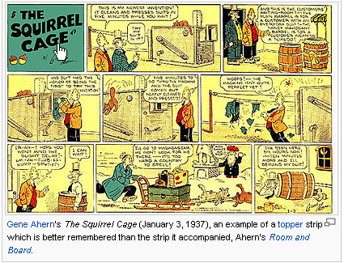
The next step after deciding how you’re going to create you strips is to complete your pre-production planning. You will need to submit your supporting documentation for each step along the way. You will be receiving 4 different grades for this project.
To begin, you need to develop your main character (s) for your cartoon stip. Once you have your characters figured out, you need to decide where it will take place. Will it be in the woods, in your garage or on the streets outside your house?
With your main concept in hand, you now need to think about what is going to happen/develop in your cartoon. This process should be logical and sequential so that it makes sense to your readers. You will need to have a start, middle and ending to your cartoon.
For this assignment, you must submit the following pre-production documentation to insure that you’re progressing in the right direction.
- Proposal: use the survey link on this web page to submit your proposal for evaluation. Open the survey and fill it out then hit submit.
- Treatment: use the survey link on this web page to submit your treatment for evaluation. Open the survey and fill it out then hit submit.
  - In addition to the survey, I have a link on our web page that explains what/how a treatment is completed.
- Storyboard: laying out the plans for each frame of your cartoon. This form has to be filled out and then scanned and e-mailed to me for evaluation. There are two scanners in the classroom that can be used to scan your work.
- Final cartoon strip: Once finished, scan and e-mail it to me for evaluation.
The requirements for your cartoon strip are:
- Your cartoon strip must have five (5) panels as a minimum and not more than 8 panels
- Each panel should flow, to the next one, following your theme
- Each panel must be the same size
- You may use traditional speech balloons or not
- If words are not being used, the image should reflect what is happening in that panel.

This is your chance to be creative and have fun with computer art.

