
Top 10 Tips for Great Pictures

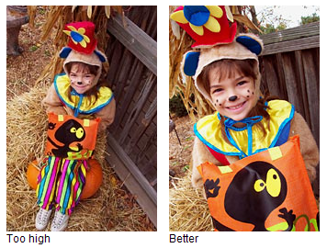
1 Look your subject in the eye

Direct eye contact can be as engaging in a picture as it is in real life. When taking a picture of someone, hold the camera at the person's eye level to unleash the power of those magnetic gazes and mesmerizing smiles. For children, that means stooping to their level. And your subject need not always stare at the camera. All by itself that eye level angle will create a personal and inviting feeling that pulls you into the picture.
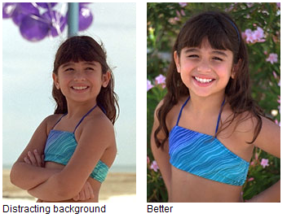
2. Use a plain background
A plain background shows off the subject you are photographing. When you look through the camera viewfinder, force yourself to study the area surrounding your subject. Make sure no poles grow from the head of your favorite niece and that no cars seem to dangle from her ears.
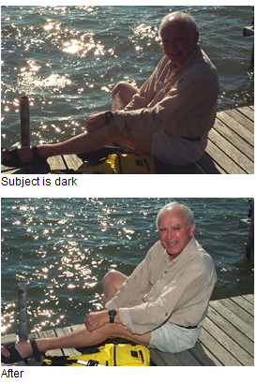
3. Use flash outdoors
Bright sun can create unattractive deep facial shadows. Eliminate the shadows by using your flash to lighten the face. When taking people pictures on sunny days, turn your flash on. You may have a choice of fill-flash mode or full-flash mode. If the person is within five feet, use the fill-flash mode; beyond five feet, the full-power mode may be required. With a digital camera, use the picture display panel to review the results.
On cloudy days, use the camera's fill-flash mode if it has one. The flash will brighten up people's faces and make them stand out. Also take a picture without the flash, because the soft light of overcast days sometimes gives quite pleasing results by itself.


4. Move in close

If your subject is smaller than a car, take a step or two closer before taking the picture and zoom in on your subject. Your goal is to fill the picture area with the subject you are photographing. Up close you can reveal telling details, like a sprinkle of freckles or an arched eyebrow.
But don't get too close or your pictures will be blurry. The closest focusing distance for most cameras is about three feet, or about one step away from your camera. If you get closer than the closest focusing distance of your camera (see your manual to be sure), your pictures will be blurry.
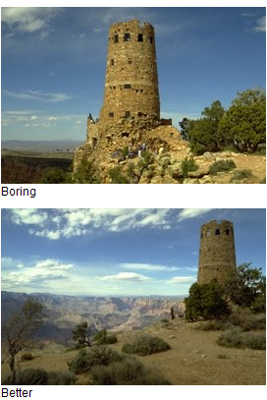

5. Move it from the middle
Center-stage is a great place for a performer to be. However, the middle of your picture is not the best place for your subject. Bring your picture to life by simply moving your subject away from the middle of your picture. Start by playing tick-tack-toe with subject position. Imagine a tick-tack-toe grid in your viewfinder. Now place your important subject at one of the intersections of lines.
You'll need to lock the focus if you have an auto-focus camera because most of them focus on whatever is in the center of the viewfinder.

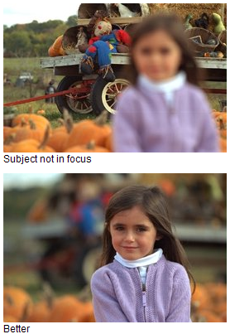
6. Lock the focus

If your subject is not in the center of the picture, you need to lock the focus to create a sharp picture. Most auto-focus cameras focus on whatever is in the center of the picture. But to improve pictures, you will often want to move the subject away from the center of the picture. If you don't want a blurred picture, you'll need to first lock the focus with the subject in the middle and then recompose the picture so the subject is away from the middle.
Usually you can lock the focus in three steps. First, center the subject and press and hold the shutter button halfway down. Second, reposition your camera (while still holding the shutter button) so the subject is away from the center. And third, finish by pressing the shutter button all the way down to take the picture.
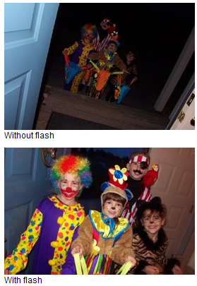
7. Know your flash's range

The number one flash mistake is taking pictures beyond the flash's range. Why is this a mistake? Because pictures taken beyond the maximum flash range will be too dark. For many cameras, the maximum flash range is less than fifteen feet—about five steps away.
What is your camera's flash range? Look it up in your camera manual. Can't find it? Then don't take a chance. Position yourself so subjects are no farther than ten feet away. Film users can extend the flash range by using Kodak Max versatility or versatility plus film.


8. Watch the light

Next to the subject, the most important part of every picture is the light. It affects the appearance of everything you photograph. On a great-grandmother, bright sunlight from the side can enhance wrinkles. But the soft light of a cloudy day can subdue those same wrinkles.
Don't like the light on your subject? Then move yourself or your subject. For landscapes, try to take pictures early or late in the day when the light is orangish and rakes across the land.

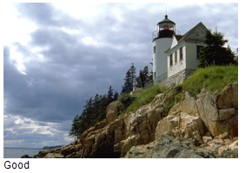
9. Take some vertical pictures

Is your camera vertically challenged? It is if you never turn it sideways to take a vertical picture. All sorts of things look better in a vertical picture. From a lighthouse near a cliff to the Eiffel Tower to your four-year-old niece jumping in a puddle. So next time out, make a conscious effort to turn your camera sideways and take some vertical pictures.
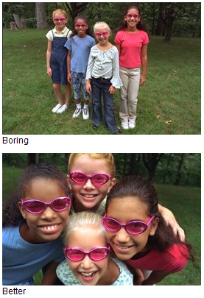
10. Be a picture director

Take control of your picture-taking and watch your pictures dramatically improve. Become a picture director, not just a passive picture-taker. A picture director takes charge. A picture director picks the location: "Everybody go outside to the backyard." A picture director adds props: "Girls, put on your pink sunglasses." A picture director arranges people: "Now move in close, and lean toward the camera."
Most pictures won't be that involved, but you get the idea: Take charge of your pictures and win your own best picture awards.

