Name _____________________________________________________________________________Date_____________________Hour________________
Jacksonville Research Project
Steps for Success
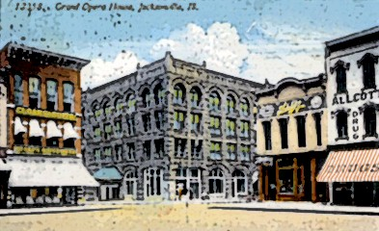

My Individual topic is ________________________

You have just finished learning a lot about Jacksonville history. Now it is YOUR turn to pick a topic that interests you, research it, and then present what you have learned to the class! The project can be really fun if you pick a topic you really like! You will also be creating a visual aid about your project to use during your presentation. (See Step 5 of the packet)
This packet is your step by step guide to completing a successful Jacksonville project. Place a check mark on the line after you complete each step. Inform me after you have completed a step and you will receive my initials indicating that you have completed the step. Use time wisely. Good luck and Happy Researching!!!

Steps 1, 2, and 3 will be totaled for a class participation grade. Point totals are attached to each step.

____________ Step 1---- Choose what topic you are going to research. Make sure it is a topic you are ready to sink
your teeth into!

________/10 pts. Remember, you will be doing your own research for your project. You must have enough information in order to speak for at least 5 minutes!

The majority of this project should be completed during school time (during humanities, study hall, or after school with Ms. Anderson.) Be productive with your time.

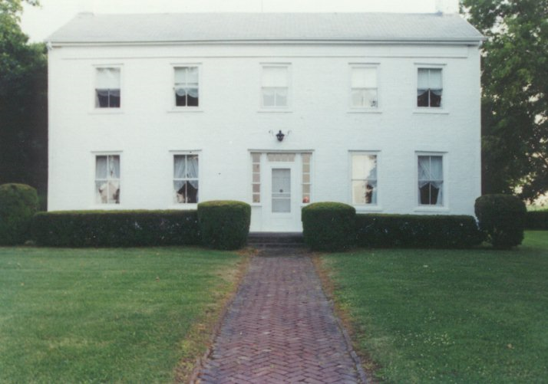

Can you interview someone about your project? Start making contacts (by phone, through relatives or people you know, etc.) If interviewing someone make sure to have a list of questions and get the questions approved by me.

*You do not have to interview someone. However, depending on your topic choice, an interview may be very helpful. Please ask me if you have any questions about the interview process!

Is it possible to gather enough information on your topic idea? This is a question that you should think about. Share your ideas with your teacher.

Finalize your topic to research by September 13 and move on to Step 2.

_________ Step 2--Submit a typed or neatly written proposal for teacher approval. The proposal
indicates what you have chosen as a topic.

____/40pts *This proposal will force you to organize your ideas and think about resources as well as a visual aid. I may also be able to give you insights into references and resources that would be especially helpful for your project.
Getting started is the hardest part!!! Once your proposal is completed, the fun part begins!!!
Use the example of a proposal I have created for you to get started!

Jacksonville Proposal Example
Topic: The Jacksonville Country Club
By: Charlene Anderson

For my Jacksonville research project I have decided to research the Jacksonville Country Club. The Country Club has been a part of my family’s past. My Grandpa and Grandma Anderson were members in the 1950’s, my father worked in the golf pro shop in his teens, and my brother has worked there since he was 15 and is now the PGA Golf Pro and General Manager. I really want to learn more about the history of the Jacksonville Country Club.
To begin my research, I am going to check to see if any of Turner’s resources contain information about the Country Club. To do this, I will look in the index of books I think might help me. I will then check Turner’s historical newspapers resources to see if there are any articles on my topic. The Jacksonville Public Library has a special collections room with vertical files on different topics. I am going to see if the library has a file on the Country Club. (Note: if you use the special collections room, you MUST BE ACCOMPANIED BY A PARENT!) I also think I might interview Grandma Anderson. She remembers a lot about the Country Club. She may even give me the name of someone else to interview. My brother will also be a resource for me and I plan to interview him to see what he knows about the history of the club. I hope I can find out enough information by utilizing all of these resources!
For my visual aid, I am going to create a 6 slide power point presentation with pictures of the club, both past and present, scanned into the slides. I want my power point to be colorful so the kids in my class want to watch it. I am also planning on playing some 1900’s music quietly in the background. I think the club may have started around that time period.
I am excited to start my research project. I know it will be a lot of work, but I am anxious to teach my classmates what I have learned about the Jacksonville Country Club.

You may type your proposal. Print one copy labeled like the example above to turn into me. Make sure you spell-checked your document before printing and your name is at the top. You may also NEATLY hand write your proposal. Please also follow the labeling format at the top of my example.

*TURN YOUR PROPOSAL INTO ME AND THEN BEGIN STEP 3!

_____ Step 3----Start Researching! Remember you picked your own topic: take pride in your research. You are the investigator~ all the information you find will be the result of hard work and staying interested in your topic. Become an EXPERT!!! YOU MUST FIND AT LEAST 15 FACTS ABOUT YOUR TOPIC. FIND MORE IF YOU CAN!

______/80pts. Use your note cards in order to record important information. Remember to look for the five key questions: Who? What? When? Where? How? Later on you will arrange your note cards in a logical manner using numbers, so that you can present your research to the class. Put only a small bit of information on each card. Also, remind yourself on your note cards to make a reference to your visual aid. (20 points)

*Start with the first listed resource and use what we have at Turner to get you started on your research!
_____ Start looking for information about your topic in the brown Morgan County books that we have been using. Be sure to use the index in the Morgan county book. Read any of the pages in the book on your topic.

REMINDER: Take brief notes on your note cards. Remember, answer the questions: Who? What? When? Where? How? Store your notecards in a baggie so that you do not lose them!!! You will organize the notecards for your presentation at a later time so that your presentation goes smoothly.

_____ Use the school’s Jacksonville reference books. You may borrow these during class time. These books are also in the media center and the public library. Ask your parents and grandparents if they have any books or materials that can help you in your research.

_____ With a parent, go to the Jacksonville Public Library. This is a request from the Library itself. Once you are there though they have many sources of material that can help you with your research. Use the special collection and the vertical files as well as books, microfilm, journals, computers, etc. Remember your parents must accompany you there!

_____ Check out the internet! You may use a Google search at home, but at school you will need to go to these websites:
www.ikeepbookmarks.com/ecanderson You can also use “Digital Jacksonville” on our Turner
www.quia.com/pages/candersontjh.html Links site. Lots of information here also!
www.quia.com/pages/patkelly.html

_____ If you are using Google at home try using Google Books. Google books will help you find books related to your topic.
Plus, you can actually read some of the material to see if it will help you or not. Also, try Google Scholar. Google Scholar will supply you with journal articles and other forms of material relative to your topic.

_____ Interview relatives and “older” friends/neighbors about what they remember about Jacksonville, specifically your topic. Prepare a set of questions to ask an expert on your topic. You should have at least 8 questions which must be pre-approved by me. Not every person will be able to interview someone, depending on your topic choice.

_____ Take notes from your interview or even take along a tape recorder or video camera---with the interviewee’s permission, of course! This is an excellent way to get first hand accounts and learn history form those who know it best!!!

_____ Try old yearbooks, newspapers, directories, pamphlets, brochures, etc. We have a lot here at Turner.

_____ Go to the Chamber of Commerce. They have many pamphlets for free and business information.

_____ Jacksonville Main Street may have information also as well as the Jacksonville Journal Courier.

_____ Check to see if there are any Walking Tour signs on your topic. We have a lot of signs for you to use!!!

_____ Find another great Jacksonville resource? Let your teacher know what it is!

Remember the difference between a primary and secondary source. A primary source is original material in which you can make your own interpretations on your topic. A secondary source is someone else’s interpretation of your topic. Both are relevant to your research, but you must be conscious of who is reporting the information you are gathering.

*Tips on searching for material on the computer: When using a search engine like Google (again at home) or searching a library’s resources many times the results you get will rely on what search term you use. When searching for your topic be specific. Try using the + sign to connect search terms. Here are a few examples:
Ken Norton + Muhammad Ali
Illinois College + Beecher Hall
Benjamin Grierson + Jacksonville, IL
Abraham Lincoln visits to Jacksonville, IL
All research should be concluded by September 27th ! I will be checking your note cards that day! Then you will have September 27th during class to practice your introduction and conclusion with your group! Of course, you should have ideas about the intro. and conclusion before then!

_____ Step 4---Create a bibliography of your resources (Due the day of your presentation)
Use the attached form to document your Jacksonville resources. You need to give credit to all of the resources you
_____/20pts. used whether it was a book, Internet site, person, walking tour sign, pamphlet, etc. When citing your sources fill in as
much information as possible!!! If you have questions about the bibliography form, do not hesitate to ask me.
I am here to help you with this. You must have at least 4 different resources on your individual topic!

_____Step 5---Create your visual aid! Be creative and artistic! (Graded during presentation. This is worth 100 points!)
* *Decide what your visual aid is going to be. Maybe you will choose to create a poster or tri-fold display. If so, make your posters/display POP! Add lots of color, captions for your pictures, headings, backgrounds, etc. It should be very attractive to the eye. Maybe you want to create a video tape, or write and perform a play, produce a puppet show, build a model, create a power point presentation, design a web page, dress in costume, etc. The possibilities are endless. Each of you has an extraordinary mind and look what you could create! Make a visual aid you are proud of! Just let me know that in your proposal.

_____Step 6---Prepare an introduction with your group. (Graded during presentation)
*Make sure everyone has a speaking part in the introduction that he/she wrote.
*Catch the audience’s attention. You want them to listen to your presentation. How are you going to get the class’s attention?
*Introduce your topic and members of your group in a unique way.
*Focuses the audience on the broad topic of the group.
*Organizes the presentation to help prepare the audience. Each person will tell what he/she will teach about Jacksonville.

_____Step 7---Prepare a conclusion with your group. (Graded during presentation)
*What are you going to do? A review game? Worksheet? Question/Answer? Skit? Quiz?
*Sum up your group’s project so the audience will remember it. After all of the hard work you did to create your project, you want it to be memorable! Your conclusion should only take about 5 minutes.
*YOUR CONCLUSION SHOULD NOT BE LONGER THAN YOUR PRESENTATION OF JACKSONVILLE HISTORY!

_____Step 8---Practice, Practice, Practice and Present! You ARE the teacher now! (Graded during presentation)
*Do a practice run through of the introduction and conclusion with your group.
*Do you know what you are saying for your presentation? Are your note cards in the proper order?
*Check the project evaluation form attached to see how you will be graded! Each person will turn in this evaluation form to the teacher from his/her packet. Each student will have 2 group grades for the introduction and conclusion and the rest will be individual grades.
*Teach the class about your topic of Jacksonville. You are the expert now!

Parent Signature required (Parent has read through the packet. If you should have questions regarding this project, please call OR email me~243-6963 or 371-2050 or canderson@jax117.org)
x___________________________________________________________
(Parent signature due by September 15 for a homework grade—it is that important!)

Student Signature (I understand what I am supposed to do on this project to be successful and promise to work during class time provided.)

x________________________________________________________
Parents—thank you for your support for this important 7th grade project! ☺
The project covers numerous state standards in both social studies and language arts. ☺

DO NOT TEAR THIS PAPER OUT OF YOUR PACKET. I WILL CHECK EACH STUDENT’S PACKET FOR PARENT SIGNATURE, RECORD THE SCORE EARNED, AND ALLOW THE STUDENT TO KEEP HIS/HER PACKET INTACT.

☺ Remember: Do your best! Make this project something that you are proud of! ☺
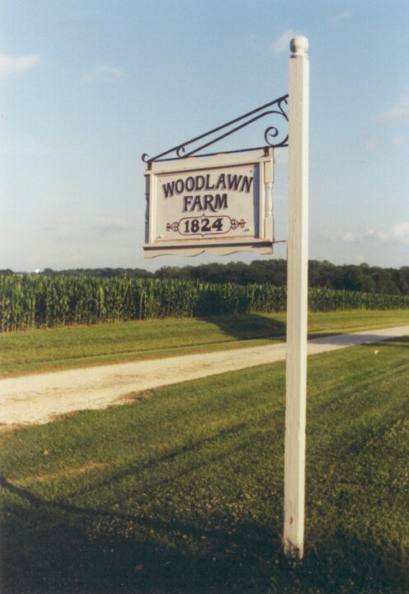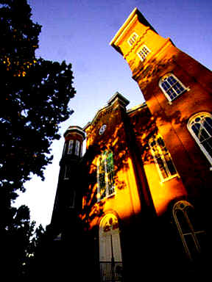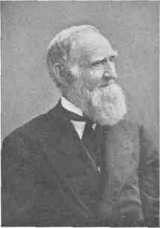

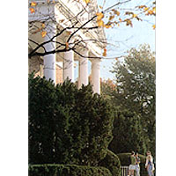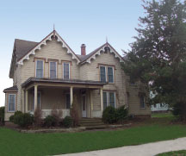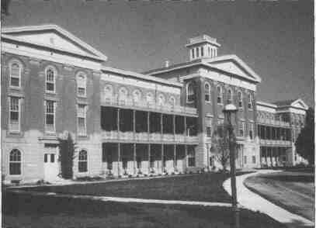
Jacksonville Research Packet Created and Revised by Charlene Anderson and Kasey Monroe, 2010

