Name____________________________________#___________

Chapter 8 Lesson #1
Geography Activity
Activity #1: 20 Points
Important!!! Review, purview this entire project before you begin, you may find a few helpful tips.
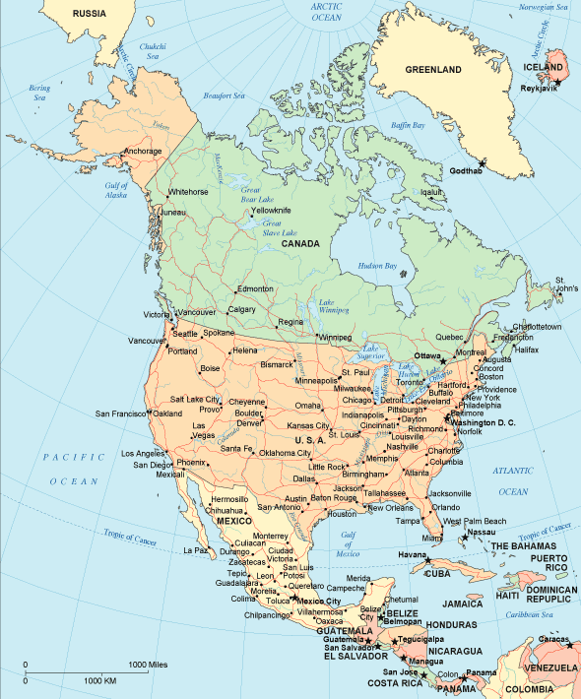
Using the map on the next page label the t countries of North America (and the bordering oceans.)
Belize - a country in Central America at the southeast border of Mexico and northeast of Guatemala.
Canada - the second-largest country in the world - it is north of the USA.
Costa Rica - a country just north of Panama.
Cuba - an island country in the Atlantic Ocean off the southeast coast of the USA.
Dominican Republic - a country located in the eastern part of the island southeast of Cuba (it is east of Haiti).
El Salvador - a country in Central America that is south of Guatemala and Honduras.
Greenland - an island in the Atlantic Ocean northeast of Canada.
Guatemala - a country in Central America south of Mexico and west of Belize.
Haiti - a country located in the western part of the island southeast of Cuba ( it is west of the Dominican Republic).
Honduras - a country northeast of Nicaragua.
Jamaica - an island country in the Atlantic Ocean south of Cuba.
Mexico - a country southwest of the USA and north of Guatemala and Belize.
Nicaragua - a country just north of Costa Rica.
Pacific Ocean - the ocean west of North America.
Panama - a country at the southernmost tip of Central America.
Puerto Rico - an island in the Atlantic Ocean east of the Dominican Republic.
United States of America (USA) - a country north of Mexico and south of Canada.

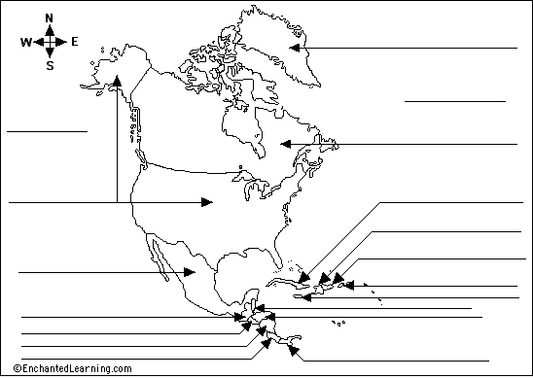

Lesson # 1

Geography Quiz
Activity #2: 100 points

1. What ocean lies to the east of North America? ___________________________
2. What ocean lies to the west of North America? ___________________________
3. What ocean lies to the north of North America? ___________________________
4. What is the name of the gulf off eastern Mexico and southeastern North America? ___________________________
5. What is the name of the sea north of western Canada? ___________________________
6. If you were to walk south from the western USA, what country would you enter? ___________________________
7. What is the name of the huge bay in northeastern Canada? ___________________________
8. If you were to travel from Canada to Guatemala, in which direction would you travel: north, south, east, or west? ___________________________
9. What country in Asia is off the northwestern coast of North America? ___________________________
10. What is the name of the group of lakes between Canada and the USA? ___________________________

Lesson #1
WB 51: 50 Points
Complete Workbook 51 leave the workbook page in your book until the instructions in this activity tell you to take the completed workbook pages out.

Lesson #1
Activity #3 60 Points

Short narrative questions. Answer the questions with one or more complete sentences. Please remember that your answers must be presented in a coherent manner using a complete sentence. You will lose points for misspelled word, improper grammar and incomplete sentences.

Quick Summary: North America is a diverse continent with varied landscapes including two major mountain ranges, the interior plains, the Mississippi River system, the Canadian Shield, and the Costal Lowlands.

1. What facts support the description of North America as “diverse”?

2. What is a basin? How does it differ from a range?

3. Describe the area south of the Appalachian Mountains.

Quick Summary: With its ten different climate regions, North America has climates raining from cold to hot and wet.

4. Describe the climates in the southern part of North America.

5. What type of climate would you expect to find in the Interior Plains?

6. Explain the meaning of moderate when it is used to describe climate.

Quick Summary: The diverse geography of North America has contributed to diversity among the groups of people living on the continent.

7. Summarize the land and climate of North America. How are they like the peoples of North America?

8. Compare and Contrast. Complete the Venn diagram shown on page 211 question #1.
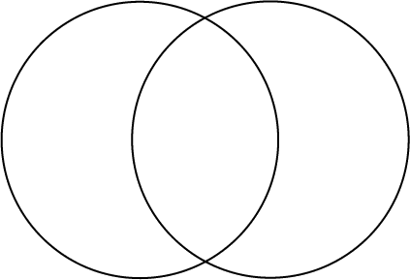

9. How were the eastern Interior Plains different in ancient times?

10. How would you describe the climate of North America?

11. What are several types of landscapes that can be found in North America?

12. How would the diverse landscapes of North America influence the cultures that developed there? Use two vocabulary words from the lesson in your answer

Lesson #1
Activity #4
Postcard 25 Points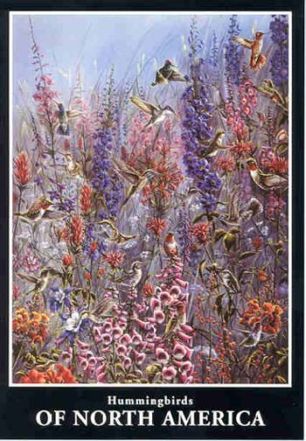 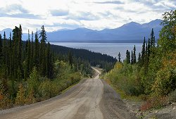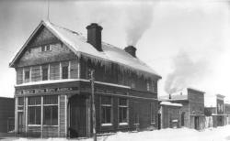

Using the large blank index card included in this Chapter 8 activity packet you are to create a postcard. On one side of the card draw an image that represents something in North America. On the opposite side of the card write a message explaining your image in detail. Tape the completed card your loose leaf paper. Be sure and place a heading on the loose leaf that sites your name and lesson #1 activity #4.

You have now completed Lesson 1. Time to move on to lesson #2.

Chapter 8
Lesson #2
The Southwestern Peoples
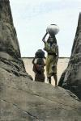

Chapter 8 Lesson #2
Activity #1: 100 points

Native Americans of the Southwest Cultural Area
By Jennifer Kenny

1 The Southwest cultural area of the Native Americans is what are now considered Arizona, New Mexico, and parts of Colorado and Utah. This is a land of majesty and contrast with both mountains and deserts. There is scorching heat in the summer and cold in the winter. Around 10,000 years ago, prehistoric people lived in this area. There was enough rain at the time for mammoths and bison so the people hunted them. Then it became much drier.

2 4,500 years ago, the people became farmers. 2,100 years ago, Hohokam, the ancestors of the Pima, learned how to dig extensive irrigation ditches for crops. Some canals extended miles.

3 2,100 years ago the Anasazi, or ancestral Pueblo people, were also here. They were referred to as Basket Makers. They hunted with a spear thrower and gathered wild foods but they were known for their fine baskets made from rushes, straw, and other materials. They lived in large pit houses, dwellings with sunken floors topped by timber frameworks covered with mud.

4 By about A.D. 700, the Basket Makers had evolved into the early Pueblo culture. They started to build their famous pueblo dwellings during the next 200 years. Sometimes they were built on cliffs, hence the term Cliff Dwellers. By the year 900, their culture dominated the Southwest. Pueblo dwellings were rectangular, multistoried apartment buildings made of terraced stone and adobe. The flat roof of one level was the floor and front yard of another. Ladders connected the different levels and allowed people to enter the rooms through holes in the roof. Hopi and Zuni used stones to cement the walls. The Pueblo Indians along the Rio Grande used adobe bricks. The largest pueblos were called Great Houses and could hold 1,000 people! The Pueblo culture built large planned towns connected by roads and irrigation systems.

5 The Pueblo Indians also built a pit house (probably evolving from the Basket Makers) called a kiva, which served as a ceremonial chamber or clubhouse of the men. It was located in a central place in the pueblo.

6 The Pueblo cultures of the Hopi and Zuni had some unique lifestyles. They grew corn, beans, squash, cotton, and tobacco. They killed rabbits with wooden throwing sticks. In the fall and winter, a mile-round circle of hunters would keep moving in until they could throw the sticks at the rabbits. They traded cotton textiles and corn in exchange for buffalo meat from the nomadic tribes. The men wove cotton textiles and cultivated the fields. The women made fine polychrome pottery.

7 The Hopi (which means "peaceful ones") and Zuni were guided by kachinas, spirit beings that enter men's bodies wearing masks and performing dances. The children had kachina dolls, not as toys, but to teach the children about the roles of the kachinas.

8 The Hopi settled in the numerous mesas in the area. A mesa is a plateau or tabletop. They built homes of stones. Dirt paths connected the mesas years ago. Today roads help a person reach them.

9 The Hopi and other Pueblo people believed snakes brought rain. They held a Snake Dance. For four days, the men hunted snakes – each day in a different direction. When the ceremony began, the snakes were brought to a priest in the center of all the people. A male dancer would take a snake and put it between his teeth. When the dance was done, the snakes were let go at the edge of a mesa. The snakes would go off in four directions asking the Water God to bring rain.

10 Another elaborate ceremony was the Niman. It started on June 26th and went for 16 days. The Indians prayed for rain and returned kachinas to the spirit world. The departing kachinas would offer the villagers symbolic gifts like ears of corn.

11 The Pueblo clothes were usually made of cotton spun into fabric for garments. Sometimes they used animal skins, furs, or feathers too. In cold weather, they added ponchos, which were rectangular cuts of cloth with a hole for the head.

12 In Pueblo society, the women owned houses. The married men lived in the homes of their wives. Tribes were organized into clans, groups of families who claimed a common ancestor. The priests were civil and religious leaders. The priests advised on matters affecting entire pueblos. They also conducted rituals of dances, songs, and prayers all throughout the year.

13 Descendants of the Hohokam people, the Pima and the Papago, also built irrigation systems to raise crops. Both worshipped Elder Brother and Earthmaker. The Pima settled by rivers to grow corn, squash, beans, and wheat. They actually had a surplus of food (so much that they supplied food to the Union Army when it was needed). The Papago were more dwellers of the desert so they had to rely on seasonal floodwater for farming. They were somewhat nomadic. They made wine for rituals from fermented fruit of certain cactus. The Pima were famous for the art of basket making.
14 The Pima houses were small, round, flat-topped, pole-framed structures covered with grass and mud. The villages had armadas – clubhouses that were rectangular with one wall for a windbreak or no walls at all.

15 There were severe droughts in the southwest area between the 1200's and 1300's. This is when the Navajo and Apache appeared from the north. The Pueblos were not warriors, but they did fight to defend themselves against the Navajo and Apache.

16 The Navajo and Apache were hunters and warriors. They were able to learn agricultural skills from the Pueblos. They also raided village people for crops. The Apache and Navajo were less formal than the Pueblos. They joined in bands made of extended clans. A headman was chosen informally for leadership and military prowess. However, other warriors could start raids without the headman's permission.

17 The Apache bands lived in wickiup, a dome or cone-shaped hut with a pole framework. A wickiup was covered with brush, grass, or reed mats. It had a central fire pit and a smoke hole.

18 The Navajo lived in hogans. Hogan in Navajo means "home place." A hogan was cone-shaped or dome-shaped with six to eight sides. Logs and poles were used for frameworks. They were covered with mud, sod, and bark. In later years, the frameworks were covered with stone or adobe. The doorways faced east. The floor symbolized Mother Earth. The roof symbolized Father Sky.

19 The Apaches believed in ga'ns, or mountain spirits. They were important in the Apache ceremonies. The Navajo believed ghosts were the spirits of dead ancestors and witches, or people who practiced magic.

20 The Navajo practiced sand painting, which was ceremonial art. Colored powders were mixed with neutral sand for healing. Sand painters led by shamans created mosaics of legendary beings and natural phenomena using white, black, blue, red, and yellow. At the end of the ceremony, the paintings were destroyed.

21 The Navajo believed in Spider Woman, a spirit being, who first taught women to weave. These skills were passed from mother to daughter. Their blankets and rugs were, and are, world famous. Their silverwork was also famous.

22 The Apache women were known for their fine beadwork. They also made beautiful baskets of willow rods.

23 One famous Apache man was Geronimo, or Goyanthlay. He was a famous Apache warrior. He fought the American invasion of Apache lands in the 1860's and 1870's. He was confined to the San Carlos reservation in 1877. In 1881, he escaped and finally surrendered in 1886.
24 Today, many of the Native Americans live on reservation lands in New Mexico and Arizona. Some raise livestock and farm. Some sell handicrafts. Tourism and casino gaming has helped. Of course, the discovery of oil, natural gas, and minerals has helped as well.
Fill in the blank. After reading the article above, fill in the blank with the correct response.

1. When the first people arrived in the Southwest, there had been enough rain to support and hunt _______________ and____________.

2. 2, 100 years ago, the ______________, or the ancestors of the Pima, learned how to dig extensive irrigation ditches for crops.

3. The Anasazi, or ancestral Pueblo people, were referred to as _________ ___________.

4. ___________ dwellings were rectangular, multistoried apartment buildings made of terraced stone and adobe.

5. In the Pueblo culture, the Indians built a ___________, which served as a ceremonial chamber located in a central place in the pueblo.

6. _____________ means "peaceful ones."

7. The Hopi and Zuni children had ____________ dolls.

8. A __________ is a plateau or tabletop.

9. The Apache bands lived in __________.

10. The Navajo lived in __________.

Chapter 8 Lesson #2
Activity #2 15 points.
Cloze activity

Native Americans of the Southwest Cultural Area By Jennifer Kenny

silverwork
natural
nomadic
cone-shaped
bands
irrigation
warrior
cultural
ceremonial
contrast
military
invasion
tabletop
area
painters

Directions: Fill in each blank with the word that best completes the reading comprehension.

The Southwest (1) _______________________ area of the Native Americans is what are now considered Arizona, New Mexico, and parts of Colorado and Utah. This is a land of majesty and (2) _______________________ with both mountains and deserts. There is scorching heat in the summer and cold in the winter. Around 10,000 years ago, prehistoric people lived in this (3) _______________________ . There was enough rain at the time for mammoths and bison so the people hunted them. Then it became much drier.
4,500 years ago, the people became farmers. 2,100 years ago, Hohokam, the ancestors of the Pima, learned how to dig extensive irrigation ditches for crops. Some canals extended miles.
2,100 years ago the Anasazi, or ancestral Pueblo people, were also here. They were referred to as Basket Makers. They hunted with a spear thrower and gathered wild foods but they were known for their fine baskets made from rushes, straw, and other materials. They lived in large pit houses, dwellings with sunken floors topped by timber frameworks covered with mud.
By about A.D. 700, the Basket Makers had evolved into the early Pueblo culture. They started to build their famous pueblo dwellings during the next 200 years. Sometimes they were built on cliffs, hence the term Cliff Dwellers. By the year 900, their culture dominated the Southwest. Pueblo dwellings were rectangular, multistoried apartment buildings made of terraced stone and adobe. The flat roof of one level was the floor and front yard of another. Ladders connected the different levels and allowed people to enter the rooms through holes in the roof. Hopi and Zuni used stones to cement the walls. The Pueblo Indians along the Rio Grande used adobe bricks. The largest pueblos were called Great Houses and could hold 1,000 people! The Pueblo culture built large planned towns connected by roads and (4) _______________________ systems.
The Pueblo Indians also built a pit house (probably evolving from the Basket Makers) called a kiva, which served as a ceremonial chamber or clubhouse of the men. It was located in a central place in the pueblo.
The Pueblo cultures of the Hopi and Zuni had some unique lifestyles. They grew corn, beans, squash, cotton, and tobacco. They killed rabbits with wooden throwing sticks. In the fall and winter, a mile-round circle of hunters would keep moving in until they could throw the sticks at the rabbits. They traded cotton textiles and corn in exchange for buffalo meat from the nomadic tribes. The men wove cotton textiles and cultivated the fields. The women made fine polychrome pottery.
The Hopi (which means "peaceful ones") and Zuni were guided by kachinas, spirit beings that enter men's bodies wearing masks and performing dances. The children had kachina dolls, not as toys, but to teach the children about the roles of the kachinas.
The Hopi settled in the numerous mesas in the area. A mesa is a plateau or (5) _______________________ . They built homes of stones. Dirt paths connected the mesas years ago. Today roads help a person reach them.
The Hopi and other Pueblo people believed snakes brought rain. They held a Snake Dance. For four days, the men hunted snakes – each day in a different direction. When the ceremony began, the snakes were brought to a priest in the center of all the people. A male dancer would take a snake and put it between his teeth. When the dance was done, the snakes were let go at the edge of a mesa. The snakes would go off in four directions asking the Water God to bring rain.
Another elaborate ceremony was the Niman. It started on June 26th and went for 16 days. The Indians prayed for rain and returned kachinas to the spirit world. The departing kachinas would offer the villagers symbolic gifts like ears of corn.
The Pueblo clothes were usually made of cotton spun into fabric for garments. Sometimes they used animal skins, furs, or feathers too. In cold weather, they added ponchos, which were rectangular cuts of cloth with a hole for the head.
In Pueblo society, the women owned houses. The married men lived in the homes of their wives. Tribes were organized into clans, groups of families who claimed a common ancestor. The priests were civil and religious leaders. The priests advised on matters affecting entire pueblos. They also conducted rituals of dances, songs, and prayers all throughout the year.
Descendants of the Hohokam people, the Pima and the Papago, also built irrigation systems to raise crops. Both worshipped Elder Brother and Earthmaker. The Pima settled by rivers to grow corn, squash, beans, and wheat. They actually had a surplus of food (so much that they supplied food to the Union Army when it was needed). The Papago were more dwellers of the desert so they had to rely on seasonal floodwater for farming. They were somewhat (6) _______________________ . They made wine for rituals from fermented fruit of certain cactus. The Pima were famous for the art of basket making.
The Pima houses were small, round, flat-topped, pole-framed structures covered with grass and mud. The villages had armadas – clubhouses that were rectangular with one wall for a windbreak or no walls at all.
There were severe droughts in the southwest area between the 1200's and 1300's. This is when the Navajo and Apache appeared from the north. The Pueblos were not warriors, but they did fight to defend themselves against the Navajo and Apache.
The Navajo and Apache were hunters and warriors. They were able to learn agricultural skills from the Pueblos. They also raided village people for crops. The Apache and Navajo were less formal than the Pueblos. They joined in (7) _______________________ made of extended clans. A headman was chosen informally for leadership and (8) _______________________ prowess. However, other warriors could start raids without the headman's permission.
The Apache bands lived in wickiup, a dome or cone-shaped hut with a pole framework. A wickiup was covered with brush, grass, or reed mats. It had a central fire pit and a smoke hole.
The Navajo lived in hogans. Hogan in Navajo means "home place." A hogan was (9) _______________________ or dome-shaped with six to eight sides. Logs and poles were used for frameworks. They were covered with mud, sod, and bark. In later years, the frameworks were covered with stone or adobe. The doorways faced east. The floor symbolized Mother Earth. The roof symbolized Father Sky.
The Apaches believed in ga'ns, or mountain spirits. They were important in the Apache ceremonies. The Navajo believed ghosts were the spirits of dead ancestors and witches, or people who practiced magic.
The Navajo practiced sand painting, which was (10) _______________________ art. Colored powders were mixed with neutral sand for healing. Sand (11) _______________________ led by shamans created mosaics of legendary beings and (12) _______________________ phenomena using white, black, blue, red, and yellow. At the end of the ceremony, the paintings were destroyed.
The Navajo believed in Spider Woman, a spirit being, who first taught women to weave. These skills were passed from mother to daughter. Their blankets and rugs were, and are, world famous. Their (13) _______________________ was also famous.
The Apache women were known for their fine beadwork. They also made beautiful baskets of willow rods.
One famous Apache man was Geronimo, or Goyanthlay. He was a famous Apache (14) _______________________ . He fought the American (15) _______________________ of Apache lands in the 1860's and 1870's. He was confined to the San Carlos reservation in 1877. In 1881, he escaped and finally surrendered in 1886.
Today, many of the Native Americans live on reservation lands in New Mexico and Arizona. Some raise livestock and farm. Some sell handicrafts. Tourism and casino gaming has helped. Of course, the discovery of oil, natural gas, and minerals has helped as well.

Chapter 8 Lesson #2
WB page 52 : 80 Points
Complete Workbook 52 (leave the workbook page in your book until the instructions in this activity tell you to take the completed workbook pages out.

Chapter 8
Read pages 216 and 217
WB page 53: 90 points
Complete Workbook 53 (leave the workbook page in your book until the instructions in this activity tell you to take the completed workbook pages out.

Chapter 8 Bias “Thinking Skills”
Activity : 18 points
Activity #1 . Place your complete sentence response to the questions below.

1. Why was it a problem for the U.S. government that Native Americans were living on Western lands?

2. What facts did Jackson include to support his opinion about Native Americans?

3. What examples of strong words and phrases Jackson used to convince people of his view point?

4. Explain why this quote “All… experiments for the improvement of the Indians have failed. It now seems to be an established fact that they cannot live in contact with a civilized community…” is a biased statement.

5. What kind of warning signs could give you clues to the hidden agenda behind President Jackson’s quote?

6. Think of a generalization or other example of bias that you have heard. Write it down and explain why you think it is bias.

Chapter 8 Lesson#3
“The Mound Builders”
The Adena Culture
Lesson #3 Activity #1: 39 Points

Place your complete sentence response to the questions below.

Quick Summary: The Adena culture, who were among the first mound builders, first developed in the Ohio River Valley and spread hundreds of miles in all directions. They thrived from about 700 B.C. to about A.D. 100.

1. How might archaeologists have determined that the Adena did more hunting than farming.

2. How did the homes built by the Adena culture reflect their natural surroundings?

3. What does the size of the great Serpent Mound tell you about the age of the structure and the people who built it?

Quick summary: The Hopewell who lived in some of the same areas as the Adena, also built mounds. They conducted trade with other Native Americans.

4. Do you think that the Hopewell and the Adena communicated with each other? Explain.

5. Which culture spread farthest east?

6. Based on archeologists’ findings, how would you describe the economic system of the Hopewell culture?

7. How were the Hopewell different from the Adena?
.

Quick Summary: The Mississippian culture lived in the same area as the Hopewell. They built temple mounds on which to hold their ceremonies.

8. Compare and contrast the mounds of the Hopewell and the Mississippian cultures.

10. Why did the Adena people build mounds?

11. Why did the Mississippians people build mounds?

12. Where can some of the remains of mound building cultures be found today?

13. Cahokia is home to 85 large mounds. What can you conclude about the people who lived in Cahokia based on this fact alone.

Chapter 8 Lesson #4
WB page 55 : 120 Points
Complete Workbook 55 leave the workbook page in your book until the instructions in this activity tell you to take the completed workbook pages out.

Chapter 8 Lesson #4
Activity 1- Canadian Geography 80 Points
Reading Comprehension
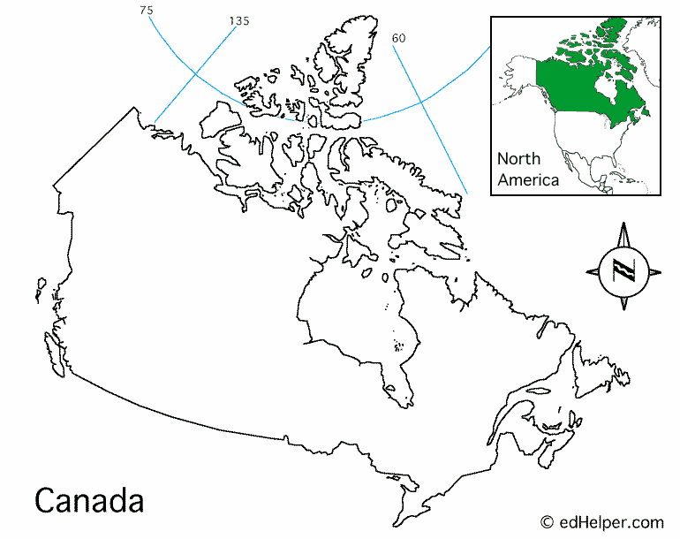

Canada - Geography
By Ekaterina Zhdanova-Redman

Instructions: Read the entire article below and then answer the multiple choice questions at the end of this article.

Situated north of the United States, between the Atlantic and Pacific oceans, Canada, after Russian Federation, is the world's second largest country. Its territory is almost as large as Europe and slightly larger then the territory of the United States. However, the population of Canada is just a little more than 10 percent of the population of the United States, and nearly 90 percent of Canadians live within 300 kilometers (about 240 miles) of the southern border Canada shares with the U.S.
Canada occupies almost the entire northern part of the North American continent. It is bounded on the north by the Arctic Ocean, on the east by the Atlantic Ocean, on the west by the Pacific Ocean and the U.S. state of Alaska, and by twelve states of the United States on the south. Canada's southern boundary dips south to a point below Detroit, Michigan, and the northernmost part of Canada, Cape Columbia on Ellesmere Island, lies closer to the Northern Pole than any other land area in the world except the northern tip of Greenland. An airplane flying from Cape Columbia would only have to travel about 760 kilometers (475 miles) to reach the North Pole.
Canada has the longest coastline of any country in the world. Including islands, it extends about 100,000 kilometers (60,000 miles) along the Atlantic, Arctic, and Pacific oceans and the great inland sea of Hudson Bay. Besides that, Canada's inland water resources--rivers, lakes, and waterfalls--are incredible, too. Among them, the Niagara River that plunges over beautiful Niagara Falls is considered to be one of the scenic wonders of the world.
Some of the most famous North American lakes are The Great Lakes that Canada shares with the United States. It is the largest group of fresh-water lakes in the world. Also, the Great Lakes, with all the rivers connecting them, and the Saint Lawrence River (which sometimes is called "the Mother of Canada") form the greatest water highway in North America.
Though much of Canadian land is lake and river-filled forest, there are mountains, plains, and even a small desert. The Great Plains, or prairies cover Manitoba, Saskatchewan, and parts of Alberta. Golden fields of wheat, or sunflowers, stretch forever in these parts. Western Canada is known for its Rocky Mountains, while the east has the country's major cities and also its most visited geographic feature, Niagara Falls. The Canadian Shield, an ancient rocky and glacially sanded region, formed more than 2.5 billion years ago, covers most of the north of the country. The Arctic region, in the far north, has frozen tundra merging into islands that are ice-bound for most of the year.
Canada has an incredible mix of native flora and fauna. Canada is known for its forests that cover about half of the land area of the country. There are many different kinds of trees, such as white and black spruce, balsam and Douglas fir, western red cedar, white pine, and others. The sugar maple is one of Canada's best-known symbols, and the maple leaf appears on the country's flag.
Canada also has rich wildlife. Common animals include the grizzly, black, brown, and polar bears, beaver, buffalo, wolf, coyote, lynx, cougar, deer, caribou, elk, and moose. There are also 500 species of birds, such as the great blue heron, Canada geese, and many varieties of duck. Fish are among Canada's most important natural resources. There is a great variety of ocean, river, and lake fish found in this country.

Natural environment is Canada's greatest attribute. To protect the wildlife, Canadians established numerous animal preserves and provincial parks. Most of the forests in Canada are owned by the federal and provincial governments, who limit the number of trees that can be cut, in addition to limiting hunting, fishing, and trapping.

Copyright © 2007 edHelper

Multiple Choice. Select the best answer to the question.

1. Canada is _____.
a. The largest country in the world
b. The fourth largest country in the world
c. The third largest country in the world
d. The second largest country in the world

2. The population of Canada is _____.
a. About 10 percent less than the population of the United States
b. About 10 percent more than the population of the United States
c. About 10 percent of the population of the United States
d. Slightly larger than the population of the United States

3. The majority of Canadians live _____.
a. Within about 300 kilometers of southern border with the US
b. Within about 1000 kilometers of southern border with the US
c. Within about 300 kilometers of the South Pole
d. Within about 300 kilometers of the North Pole

4. Which natural feature of Canada is the longest in the world? ________
a. The coastline
b. The Saint Lawrence River
c. The mountain system
d. The Niagara River

5. With which country does Canada share the Great Lakes?

6. Rocky Mountains are situated in:
a. Northern Canada
b. Southern Canada
c. Eastern Canada
d. Western Canada

7. Leaf of what tree is one of Canada's national symbols?
a. White pine
b. Black spruce
c. Sugar maple
d. Red cedar

8. What is the large open space in the Great Plain region in Canada called?
a. Desert
b. Prairies
c. Tundra
d. Taiga

Chapter 8 Lesson # 4 Activity #2: 100 points (50 points writing/ 50 points coloring)
Coloring and writing activity

In the arctic region of what is now northern Canada, the Inuit used materials from the world around them to survive in the harsh conditions. For this activity I would like you to write a descriptive paragraph about the ways the Inuit used their natural resources. Write the paragraph on your loose leaf paper. Once you have completed your paragraph, color the igloo on the next page, you may use crayons or colored pencils, your goal is to make this igloo scene a realistic as possible.
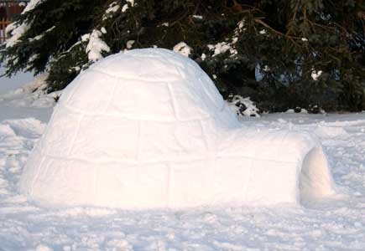
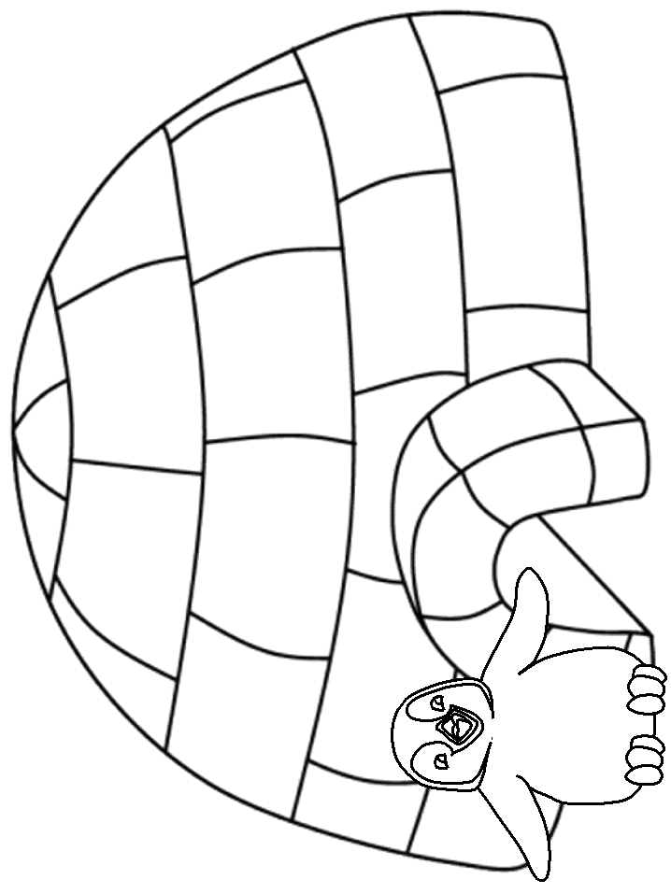

Unit 3 Crossword puzzle
Activity 120 Points

Directions: place your answers in the puzzle

Open Book Independent Activity Chapter 8
Multiple Choice
Identify the letter of the choice that best completes the statement or answers the question.

____ 1. How are the Appalachian Mountains different from the Rocky Mountains?
a. | The Appalachians are geologically older than the Rockies.
b. | The Appalachians have eroded less than the Rockies.
c. | The Appalachians lie far to the west of the Rockies.
d. | The Appalachians are on a different continent than the Rockies.

____ 2. What was the eastern Interior Plains like in ancient times?
a. | It was full of small mountains.
b. | It was an area of grasslands.
c. | It was covered with forests.
d. | It was along the eastern coast.

____ 3. What is NOT a characteristic of a moderate climate?
a. | thunderstorms
b. | tundra
c. | tornadoes
d. | hurricanes

____ 4. Which of these did NOT contribute to the diversity of cultures in North America?
a. | the continent’s diverse climate
b. | the continent’s basins and ranges
c. | the continent’s rivers and plains
d. | the continent’s uniform landscape

____ 5. How were the Hohokam different from the Anasazi?
a. | The Hohokam built pueblos.
b. | The Hohokam invented the process of etching.
c. | The Hohokam lived in North America.
d. | The Hohokam thrived in the Southwest.

____ 6. How are pit houses and pueblos alike?
a. | The Hohokam built both of them.
b. | They both are made of bricks.
c. | They both are made using mud.
d. | The Anasazi used them for storage.

____ 7. What type of bricks were used to build Anasazi pueblos?
a. | adobe
b. | concrete
c. | diamond
d. | pottery

____ 8. How did the Hohokam and Anasazi keep their crops watered?
a. | by hoping for rain
b. | by using irrigation
c. | by draining cacti
d. | by melting snow

____ 9. Who is buried in each Adena burial mound?
a. | one important leader
b. | the richest man in the village
c. | the village medicine man
d. | many people

____ 10. How were the Adena and Hopewell alike?
a. | They both were primarily farmers.
b. | They both traded over a vast area.
c. | Their cultures both began about 1000 B.C.
d. | They both built burial mounds.

____ 11. What type of mounds did the Mississippian culture build?
a. | burial mounds
b. | pitcher’s mounds
c. | temple mounds
d. | small mounds

____ 12. Where is the Cahokia Mounds State Historic Site located?
a. | Illinois
b. | Arizona
c. | Missouri
d. | Mississippi

____ 13. Which CANNOT be seen at the Cahokia Mounds State Historic Site?
a. | 85 temple mounds
b. | large burial mounds
c. | Mississippian mounds
d. | a 100-foot-high mound

____ 14. Which was NOT a way the Inuit used seals?
a. | waterproof jackets
b. | boat covers
c. | spear points
d. | household pets

____ 15. Where did the Iroquois live?
a. | along the Mississippi River
b. | around the eastern Great Lakes
c. | in the northern part of Canada
d. | in the Southwest region

____ 16. Which natural resource did the Iroquois use in building their longhouses?
a. | trees
b. | grass
c. | snow
d. | water

____ 17. Why were the Algonquin hunters instead of farmers?
a. | Few plants could survive where they lived.
b. | Their forested homeland was rich in deer and moose.
c. | No one in their community knew how to farm.
d. | They did not have access to seeds or tools.

____ 18. How were the Inuit and the Algonquin alike?
a. | They both lived in northern Canada.
b. | They both were primarily farmers.
c. | They both lived in snowhouses.
d. | They both were primarily hunters.

Use the map to answer the questions. Use Latitude and Longitude
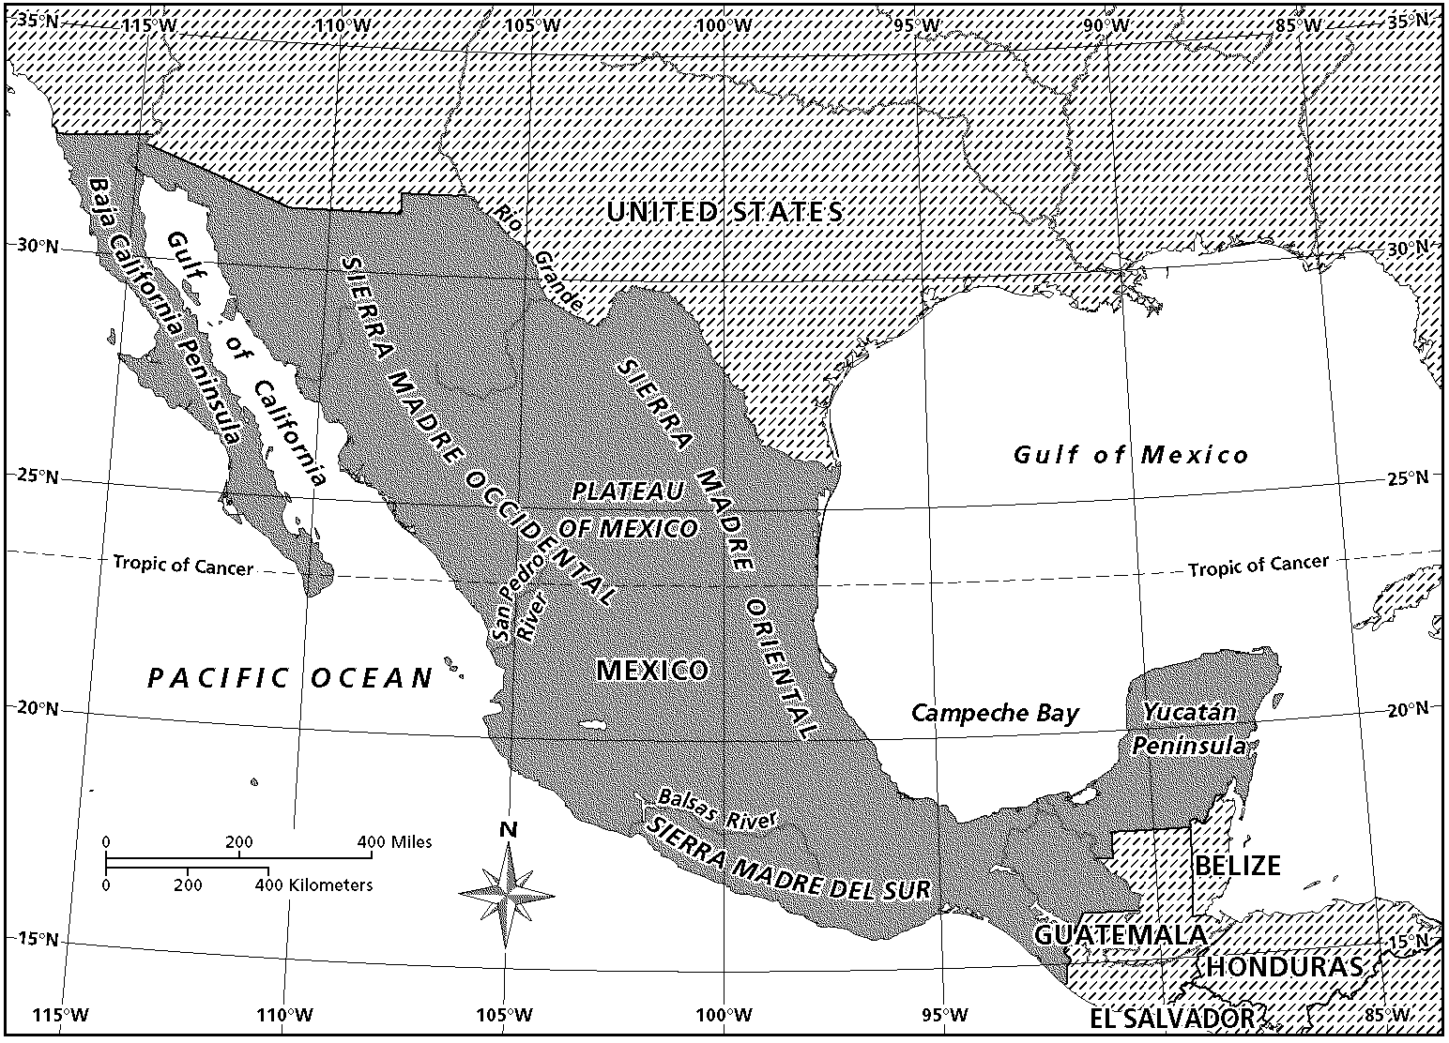
Mexico

19. What is the name of the imaginary lines that run north and south on the map?

20. Where are you if you are vacationing at 20°N and 90°W?

21. Estimate the longitudinal location to which the Baja California Peninsula extends.

Chapter 8
Grade Totals:

Lesson 1 Activity #1 __________/20
Activity #2 __________/100
Activity #3 __________/60
Activity #4 __________/25
Lesson 2 Activity #1 __________/100
Activity #2 __________/15
“Thinking Skills” __________/18
Lesson 3 Activity #1 __________/39
Lesson 4 Activity #1 __________/80
Activity #2 __________/100
Activity #3 _____90/90
Crossword Puzzle __________/120

Daily grade Total __________/767

1. Test Grade: Complete Chapter 8 Test _______/100

1. How might archaeologists have determined that the Adena did more hunting than farming? Archaeologists may have found more weapons used for hunting than tools used for farming.

2. How did the homes built by the Adena culture reflect their natural surroundings?

3. What does the size of the great Serpent Mound tell you about the age of the structure and the people who built it? The size might indicate that the people who built it lived in one place for a long time. The mounds were continually built up over the years, so the Great Serpent Mound must be very old.

Quick summary: The Hopewell who lived in some of the same areas as the Adena, also built mounds. They conducted trade with other Native Americans.

4. Do you think that the Hopewell and the Adena communicated with each other? Explain. Yes; their cultures shared many similarities, such as burial mounds and houses made of materials found their environment.

5. Which culture spread farthest east? Hopewell.

6. Based on archeologists’ findings, how would you describe the economic system of the Hopewell culture? The Hopewell cultures were able to grow much of their food, but they needed to trade to obtain other items they needed. Some of the Hopewell had jobs for which they may have been specially trained.

7. How were the Hopewell different from the Adena? They lived over a larger area, built larger mounds, depended more on Agriculture, and traded over a larger area.

Quick Summary: The Mississippian culture lived in the same area as the Hopewell. They built temple mounds on which to hold their ceremonies.

8. Compare and contrast the mounds of the Hopewell and the Mississippian cultures. Both cultures built large mounds; the Hopewell built burial mounds; while the Mississippian built temple mounds.

9. Compare and Contrast. On your loose leaf copy and complete the Venn diagram shown on page 221 question #1.

10. Why did the Adena people build mounds? For burial purposes.

11. Why did the Mississippians people build mounds? For ceremonial and religious purposes

12. Where can some of the remains of mound building cultures be found today? Eastern United States, Ohio River Valley, from Great Lakes to the Gulf coast, and near St. Louis, Missouri.

13. Cahokia is home to 85 large mounds. What can you conclude about the people who lived in Cahokia based on this fact alone? That making mounds was important to them and that they lived in the area for some time.
4. Describe the climates in the southern part of North America. In the southeast, the climate is tropical and humid. In the southwest, the climate is hot and dry, or arid.

5. What type of climate would you expect to find in the Interior Plains? Cold winter, hot or dry summer, wet

6. Explain the meaning of moderate when it is used to describe climate. Moderate means that the temperatures are not consistently extremely hot or extremely cold, but they can be. Regions with moderate climates may still experience extreme weather conditions, such as tornadoes, hurricanes, floods, and blizzards.
Quick Summary: The diverse geography of North America has contributed to diversity among the groups of people living on the continent.

7. Summarize the land and climate of North America. How are they like the peoples of North America? The land and climate are diverse, just as the groups of people on the continent are.

8. Compare and Contrast. On your loose leaf copy and complete the Venn diagram shown on page 211 question #1.

9. How were the eastern Interior Plains different in ancient times? In ancient times, the eastern Interior Plains were heavily forested.

10. How would you describe the climate of North America? Diverse; it ranges from cold and dry to hot and wet.

11. What are several types of landscapes that can be found in North America? Deserts, tundra, mountains, forests, and costal areas.

12. How would the diverse landscapes of North America influence the cultures that developed there? Use two vocabulary words from the lesson in your answer. The cold northern tundra regions would be best for people who hunted, but not for farmers. Farming cultures would most likely develop in the south and east. The arid desert regions might be hard to farm.

1. OBJ: Lesson Objective (8–1:1)

2. OBJ: Lesson Objective (8–1:2)

3. OBJ: Lesson Objective (8–1:3)

4. OBJ: Lesson Objective (8–1:3)

5. OBJ: Lesson Objective (8–2:1) | Lesson Objective (8–2:2)

6. OBJ: Lesson Objective (8–2:3)

7. OBJ: Lesson Objective (8–2:3)

8. OBJ: Lesson Objective (8–2:4)

9. OBJ: Lesson Objective (8–3:2)

10. OBJ: Lesson Objective (8–3:1)

11. OBJ: Lesson Objective (8–3:2)

12. OBJ: Lesson Objective (8–3:3)

13. OBJ: Lesson Objective (8–3:3)

14. OBJ: Lesson Objective (8–4:3)

15. OBJ: Lesson Objective (8–4:2)

16. OBJ: Lesson Objective (8–4:3)

17. OBJ: Lesson Objective (8–4:3)

18. OBJ: Lesson Objective (8–4:1)

