5th Grade final (possible essay/narrative questions) Study Guide

Essay

1. Evaluate Which of the following people do you think was most important to Egyptian history: King Menes, Manetho, Khufu, or Amenemhet? Why?

2. Summarize How were Egyptian pharaohs’ bodies prepared for the afterlife? Why was this done?

3. Summarize Write at least three main ideas that you would include in a summary about the North China Plain.

4. Make Inferences How do you think the Bronze Age received its name?

5. Main Idea and Details Write three details to support the following main idea: The second part of the Zhou dynasty is referred to as a “golden age” in China.

6. Evaluate Which of the Chinese dynasties do you think was the most important? Explain your reasoning.

7. Compare and Contrast Compare the climate of South Asia with the climate of your region.

8. Summarize What are three facts that you would include in a summary about the Persian Empire?

9. Generalize What role does the Rig Veda play in the Hindu religion?

10. Make Inferences How might the belief in reincarnation affect Hindus’ daily lives?

11. Summarize List three main points you would include in a summary about Siddhartha Gautama.

12. Compare and Contrast How were the Olmec and Aztec civilizations alike and different?

13. Point of View Suppose that you were an advisor to Moctezuma II. What might you have told him about Cortés? Should he have allowed Cortés to enter Tenochtitlan? Why or why not?

14. Express Ideas Which civilization do you admire most—the Olmec, the Maya, or the Aztec? Why?

15. Why is knowing the type of projection a mapmaker uses important when reading a map?

16. Hypothesize Why do you think people such as the Chavín and Mochica created art?

17. Sequence Write the main events of the Inca Empire from about A.D. 1200 until 1527 in the order in which they happened.

18. Hypothesize Why do you think the Inca’s elaborate system of roads was reserved only for military and government use?

19. Express Ideas Which civilization do you think was the most important: the Chavín, the Mochica, or the Inca? Why?

Use the map to answer the questions. Use Latitude and Longitude
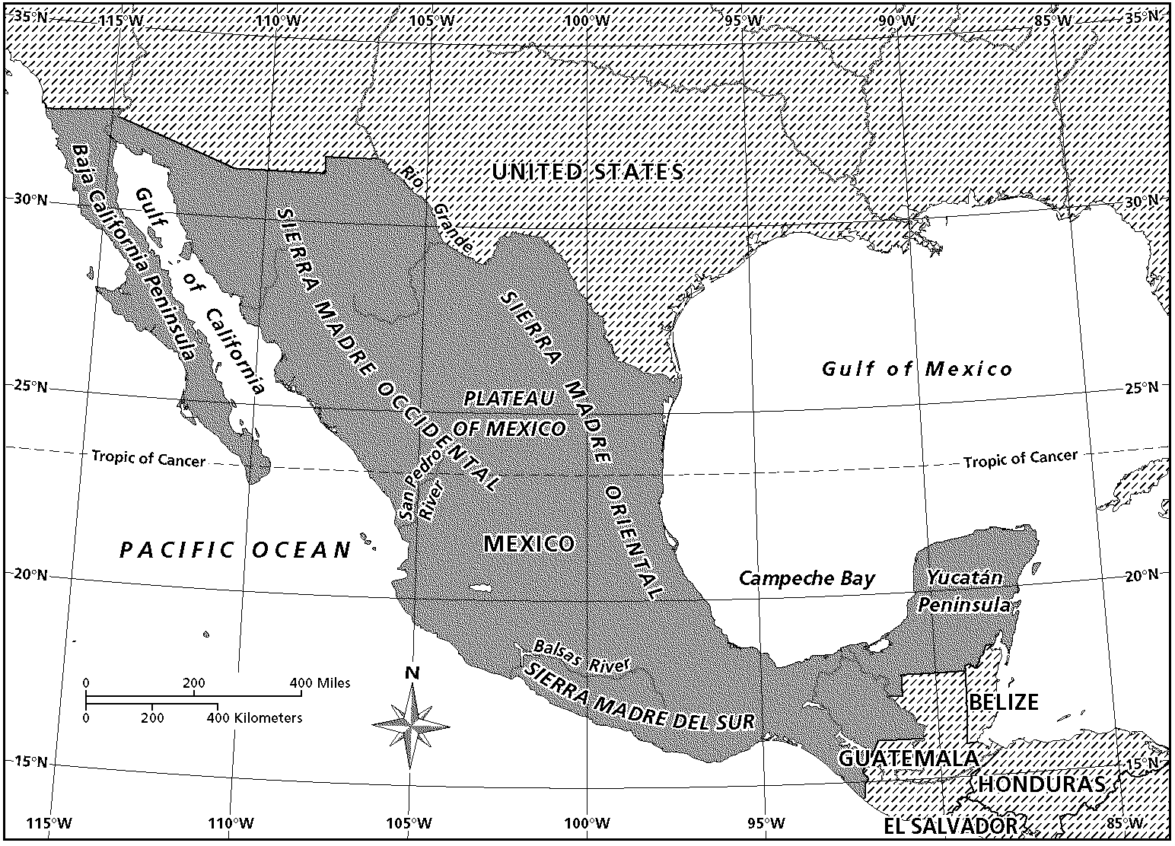
Mexico

20. What is the name of the imaginary lines that run north and south on the map?

21. Where are you if you are vacationing at 20°N and 90°W?

22. Estimate the longitudinal location to which the Baja California Peninsula extends.

23. Cause and Effect How did the physical geography of ancient Greece cause it to separate into independent communities?

24. Compare and Contrast How was democracy in ancient Athens different from democracy in the United States?

25. Compare and Contrast Athens and Sparta both contributed to the Greek culture that shaped Western Civilization. Describe two ways in which these city-states were alike and two ways in which they were different.

26. Main Idea and Details Describe three characteristics of the Golden Age of Athens.

27. Sequence Describe the events that occurred during the Peloponnesian War.

28. Summarize What contributions were made in the field of medicine during the Hellenistic Age?

Use the maps to answer the questions. Compare City Maps at Different Scales
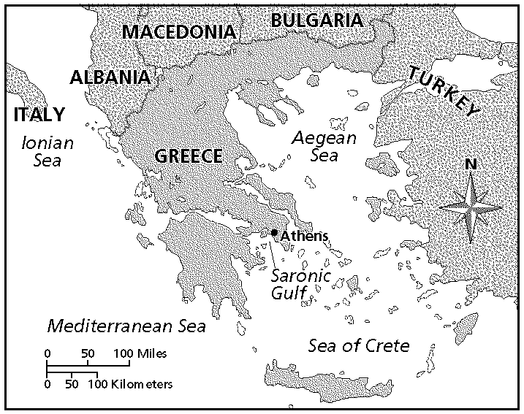  Map A | 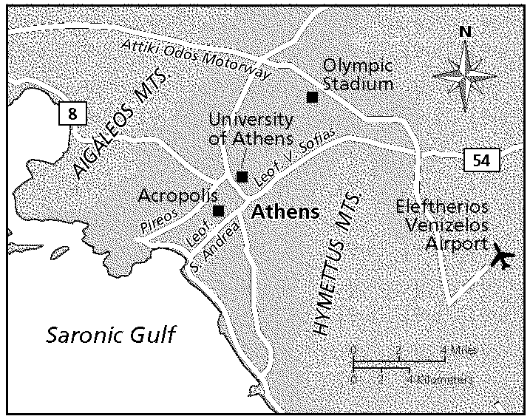  Map B

29. Which map shows more of the area surrounding Athens?

30. Why do you think the mapmaker chose a different scale for Map B?

31. When might Map A be more useful than Map B?

32. Draw Conclusions How do you think the location of Italy may have helped launch the Roman Empire?

33. Summarize Describe how the Roman republic was originally set up, including the different levels of power in the government.

34. Main Idea and Details What were some of the ways the Romans tried to make friends with the peoples they conquered?

35. Compare and Contrast Describe how the Roman Empire changed after the Five Good Emperors came into power.

36. Sequence What sequence of events led to Christianity becoming the main religion in the Roman Empire?

37. Sequence How did the division of the Roman Empire lead to the division of Christianity?

38. Summarize What events led to the downfall of the city of Rome?

39. Hypothesize If a German ruler had not arrested the soldier Orestes and his son, the last Roman emperor, what do you think might have happened?

