Field Trip ♦ Field Trip ♦ Field Trip ♦ Field Trip ♦ Field Trip ♦ Field Trip ♦ Field Trip
Salem, Massachusetts
Home of the Notorious Witch Trials of 1692

Friday, October 13

The Crucible, Arthur Miller’s classic play about suspicion and persecution, is based on real-life events that transpired at Salem, Massachusetts in 1692. We will be taking a field trip to Salem on Friday, October 13 to see some of the historic sites.

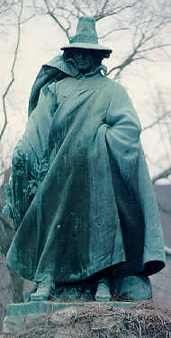
Attractions to be visited are:

♦Witch Dungeon Museum – includes a reenactment of the 1692 witch trial of Sarah Good.

♦Witch House – Historical home of one of the Salem judges.

♦The Salem Witch Trials Memorial, which pays tribute to victims of the witch-hunt, & Old Salem Burying Point, as well as the Essex Street Pedestrian Mall (shopping & food).

♦House of the Seven Gables – this house, the oldest surviving mansion in New England, inspired Nathaniel Hawthorne’s novel of the same name. Also includes Hawthorne’s birth home.

Who can go? The trip is open to students enrolled in English 11R and English 10H.

The cost is $42 per student. Cash (exact change) or check – please make check payable to C-A High School). You will receive a permission form when your payment is received. You should bring some money for lunch in Salem and dinner on the Massachusetts Turnpike. Dress appropriately for the weather outside!

When do we leave? Early!!! The motor coach leaves at 5:45 a.m. from the high school (bus riders will need to find alternate transportation to and from school) – Please don’t be late!!!
When do we return? Approximately 8 p.m. at the high school, depending on traffic. Again, students will need their own transportation home.

Chaperones: Mr. Dial (English), Ms. Gaffuri (English), Mrs. Murphy (English), and Mrs. Mousseau (Guidance Counseling).

