KMS ID | 186271: Globe Rewards Tiering Program Handling
Summary | Last March 25, 2014, Globe released a new rewards tiering program for Postpaid Telephony, LTP, Tattoo Postpaid Nomadic and TattooAtHome Customers.
Affected Segments | Wireless Platinum Hotline (Blue)
Attachments | None
For Emphasis
The new Globe Rewards Tiers are as follows:
a. PLATINUM MEMBERS
- Globe Rewards Platinum Elite
- Globe Rewards Platinum
b. BLUE MEMBERS
- Globe Rewards Blue
c. BASE CUSTOMERS
- Globe Rewards

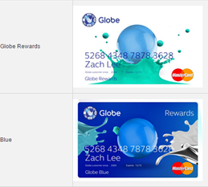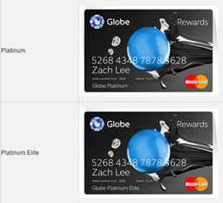

March 14, 2014 – The Tiering Program was launched and only Platinum Elite and Platinum members received the Globe Rewards Welcome Kit

October 14, 2014 – We started sending the kit to our Blue and Base Customers

Below are the things that front liners need to remember:

- The membership card that the customer will receive will also serve as the customer’s GCASH ATM Card and Master Card Debit Card.
- The Globe Rewards card is not related to Globe Rewards Points

The following GCASH inquiries shall be accommodated by the Blue and Platinum Hotline and the processes are also updated in the AFTER SALES HANDLING section of the KMS article mentioned above:

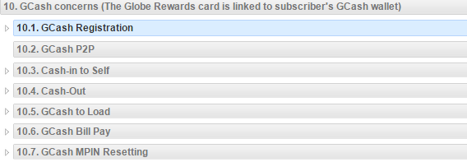

** Other inquiries/ concerns apart from those mentioned above should be warm transferred to the GCASH Hotline.

