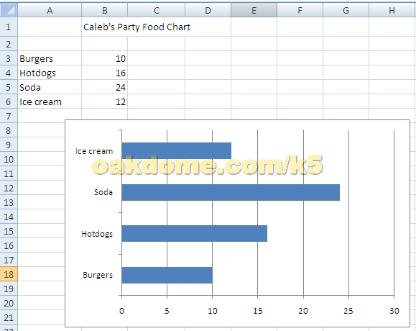
- Type your title “Caleb’s Party Food Chart in Cell B1
- Add the party food data from Column A cells
- Add the quantities in Column B cells
- Select the food labels and the number values in columns A and B
- On the Insert menu tab, select the bar chart and choose 2 D bar
- Double click the chart and then choose “chart layouts” on the ribbon. Choose a chart layout
- Click the office button and choose Save As—save to your Z drive

