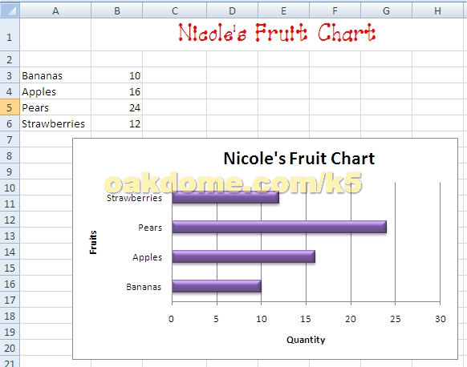
- Enter your chart title in C1
- Click in Cell C1 and drag the mouse to H1. In the Home tab, alignment group, find and apply “Merge and Center” to the title
- With the title still selected, on the Home tab, Font group, apply a new font color, font size, and font style
- Enter the fruit labels in column A starting with cell A3. Enter the fruit quantities in column B starting in Cell B3
- Click in cell A3 and drag mouse down to select all foods down to cell A6. Continue to drag to select all the numerical values on column B
- Create a bar chart. Go to Insert tab, Charts group, Bar, 2D bar
- Format the chart. Click to select the chart. Go to Designs tab, chart layouts group, choose a chart layout that will produce a chart title and horizontal and vertical axis labels.
- Fill in the appropriate text for the Chart Title and the axis. “Nicole’s Fruit Chart”
- In the Design tab, Chart Styles Group, choose style for the bars.
- Go to Save As and save to your Z drive.

