IF I WERE A PUMPKIN
I would taste
I would be full of
I would like to
I’d want
IF I WERE A PUMPKIN
I would
I would wish
I would love
I would list
I would

WRITE ABOUT HALLOWEEN AND/OR YOUR FAVORITE KIND OF CANDY
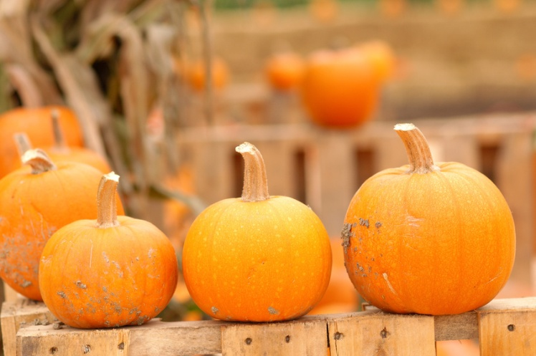
Your name here

