- I really love Thanksgiving.
- It is a time when my family gets together.
- I love all the food that we get to eat at Thanksgiving.
- My favorite thing to eat is turkey with lots of gravy and homemade mashed potatoes.
- I love to eat pumpkin pie too.
- I love to spend time with my family.
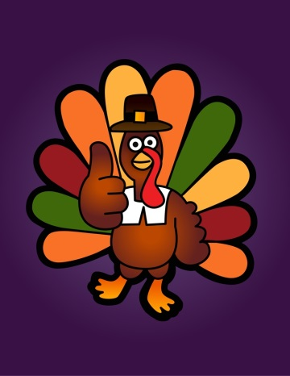
Mrs. Rettig-Seitam

