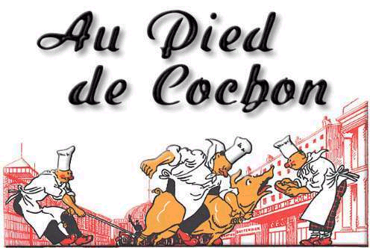
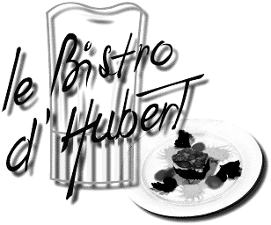
RESTAURANT MENU

PROJECT GUIDELINES
http://www.paris.org/Restaurants/

Chapters 5 & 6
Powerpoint (on diskette—AND printed version)
Poster Size (open): 12 X 14 or smaller
[able to fold in half]

- Three full meals, plus list of drinks
and desserts. All text in French
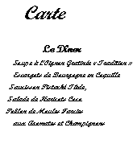
B. Illustration of each meal
1. Photo, paper clipping, clipart, drawing
- Label cuisine (italien, grèc, espagnol,
etc.,)
C. Write in French:
- Categories (5)
- Food item (3 entrées)
- Price per item in Euros €
- Give a house “specialty”
- Hours of operation, full address (zone) and phone number
http://www.concierge.com/destination/paris/eating?mbid=google

Example:
- le petit déjeuner, les boissons, les desserts,
- des oeufs au jambon, du pain grillé
3) Steak frites 38,50 €
4) Détail des spécialités : Crevettes Sauce à l’Ail
5) Ouvert le midi à partir de 12h00 jusqu'à 14h00
Ouvert le soir à partir de 19h30 jusqu'à 22h00

Grading:
Guideline Accuracy, Spelling, Grammar, Neatness & Creativity

Due: Drafts due: April 26 (B day) – April 27 (A day)
Project due: April 30 thru May 2 (No penalty)
After May 3 No credit

