Simple Machines on the Net

The Odd Machine
Go to the website: http://www.edheads.org
- Put mouse over the green box that says chose an activity
- Click on The Odd/Compound Machine
- Click on the robot that says “click hear to start”
- Go through the entire activity until you are given your score

Answer the questions below:

- What object does the robot ask you to find?_____________________
- What do you save from a boiling pot of water?______________________
- What do you give the hamster? __________________________
- What does the match on the mousetrap light?_________________________
- What was your final score?________________

Simple Machines
Go to the website: http://www.edheads.org
- Put mouse over the green box that says chose an activity
- Click on Simple Machines
- Click on the robot that says “click hear to start”
- Click on the HOUSE not the tool shed
- Pick a room in the house
- Find all 10 Simple Machines and record in chart

Kitchen Bathroom
Item | Type | Item | Type
1. |  | 1.
2. |  | 2.
3. |  | 3.
4. |  | 4.
5. |  | 5.
6. |  | 6.
7. |  | 7.
8. |  | 8.
9. |  | 9.
10. |  | 10.

Bedroom Garage
Item | Type | Item | Type
1. |  | 1.
2. |  | 2.
3. |  | 3.
4. |  | 4.
5. |  | 5.
6. |  | 6.
7. |  | 7.
8. |  | 8.
9. |  | 9.
10. |  | 10.

Leonardo Da Vinci

- Go to the website http://www.mos.org/sln/Leonardo/LeoHomePage.html
- Read about Da Vinci
- Click on Inventor’s Workshop – READ THE PAGE
- Click on Leonardo’s Mysterious Machinery
- Click on the RED buttons to access each machine.
- Record what each machine is, and you figure out and record what simple machine it uses

*** When you are done feel free to click on the links WITHIN this website to further explore Da Vinci

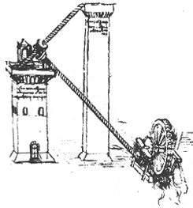
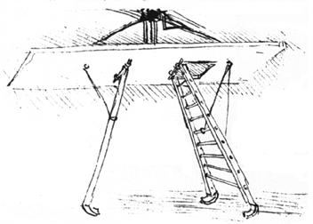

Name of Machine:____________________ Name of Machine:____________________

Simple Machines used: ____________________ Simple Machines used: _______________________
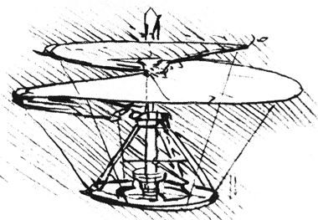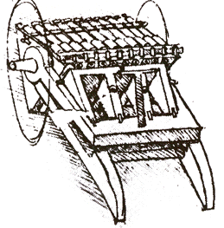

Name of Machine:____________________ Name of Machine:____________________

Simple Machines used: ____________________ Simple Machines used: _______________________

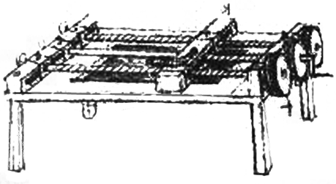

Name of Machine:____________________

Simple Machines used: _______________________

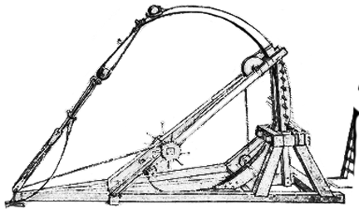

Name of Machine:____________________

Simple Machines used: _______________________

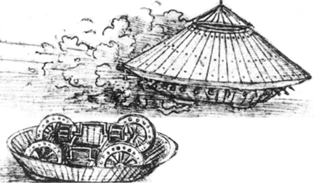

Name of Machine:____________________

Simple Machines used: _______________________

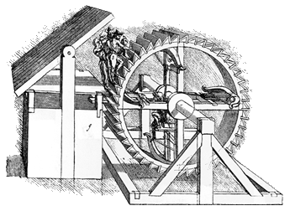

Name of Machine:____________________

Simple Machines used: _______________________

Check out Ms. Haley’s website

- Go to www.middletownschools.org
- Click on “Our Schools” at the top
- Click on “Woodrow Wilson”
- Click on “Faculty and Staff Directory”
- In keywords type in “Haley”
- When you see my name click on “website”
- Click on the links on the left or at the bottom of the page.

