Your Name _______________________________Period_____ Date___________________

Ch. 21 Title Record Here _____________________________________________________________________

Learning Targets:
21-1 Outline the major sources of renewable energy and assess their potential for growth
21-2 Describe solar energy and the ways it is harnessed, and evaluate its advantages and disadvantages
21-3 Describe wind energy and the ways it is harnessed, and evaluate its advantages and disadvantages
21-4 Describe geothermal energy and the ways it is harnessed, and evaluate its advantages and disadvantages
21-5 Describe ocean energy sources and the ways they could be harnessed
21-6 Explain hydrogen fuel cells and assess future options for energy storage and transportation

Central Case: Iceland Moves Toward a Hydrogen Economy pp. 603-604
Read this case study and watch the following youtube clip. Summarize 5 main points about Hydrogen as a fuel.
https://www.youtube.com/watch?v=bgGlE97rJl4 (3 min)
*

*

*

*

*

“NEW” RENEWABLE ENERGY SOURCES- pp. 604-607
Why is the term “new” used for the energy resources presented in this chapter- wind, geothermal…?
https://www.youtube.com/watch?v=0KhDUz13kBc (History Channel Documentary)- watch and then rewrite the three reasons given in textbook or your interpretation from the video on the idea of “new” and renewable
(1)

(2)

(3)

The new renewables currently provide little of our power
Using the figure 21.1- record what the top to renewable energy resources is used by the US by
consumption and the % , using different color or highlighters- add in percentage of US electricity generated from these same two- which on is #1 for electricity?

1.________________________%______ 2. _______________________________%_____;

1. ________________________%______ 2. _______________________________%_____

The new renewables are growing fast
Using Figure 21.2- what trend is being emphasized?

Using Figure 21.3- Rewrite the caption for this graph- in one sentence or fragment

Our transition must begin soon
Historically- most of the US research and development funding for energy has gone towards _______________ power and _________________________

Recreate the CAUSES AND CONSEQUENCES DIAGRAM ON p. 607 – fill it in

SOLAR ENERGY- pp. 607-612 https://www.youtube.com/watch?v=nr-grdspEWQ (good documentary)
Watch- then record 3 facts you took away from the film about solar energy.

1-

2-

3-

Passive solar heating is simple and effective
Define in your own words “passive” solar. Give 2 examples of passive solar heating.

Active solar energy collection can heat air and water in buildings
Define in your own words “active” solar. Give 2 examples of active solar heating.

Concentrating solar rays magnifies energy
What is the name for simple portable ovens that use reflectors to focus sunlight onto food and cook it?

Almost all energy resources works on this principle- as mentioned in Fig. 21.6 caption. ________ is

transported through fluid-filled pipes to a ___________________-driven generator that produces

______________________

Photovoltaic cells generate electricity directly
What is the photoelectric effect?

Confused? Watch this clip to understand photoelectric effect: https://www.youtube.com/watch?v=0qKrOF-gJZ4
Solar power is little used but fast growing
Use of PV cells is growing fast, with ____________________ leading the world in production and ______________________leading the world in installation.

Use of solar technology should continue to increase as __________fall, ___________________improve, and governments enact _____________________incentives to spur investment.

Solar power offers many benefits
Name and memorize 3 benefits:
1)

2)

3)
Location and cost can be drawbacks
Name and memorize 3 drawbacks:
1)

2)

3)

Read and interpret the figure and caption for 21.9 on p. 611- In the US, where is solar radiation the highest?

Where is it the lowest?

WIND ENERGY- pp. 612-616 https://www.youtube.com/watch?v=NiSWe3_GEUA (Discovery Channel)
Wind has long been used for energy
Where did wind turbines get their historical roots?

Where was the first wind turbine built to generate electricity in the US in the 1800s?

Modern wind turbines convert kinetic energy to electrical energy
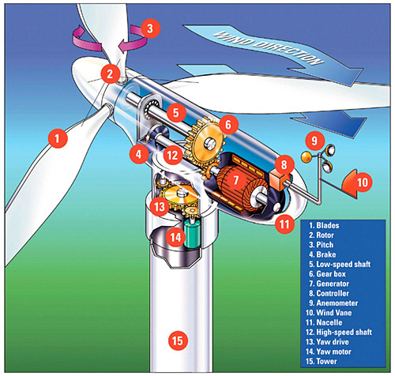
How many parts can you name?
1.____________________ 2.__________________
3.____________________ 4.__________________
5.____________________ 6.__________________
7.____________________ 8.__________________
9.____________________ 10._________________
11.___________________
Using Figure 21.11, the youtube clip and reading in this section- explain how a wind turbine works:
Wind power is the fastest-growing energy sector
Most of the world’s fast-growing wind-power generating capacity is concentrated in a handful of countries. Which country has developed more total wind capacity?
This tiny country, ___________________ obtains the highest percentage of its energy needs from wind.

Offshore sites can be promising
What are the advantages to offshore sites?

What are the disadvantages?

Wind power has many benefits
Memorize at least 3 for each type of renewable energy source in this chapter- make notecards or one chart to study. These topics make for good free response questions. Last year the topic was nuclear energy.
What are 3 benefits of wind power?
1)

2)

3)

THE SCIENCE BEHIND THE STORY- Idaho’s Wind Prospectors- pp. 615
Read this story- and identify the investigative question.
Record the question the scientists had here:

Based on their approach to answering this question what do you think their hypothesis or predictions were?

Where did they determine the good prospects for commercial wind farms could be located?

Wind power has some downsides
Name 3:
- 2) 3)

GEOTHERMAL ENERGY- pp. 617-620 https://www.youtube.com/watch?v=Uv8bTAGr0tU (3 min)
We harness geothermal energy for heating and electricity
After reading this section- and watching the youtube clip- label the diagram below- and write you own caption explaining how geothermal energy works for heating and producing electricity.

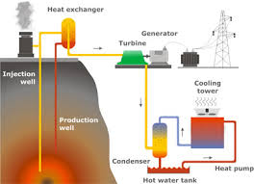
Caption Box:
Use of geothermal power is growing- What are the top 3 countries leading the world in its use?

Geothermal power has benefits and limitations
Make a T-chart that lists at least 3 benefits and 3 limitations of geothermal power

OCEAN ENERGY SOURCES- pp. 620-621 https://www.youtube.com/watch?v=KkSwx40lIGE (9min)
We can harness energy from tides, waves, and currents
Read this section- 3 ways to harness marine kinetic energy is described. What are these 3 processes?

1)

2)

3)

The ocean stores thermal energy
What does OTEC stand for?

In the _______________approach, warm surface water is piped into a facility to evaporate chemicals, such as ammonia, that boil at low temperatures. These evaporated gases spin turbines to generate electricity.

In the open cycle approach- what is different?

HYDROGEN- pp. 621-625 https://www.youtube.com/watch?v=76ujMtLr5Z8 (56 min documentary)

Hydrogen fuel may be produced from water or from other matter
Using the reading in this section of your textbook and Figure 21.19 to explain in your own words the diagram below on how hydrogen fuel drives electricity generation in a fuel cell.
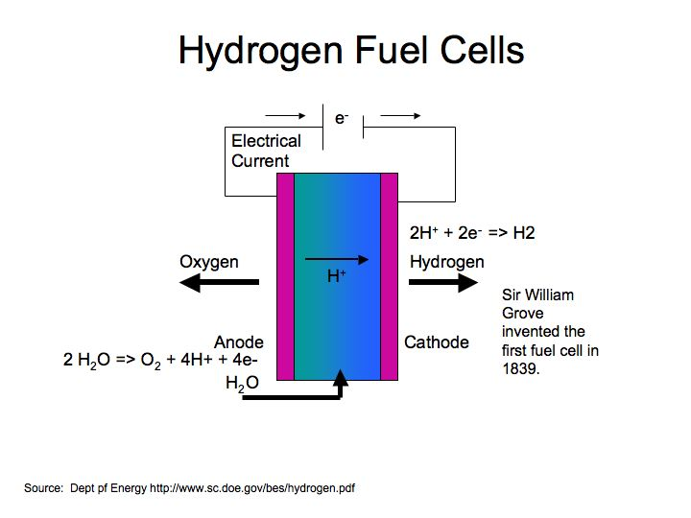
Explain how this fuel cell works- make a flowchart of steps similar to Figure 21.19.

Fuel cells produce electricity by joining hydrogen and oxygen
In ___________________, the process being pursued in Iceland, electricity is input to split hydrogen atoms from oxygen atoms of water molecules: Know this formula→

Another chemical formula you need to be familiar with- is the one of extracting hydrogen from the methane in natural gas entails producing one molecule of greenhouse gas carbon dioxide for every 4 molecules of hydrogen gas: Know this formula→

Hydrogen and fuel cells have many benefits
What are 3 of the benefits?
1)
2)
3)

THE SCIENCE BEHIND THE STORY: Algae as a Hydrogen Fuel Source- pp. 624
Alternative video clips explaining how algae as a fuel source work
https://www.youtube.com/watch?v=QP_HbQ5cWSk (3 min)
https://www.youtube.com/watch?v=Myf9BZH5zU8 (16 min)
https://www.youtube.com/watch?v=QVY6nIV_X5A (4 min)
What was the investigative question?

What was their prediction or hypothesis being tested?

Give a brief explanation of their experimental procedures. Evidence collected. And conclusions.
Methods:

Evidence/Observations:

Conclusions:

https://www.youtube.com/watch?v=tyBcyccpk0U (latest research by US Navy- 1 min)
https://www.youtube.com/watch?v=_Ox92f1QfsU (Future of Clean Energy documentary)
Bonus Points- Watch the Documentary above- record 10 facts you found interesting and won’t forget by May:
1)
2)
3)
4)
5)
6)
7)
8)
9)
10)

Homework List Revisions: TYC: #3,4,8,10; SSs: #5&6; IG&D: #1-4 ALL

