The Renaissance

Background
The Renaissance was a time of creativity and change in Europe. It was a rebirth of cultural and intellectual pursuits after the stagnation of the Middle Ages. The Renaissance produced a golden age with many achievements in art, literature, and science, but most importantly, it produced a new concept of how people thought of themselves, each other, and the world around them. The Renaissance was centered in Italy during the 1300s, before spreading throughout Europe in the 1500 and 1600s.

Humanism
Humanism was an intellectual movement where people began to focus on life in the present, which was in contrast to the Middle Ages' focus on the after life. Humanism stressed the importance of education, with the study of ancient Greek and Roman texts becoming the learning standard. Humanism also stressed the importance of the individual. This movement was the driving force of the Renaissance and is reflected in the period's artistic, literary, and scientific achievements.

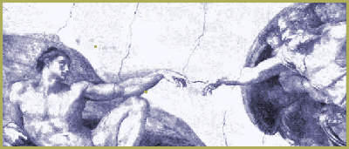
Art & Architecture
Renaissance artists and architects produced some of the finest works in all the world. While religious art was still very prominent, new styles were developed. Humanist ideas, and the concept of realism, was reflected in many art forms. Artists such as Leonardo Da Vinci studied anatomy, while others used live models to better catch the human form. Artists also learned the rules of perspective allowing them to give their works a 3 dimensional appearance.
Architects revived many ancient Greek and Roman styles, such as the use of columns, domes, and arches.

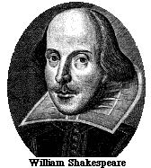
Artists
Michelangelo: Sculptor, painter, poet, engineer, and architect. Famous works include the mural on the ceiling of the Sistine Chapel, and the sculpture of the biblical character David.
Leonardo Da Vinci: A true Renaissance man interested in a variety of subjects. He was a painter, sculptor, engineer, and inventor. Famous works include paintings Mona Lisa and The Last Supper. Also left a variety of sketches showing flying machines and underwater boats centuries before the invention of planes and submarines.

Literature
Humanist ideas are reflected in works of Renaissance literature. The most famous writer of the time, William Shakespeare, wrote 37 plays between 1590 and 1613. His plays reflect the ideas of individualism and the unconquerable human spirit, and most of them are still performed today. Other important Renaissance authors include Dante, who wrote The Divine Comedy, and Miguel de Cervantes who wrote the comedic tale Don Quixote.
Besides works of fiction, writings on political philosophy reappeared during this time period. the most well know political philosopher of the Renaissance was Niccolo Machiavelli, whose book The Prince, reads as a "how to" guide for successful rule.

Copernicus
Nicolaus Copernicus developed the heliocentric model of the universe. This states that the sun is the center, and that the earth revolves around it. Despite his calculations, many scholars disagree with his theories and continue to believe in the geocentric model proposed by the ancient Greek Ptolemy 1500 years earlier.

Galileo
Galileo continues Copernicus' work by observing the skies with a homemade telescope. Although he was able to prove Copernicus correct, his work was rejected by the Church and he was forced to recant (take back) or face execution.
Newton
Isaac Newton built upon the earlier work of Copernicus and Galileo and used mathematics to describe gravity as the force that keeps planets revolving around the sun. He also explained that this same force is what causes objects to fall to earth.

Descartes
Rene Descartes was a French intellectual who challenged traditional ideas. He said that human reason was capable of discovering and explaining the laws of nature and man. The idea of human reason being superior to tradition led to the beginning of the Enlightenment, a time of political awakening that became revolution.

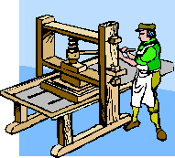
Technology
The most important technological innovation of the time was the printing press. The technology to make this possible was introduced from China in the 1300s. By the 1400s, movable type was being used in Europe as Johann Gutenberg began printing the Bible in everyday language. Soon millions of books were in circulation. This invention led to a higher literacy rate among people, and helped with the spreading of Renaissance ideas.

Scientific Revolution
The Scientific Revolution develops as a offshoot of the Renaissance. The same spirit of inquiry that fueled the Renaissance, led scientists to question traditional beliefs about the workings of the universe. One of the main ideas to come out of the Scientific Revolution was the use of the Scientific Method. The Scientific Method uses observation and experimentation to explain theories on how the universe works.

