Find four different political cartoons. Attach them to a separate piece of paper. Analyze the cartoons using the following criteria:

- Describe the situation.
- Is there a play on words?
- Is this referencing another famous situation, pop culture, etc.? If yes, what?

- What is the message?
- Be specific
- Describe the metaphor.
- How do you know this is the message?

- Is the cartoon effective? Why or why not?
- Rate on a scale of 1-10 (10 = best)
- Why did you give it that score?
- Could the cartoon be improved? How?
EXAMPLE:
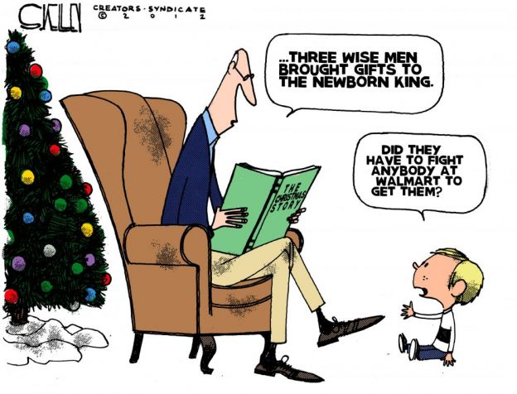

This cartoon is a play on Black Friday and the meaning of the Christmas. The grandfather is reading the story of the birth of Jesus Christ and the three wise men. The child asks if the wise men had to fight people at WalMart when buying the gifts. Over the past few years there have been several instances of violence during Black Friday shopping.

The message is that shopping and materialism has become more important than the religious message of Christmas. This is shown because the child doesn’t understand the importance of the three wise men and thought the gifts they brought Jesus could be brought at WalMart.

On a scale of 1-10 I would give this cartoon a ten. I gave it this score because the message is clear and references current events. It is also appropriate for the time of year when the cartoon was published.

