Unit II study guide
1. Name the following image: ___________________________________________________
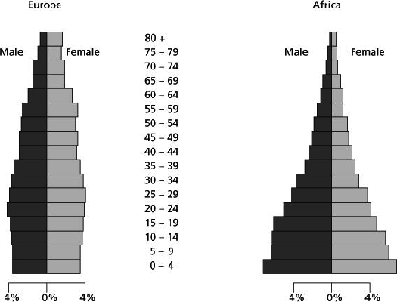

2. What conclusions can you make regarding comparing the populations of Europe & Africa?

_____________________________________________________________________________________

_____________________________________________________________________________________

_____________________________________________________________________________________

_____________________________________________________________________________________

_____________________________________________________________________________________

3. Name the 4 regions where most of the Earth’s inhabitants are clustered.

_______________________ _______________________

_______________________ _______________________

4. Match the population pyramid to the correct stage of the Demographic Transition Model:
Stage 1 Stage 2 Stage 3 Stage 4

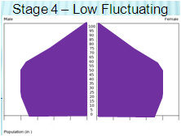
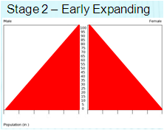

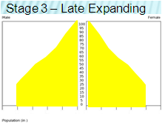
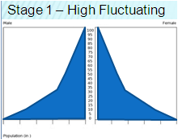

5. Places of permanent human settlement are called ________________________________________ .

6. Which of the following would geographers consider overpopulation?
A. Too many people for an area to sustain as based on economic measures of poverty.
B. More than 1-million people, & there is concern about the finite limits of resources, but it
appears there are enough resources for those people
C. Less than 1-million people, but there are concerns that the resources will only sustain
approximately half of that number.
D. More than 1-million people, but resources are evenly distributed
E. More than 1-million people; there are enough resources, but those resources are
concentrated in the hands of the affluent and elite. There are many people in harsh poverty.

7. How likely would a homeless man be included in the census in a small town when compared with a large city?

Less likely Just as likely More likely There is not enough info to answer

8. More people are alive now than at any time in the past. True False

9. More than half of the people in the world live in_____________ .

Asia Europe Africa S. America N. America

10. Describe the four phases of the Democratic Transition Model

_____________________________________________________________________________________

_____________________________________________________________________________________

_____________________________________________________________________________________

_____________________________________________________________________________________

_____________________________________________________________________________________

_____________________________________________________________________________________

_____________________________________________________________________________________

_____________________________________________________________________________________

_____________________________________________________________________________________

_____________________________________________________________________________________

_____________________________________________________________________________________

_____________________________________________________________________________________

_____________________________________________________________________________________

_____________________________________________________________________________________

_____________________________________________________________________________________

_____________________________________________________________________________________

_____________________________________________________________________________________

_____________________________________________________________________________________
11. What are the three measures of density geographers use to describe an area?

______________________ __________________________ ___________________

12. Describe how all 3 measures are calculated.

_____________________________________________________________________________________

_____________________________________________________________________________________

_____________________________________________________________________________________

_____________________________________________________________________________________

_____________________________________________________________________________________

_____________________________________________________________________________________

_____________________________________________________________________________________

_____________________________________________________________________________________

_____________________________________________________________________________________

13. What is TFR? ______________________________________________________________________

14. How is TFR measured? _______________________________________________________________

_____________________________________________________________________________________

15. The TFR for the world is: 2 2.5 3 3.5 4

16. Which number would correctly identify Infant Mortality Rate:

0.07% 1 12 out of 1000
753

17. What are the two ways which successfully decreasing birth rates?

_____________________________ ____________________________

18. What statement would reflect Malthus’ view of the population? ______________
A. Africa is having problems because the rich are not sharing the wealth.
B. Germany’s declining population will be future problem due to a decreased work force.
C. Don’t sweat it, man. Advanced agricultural methods have greatly increased food production.
D. There will be violence because neighbors are competing for the same resources (water, soil)
E. Without population checks, a tragic event (e.g. nuclear war) will bring the population back
to sustainable numbers.

19. All things being equal, which area would be the most likely place for a person to settle?

Mecca, Saudi Arabia San Jose, Costa Rica Kathmandu, Nepal Stockholm, Sweden

20. Explain why you made the choice you did for question 19.

_____________________________________________________________________________________

_____________________________________________________________________________________

_____________________________________________________________________________________

_____________________________________________________________________________________

_____________________________________________________________________________________

21. Which country could best be described in Stage 5 of the DTM?

Nigeria Philippines Japan Belize United States

22. Explain your answer to number 21.

_____________________________________________________________________________________

_____________________________________________________________________________________

_____________________________________________________________________________________

_____________________________________________________________________________________

_____________________________________________________________________________________

_____________________________________________________________________________________

23. Define counterurbanization ___________________________________________________________

_____________________________________________________________________________________

_____________________________________________________________________________________

_____________________________________________________________________________________

_____________________________________________________________________________________

24. Describe the five stages of the Epidemiologic Transition Model
_____________________________________________________________________________________

_____________________________________________________________________________________

_____________________________________________________________________________________

_____________________________________________________________________________________

_____________________________________________________________________________________

_____________________________________________________________________________________

_____________________________________________________________________________________

_____________________________________________________________________________________

_____________________________________________________________________________________

_____________________________________________________________________________________

_____________________________________________________________________________________

_____________________________________________________________________________________

_____________________________________________________________________________________

25. Match the situation to the correct stage of the Epidemiologic Transition Model
______ A new disease is discovered that harms the body by preventing the creation of vitamin E. Due to this, vital organs such as the heart & lungs grow weak and eventually collapse.
______ A controversial procedure uses the cells of puppies to reduce the negative effects of anaphylaxis. Schools across America are now allowing peanut butter cookies during classroom parties since deaths from allergic reactions have dropped 12% in the past 5 years.
______A virus originally from the Amazon Basin has mutated and killed 135,000 in Scandinavia in 4 weeks.
______ Headline in Hamburg reads: The plague returns. Hundreds of thousands rotting carcasses litter the streets.
______ Who knew that something as simple as filtering a city's water supply would reduce the spread of cholera? Well, the English found out in the late 1800s.

26. Explain your reasoning for your choices in question 25.
_____________________________________________________________________________________

_____________________________________________________________________________________

_____________________________________________________________________________________

_____________________________________________________________________________________

_____________________________________________________________________________________

_____________________________________________________________________________________

_____________________________________________________________________________________

_____________________________________________________________________________________

_____________________________________________________________________________________

27. This is the word which describes movement in generalized terms ___________________________.

28. This is the term which is defined as short, repetitive acts of mobility ________________________.

29. Give a unique example of the term used in question 28 and explain WHY it illustrates the term from question 28. You may NOT use the example from you notes!!

_____________________________________________________________________________________

_____________________________________________________________________________________

_____________________________________________________________________________________

_____________________________________________________________________________________

_____________________________________________________________________________________

_____________________________________________________________________________________

30. Which of the following is an example of an

asylum seeker ______ refugee ______ internally displaced person ______

- A young girl has travelled to Turkey from her homeland in Afghanistan. She has left because the Taliban-supported government has passed laws requiring forced castration for all females under the age of 15. Any females opposing this new policy will be publicly executed in order to set an example to others.

- During the 1960s-70s violence between the United Kingdom & Ireland escalated over control over Northern Ireland, which is controlled by the despite it sharing a border on the same island as Ireland. A Catholic man in his 20s that lives in Northern Ireland is concerned about his safety and decides to head southwest hoping that the government of Ireland will allow him to enter.

- In Columbia a civil war between the Columbian government and FARC (a leftist military group) has raged on since the early 1960s. A middle-aged man has decided to move his family from Bogota in the center of Colombia to the coastal city of Cartagena because there are many battles occurring near his home.

31. Over time, the migration in the United States has moved in which direction?

North South East West

32. Which is a current intraregional migration pattern in the U.S.? ________
A. urban to suburban
B. rural to urban
C. Midwest to Southeastern Coast
D. Mexico to Southwestern U.S.
E. Iowa to Nebraska

33. Which of the following are push factors? CHOOSE ALL THAT APPLY __________________

34. Which of the following are pull factors? CHOOSE ALL THAT APPLY __________________

A. civil war
B. several seasons of failed harvests
C. the opening of a new factory
D. family reunification
E. flooding of a river

35. Define the term “white flight” and how does it apply to migration?

_____________________________________________________________________________________

_____________________________________________________________________________________

_____________________________________________________________________________________

_____________________________________________________________________________________

_____________________________________________________________________________________

_____________________________________________________________________________________

_____________________________________________________________________________________

_____________________________________________________________________________________

_____________________________________________________________________________________

36. _________________________________ is the geographic term that describes a talented baseball player who has decided to leave his native home of Venezuela and come to the United States and play center field for the New York Mets.

True or False?

37. ______ Most immigrants come to the U.S. to avoid political persecution.

38. ______ The U.S. passed laws to limit the number of immigrants entering the country.

39. ______ Long-distance immigrants are generally characterized as a young male moving with his
family.

40. ______ Russia’s placement of its factories in remote locations has hindered its ability to attract
Immigrants.

41. ______ U.S. immigration issues have been simple and are easily addressed.

42. ______ Historically, the U.S. has received the most immigrants from Europe.

43. ______ A family has left Turkey to travel to Italy for economic opportunities. It would be correct
to say that family has emigrated to Italy.

44. ______ Southern Mexico has seen an increase in unauthorized immigrants and have adopted a
welcoming philosophy of empathy and understanding towards the immigrants.

45. ______ A family moving from Loretto, TN to Nashville is an example of counterurbanization.

46. ______ If you had no other information other than you know your family came to the U.S.
during the 1890s, you could reasonably assume that they came from southern Asia.

47. ______ The Irish Potato Famine is an example of a push factor.

48. ______ Latin America is experiencing a net in-migration.

49. ______ Europe is experiencing a net in-migration.

50. ______ Asia is experiencing a net out-migration

51. ______ Africa is experiencing a net out-migration.

52. ______ Oceana is experiencing a net in-migration.

