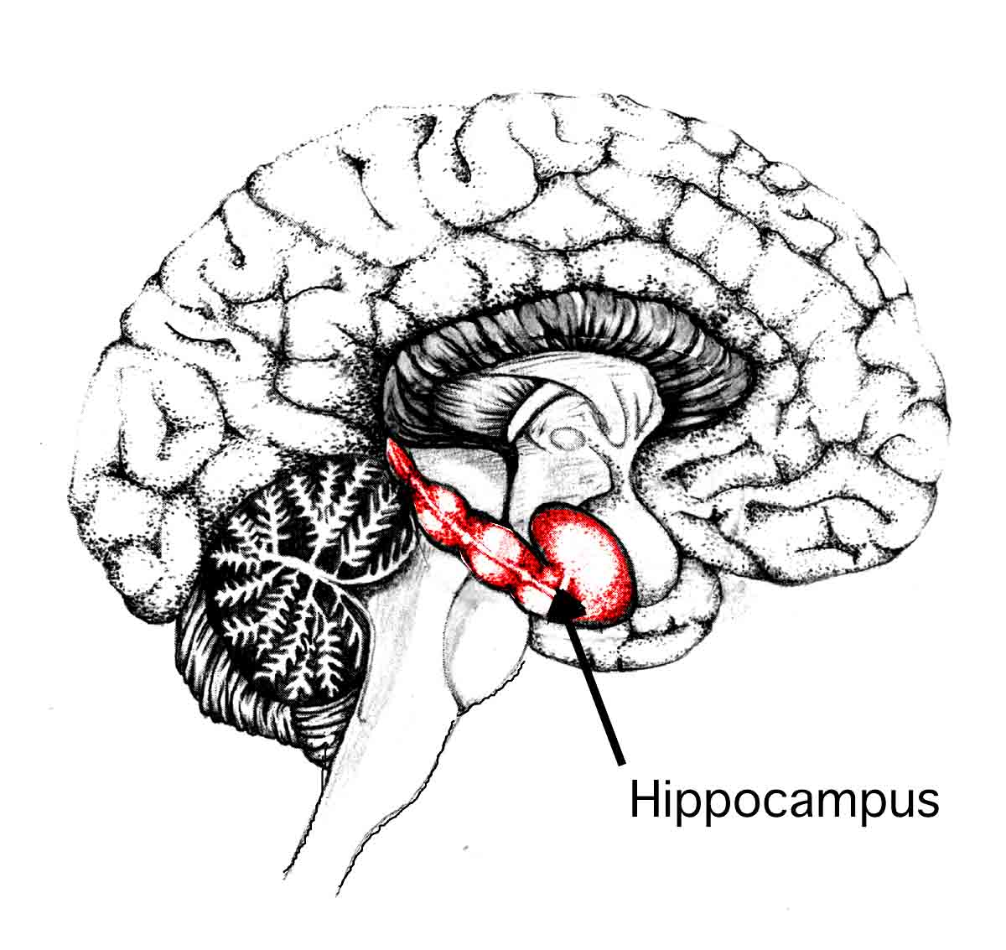

Hmmmm, now where did I put my…
Shoot, what was I doing again?
#hippocampus

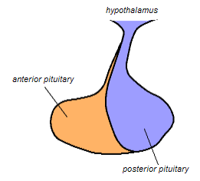
President Hypothalamus has given the glands their marching orders. Time to move out.
#Pituitary

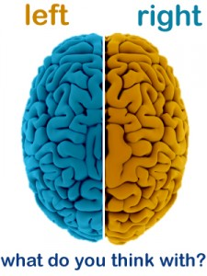
L brain & R brain QUIT ARGUING! R U an old married couple? Stop or I’ll get cut and you won’t b able to communicate. #CorpusCallosum

