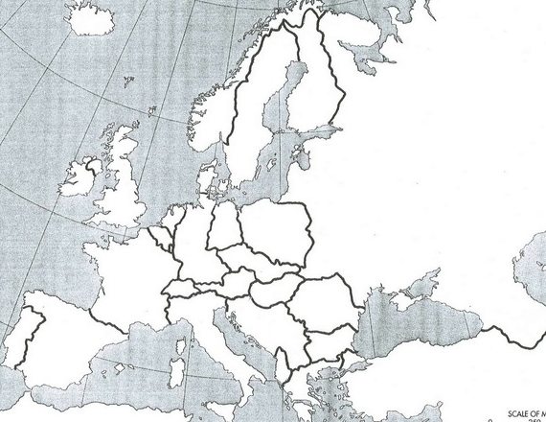
Key
_____ U.S.S.R. _____ U.S.A.
_____ Communist Nations _____ NATO
_____ Warsaw Pact (1955)
_____Berlin

Early Cold War: Postwar Soviet Expansion & U.S. Reaction

