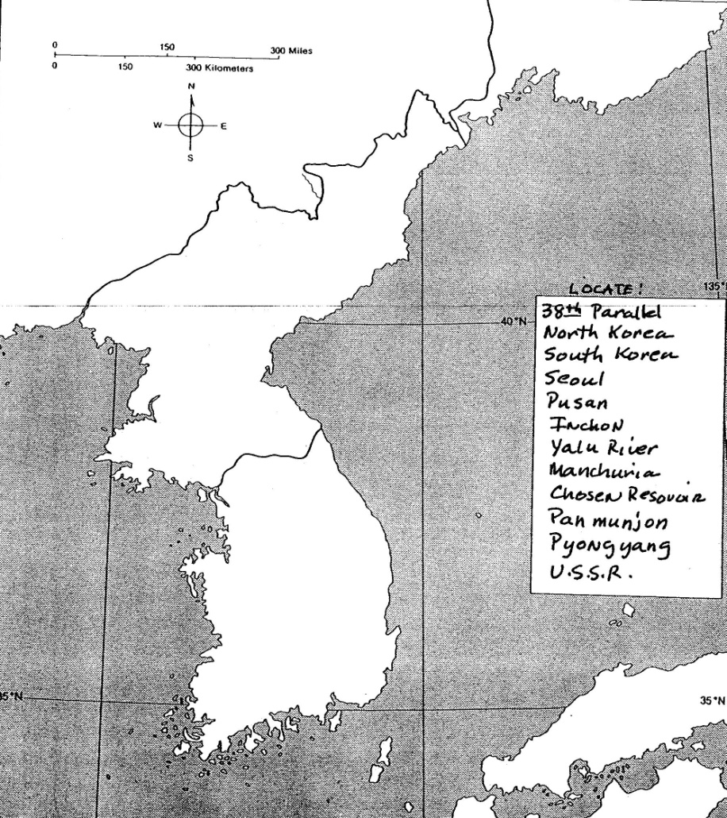
The Korean War & Cold War in Asia
Key
_________ Formosa
_________ Philippines
________ Japan
_________ People’s Republic of China
_________ U.S.S.R.
_________ North Korea
________ South Korea
_________ Seoul
_________ P’yongyang

