Mrs. Jordan Name: _________________________
APUSH
Unit 11 Score: ______/10
DBQ Preparation

Directions: Please answer the questions below in order to better analyze the documents. It is also recommended that you make additional line notes (think APPARTS/SOAPS) for each document if needed as you will be able to use this worksheet (and only this worksheet) for the essay test.

Document A:
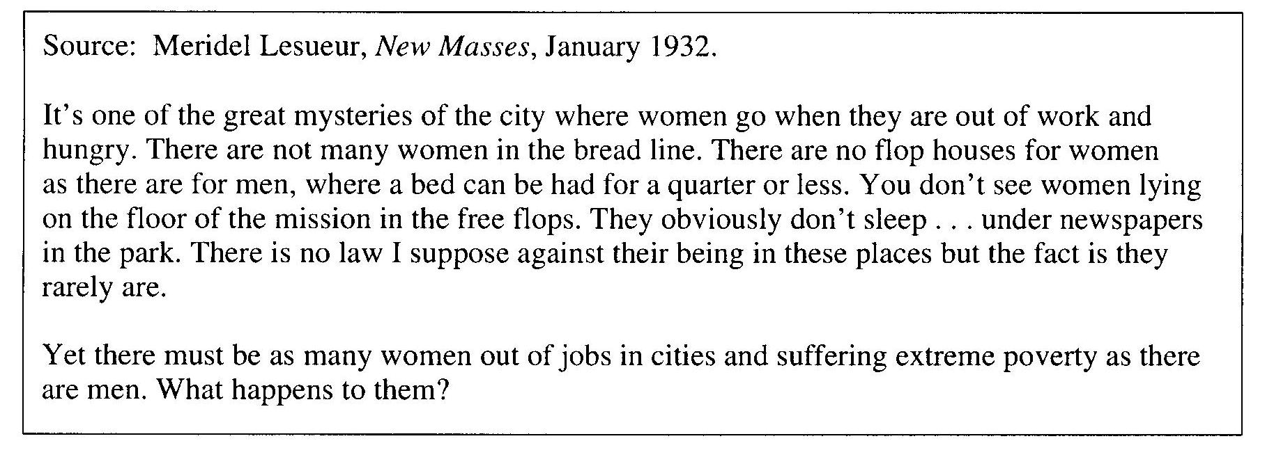
- Summary: What is this document discussing or portraying? Be specific.

- Point of View of the Document: (Is it praising Roosevelt’s policies of criticizing them?—examine the source, this will give clues.)

- Significance: What does this tell you about the effectiveness of the Roosevelt administration in dealing with the ills of the Great Depression?

- List at least two pieces of specific pertaining outside information (think key terms/people from the New Deal Era):

Additional Notes:

(OVER)
Document B:
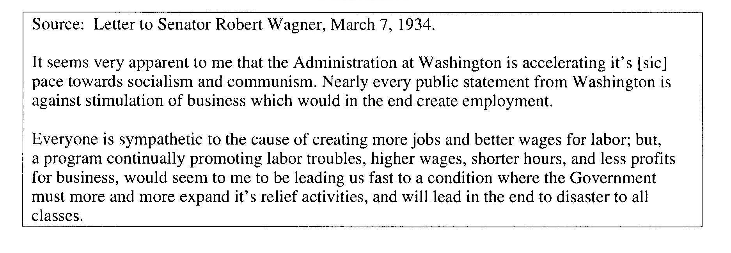
- Summary: What is this document discussing or portraying? Be specific.

- Point of View of the Document: (Is it praising Roosevelt’s policies of criticizing them?—examine the source, this will give clues.)

- Significance: What does this tell you about the effectiveness of the Roosevelt administration in dealing with the ills of the Great Depression?

- List at least two pieces of specific pertaining outside information (think key terms/people from the New Deal Era):

Additional Notes:

(NEXT)

Document C:
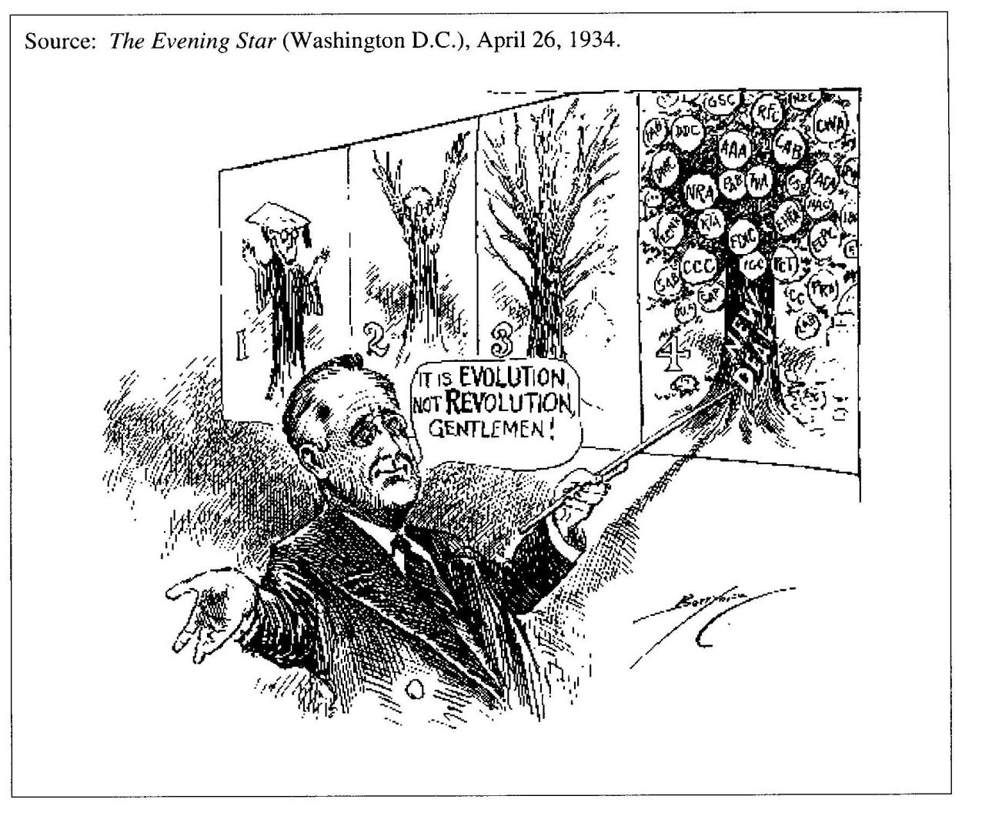
- Summary: What is this document discussing or portraying? Be specific.

- Point of View of the Document: (Is it praising Roosevelt’s policies of criticizing them?—examine the source, this will give clues.)

- Significance: What does this tell you about the effectiveness of the Roosevelt administration in dealing with the ills of the Great Depression?

- List at least two pieces of specific pertaining outside information (think key terms/people from the New Deal Era):

Additional Notes:

(OVER)
Document D:
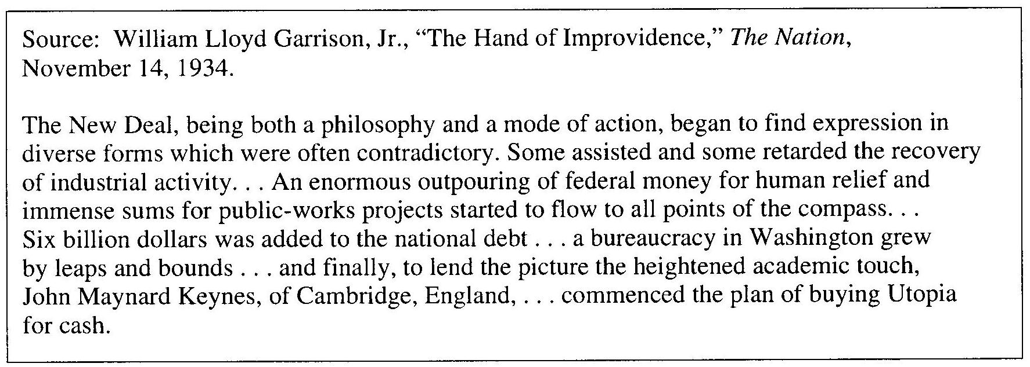
- Summary: What is this document discussing or portraying? Be specific.

- Point of View of the Document: (Is it praising Roosevelt’s policies of criticizing them?—examine the source, this will give clues.)

- Significance: What does this tell you about the effectiveness of the Roosevelt administration in dealing with the ills of the Great Depression?

- List at least two pieces of specific pertaining outside information (think key terms/people from the New Deal Era):

Additional Notes:

(NEXT)

Document E:
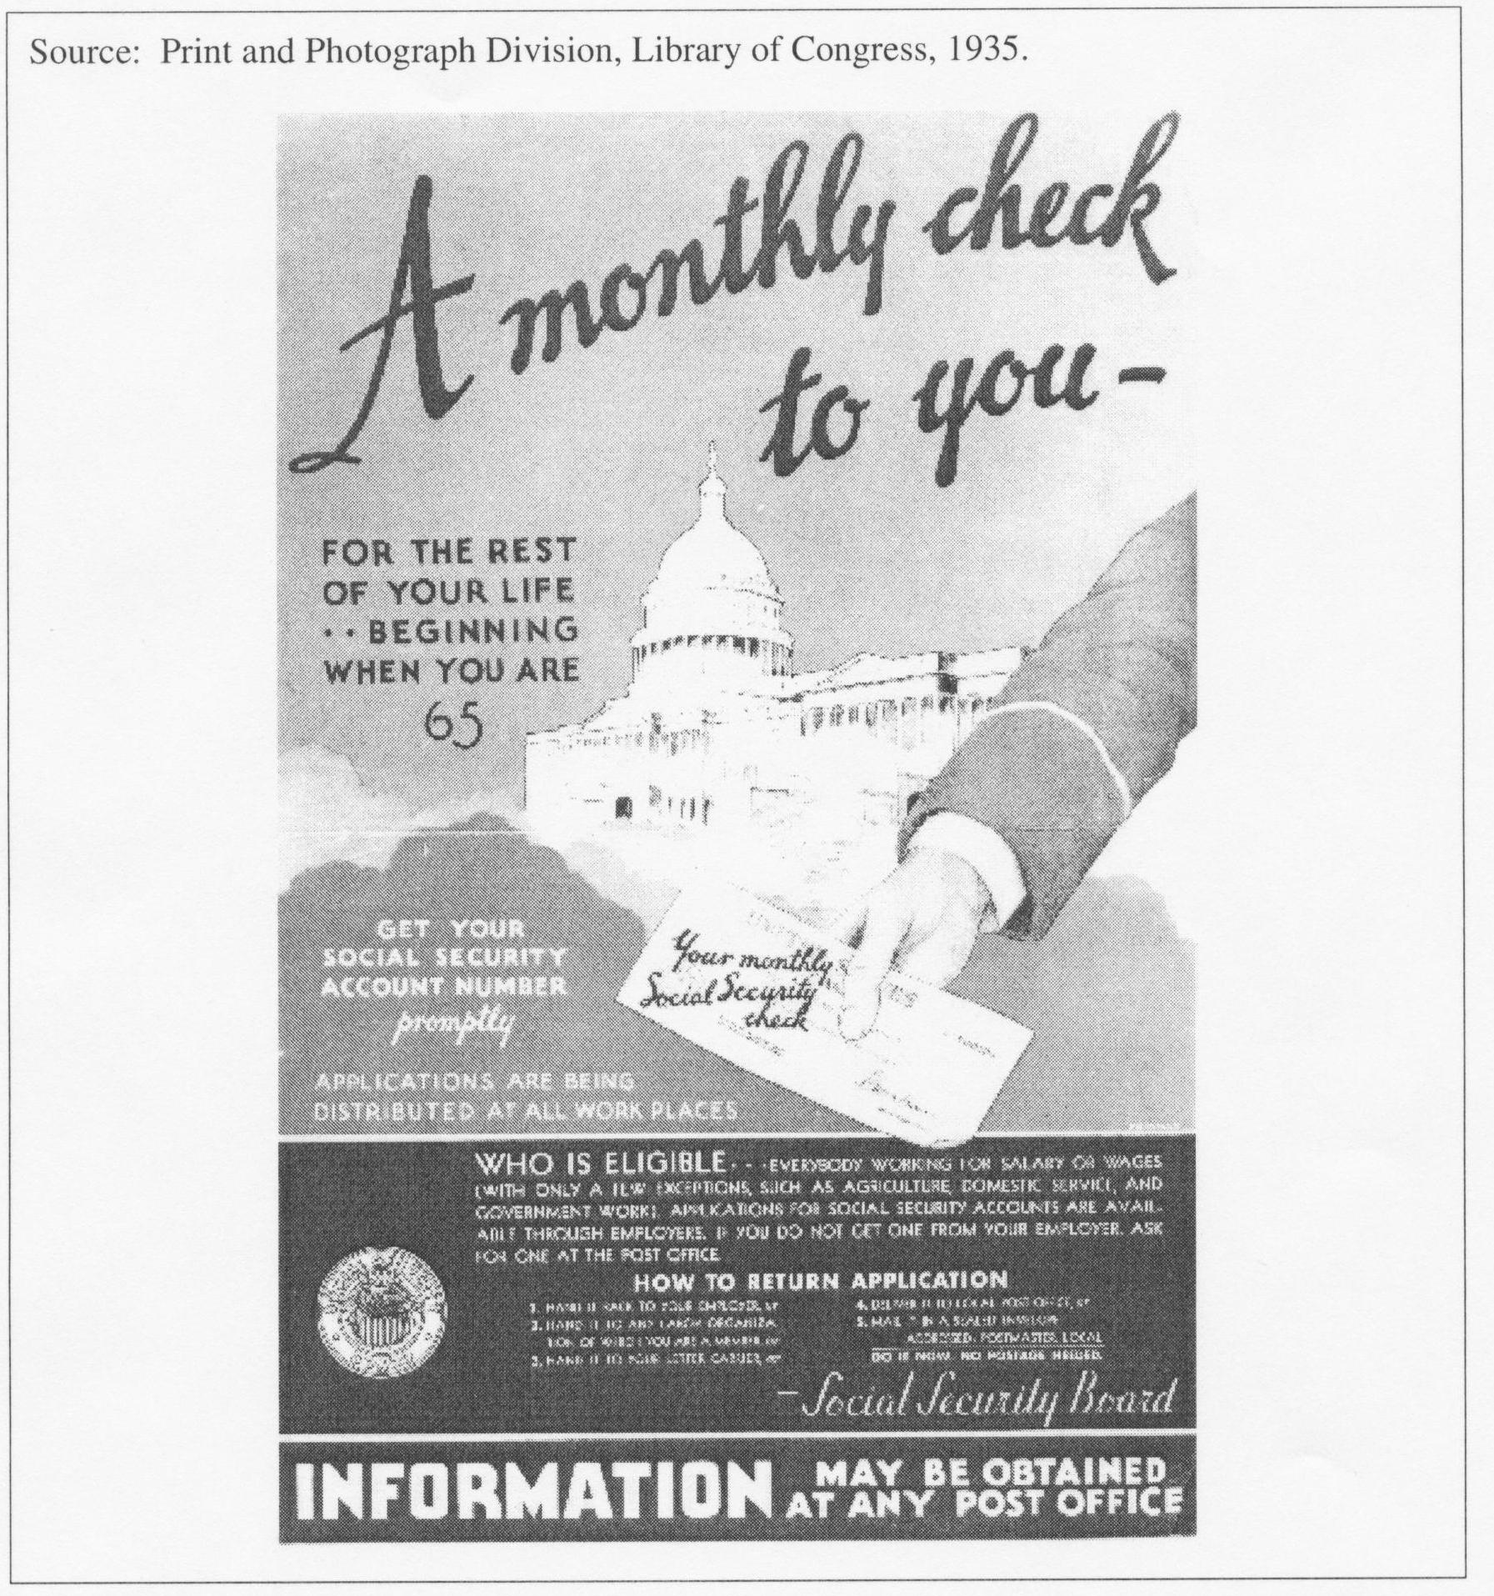
- Summary: What is this document discussing or portraying? Be specific.

- Point of View of the Document: (Is it praising Roosevelt’s policies of criticizing them?—examine the source, this will give clues.)

- Significance: What does this tell you about the effectiveness of the Roosevelt administration in dealing with the ills of the Great Depression?

(OVER)
- List at least two pieces of specific pertaining outside information (think key terms/people from the New Deal Era):

Additional Notes:

Document F:
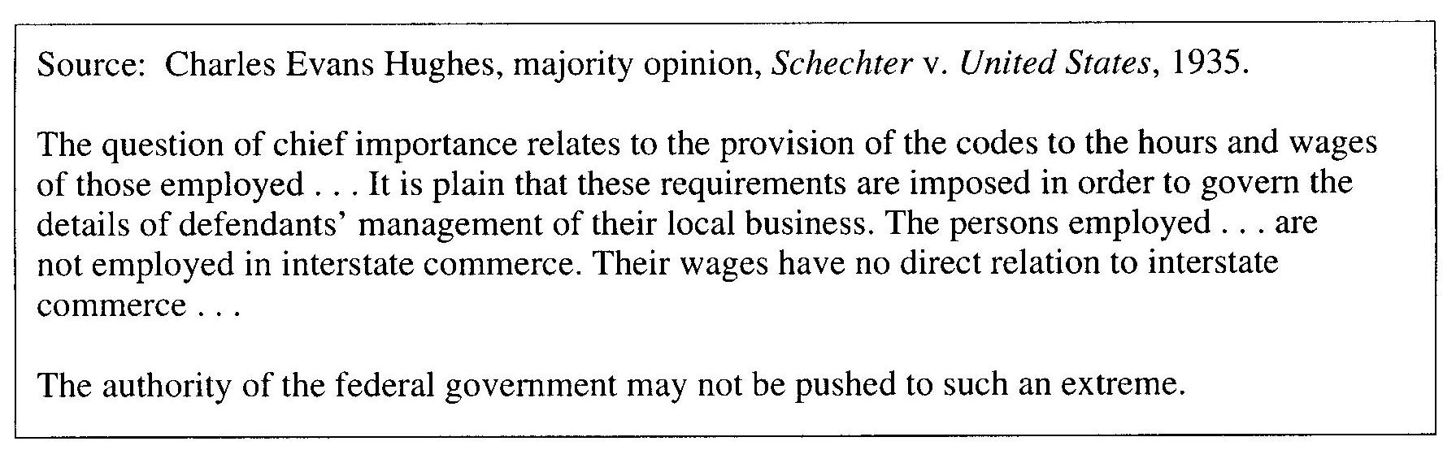
- Summary: What is this document discussing or portraying? Be specific.

- Point of View of the Document: (Is it praising Roosevelt’s policies of criticizing them?—examine the source, this will give clues.)

- Significance: What does this tell you about the effectiveness of the Roosevelt administration in dealing with the ills of the Great Depression?

- List at least two pieces of specific pertaining outside information (think key terms/people from the New Deal Era):

Additional Notes:

(NEXT)

Document G:
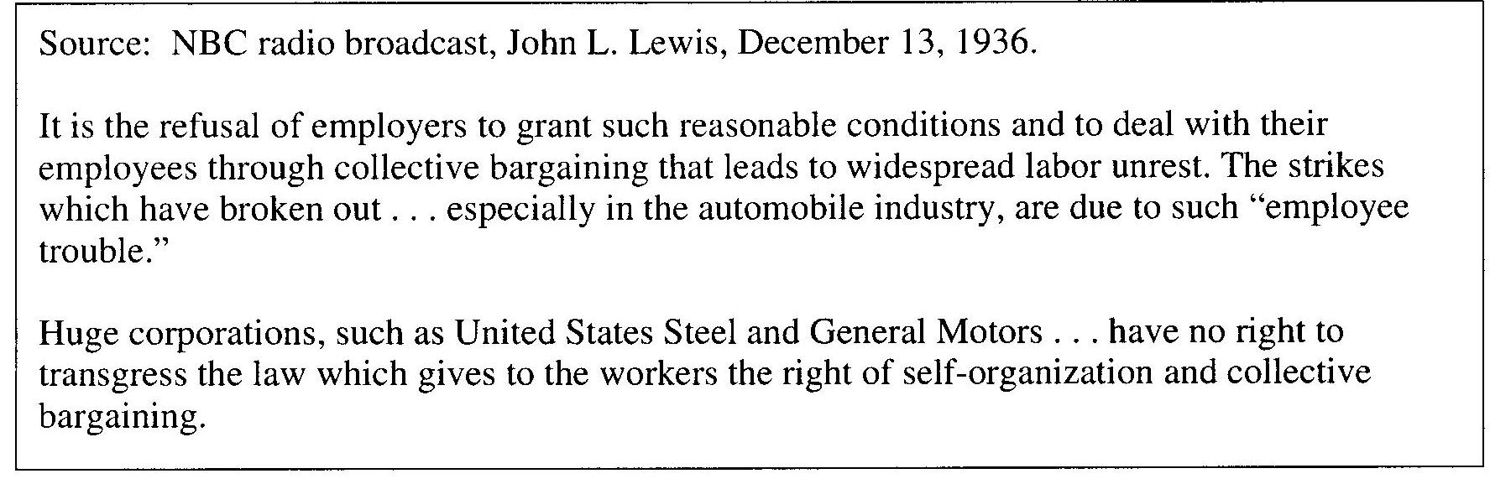
- Summary: What is this document discussing or portraying? Be specific.

- Point of View of the Document: (Is it praising Roosevelt’s policies of criticizing them?—examine the source, this will give clues.)

- Significance: What does this tell you about the effectiveness of the Roosevelt administration in dealing with the ills of the Great Depression?

- List at least two pieces of specific pertaining outside information (think key terms/people from the New Deal Era):

Additional Notes:

(OVER)

Document H:
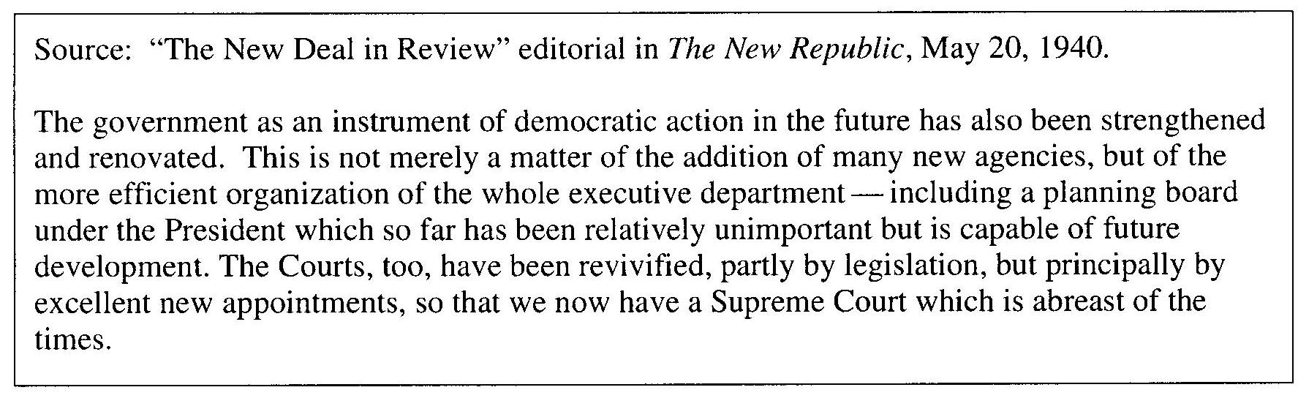
- Summary: What is this document discussing or portraying? Be specific.

- Point of View of the Document: (Is it praising Roosevelt’s policies of criticizing them?—examine the source, this will give clues.)

- Significance: What does this tell you about the effectiveness of the Roosevelt administration in dealing with the ills of the Great Depression?

- List at least two pieces of specific pertaining outside information (think key terms/people from the New Deal Era):

Additional Notes:

(NEXT)

Document I:
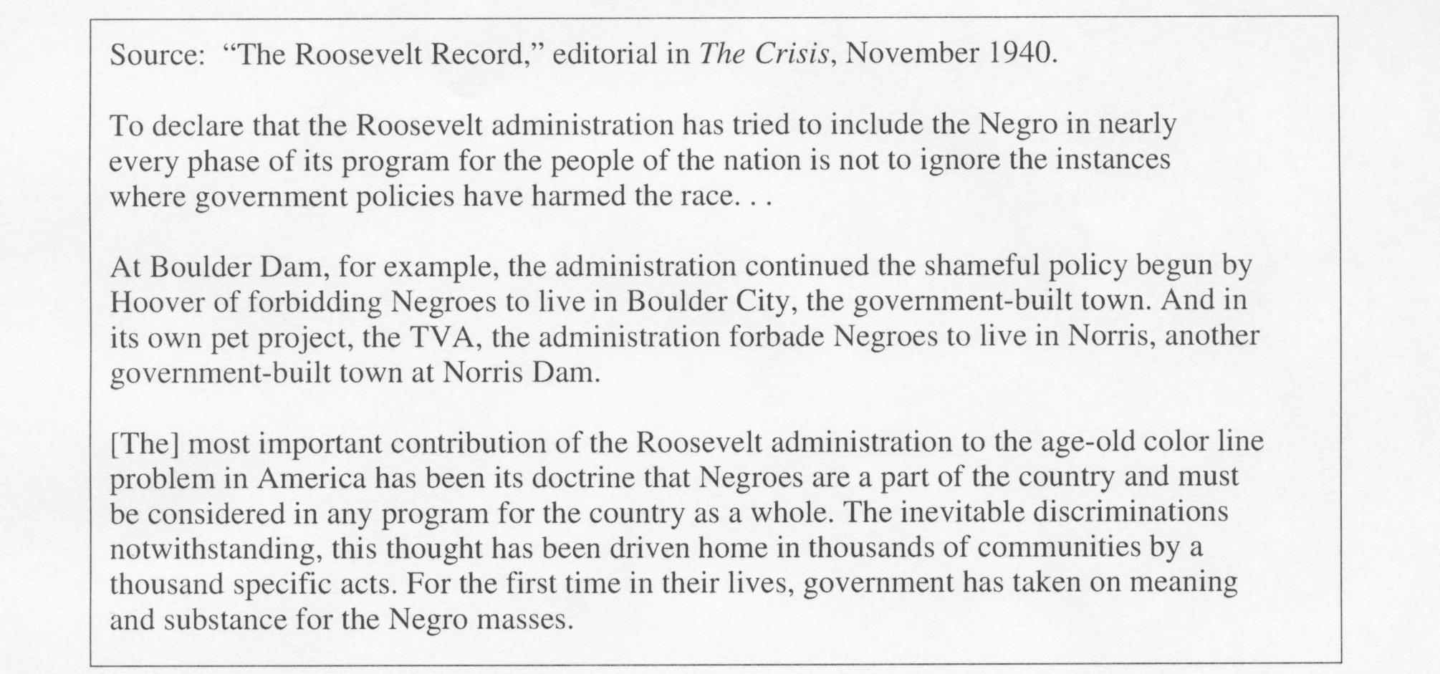
- Summary: What is this document discussing or portraying? Be specific.

- Point of View of the Document: (Is it praising Roosevelt’s policies of criticizing them?—examine the source, this will give clues.)

- Significance: What does this tell you about the effectiveness of the Roosevelt administration in dealing with the ills of the Great Depression?

- List at least two pieces of specific pertaining outside information (think key terms/people from the New Deal Era):

Additional Notes:

(OVER)

Document J:
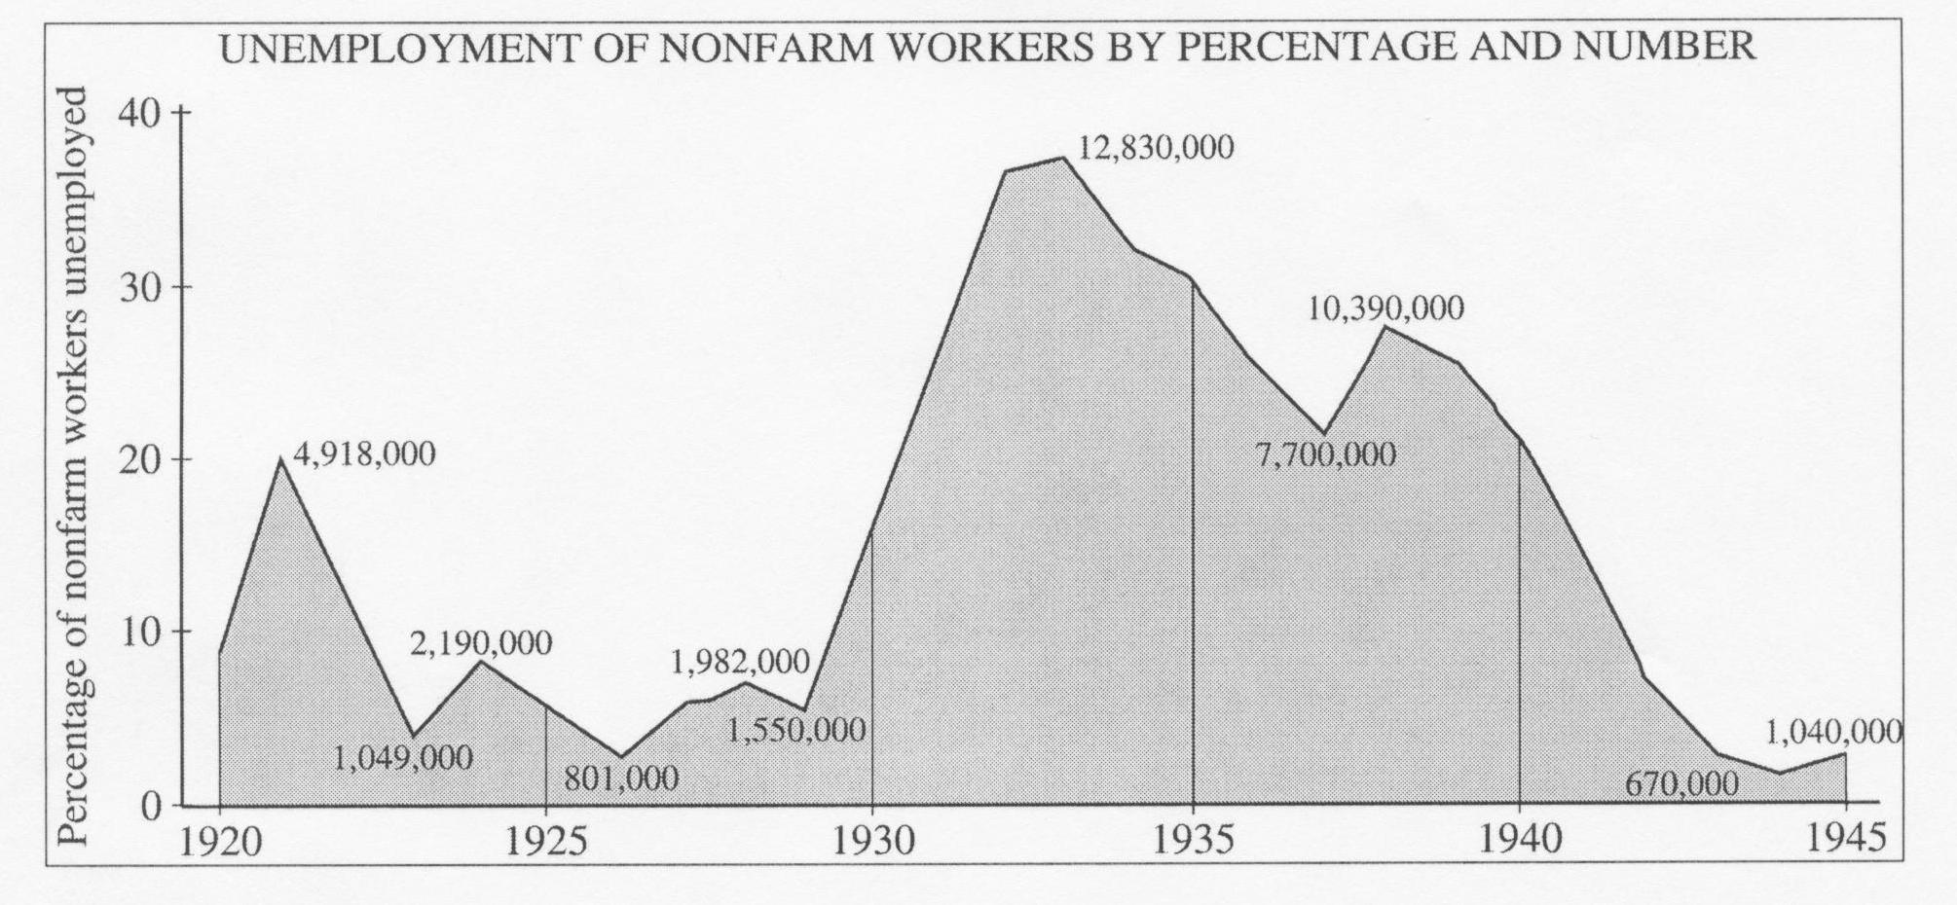
- Summary: What is this document discussing or portraying? Be specific.

- Point of View of the Document: (Is it praising Roosevelt’s policies of criticizing them?—examine the source, this will give clues.)

- Significance: What does this tell you about the effectiveness of the Roosevelt administration in dealing with the ills of the Great Depression?

- List at least two pieces of specific pertaining outside information (think key terms/people from the New Deal Era):

Additional Notes:

