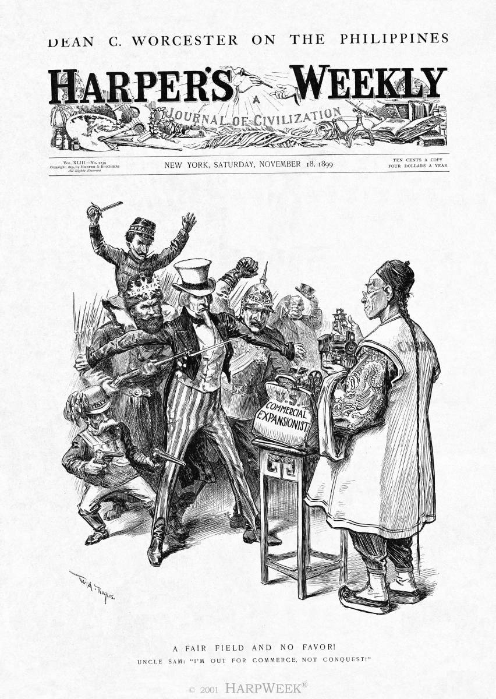
Cartoon C
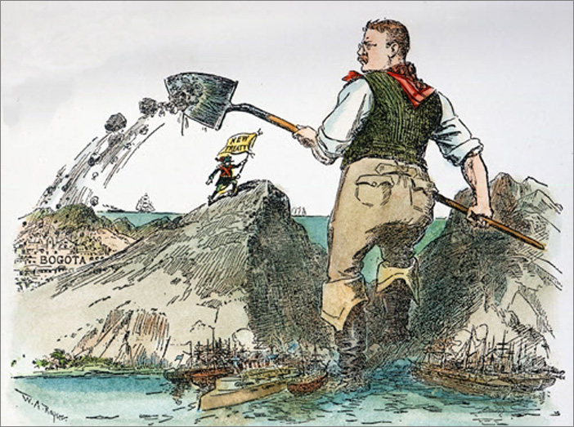
“The News Reaches Bogota”
Cartoon by Rogers from New York Herald Copyright 1903,
courtesy New York Sun, Inc., New York, NY.
Cartoon A
Cartoon D

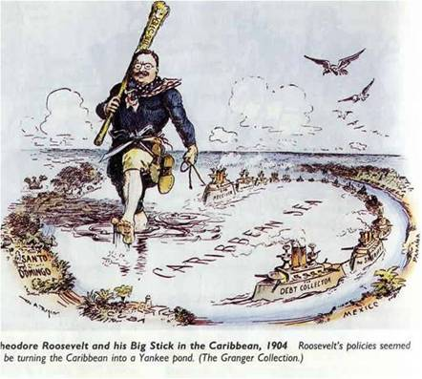
Cartoon B

