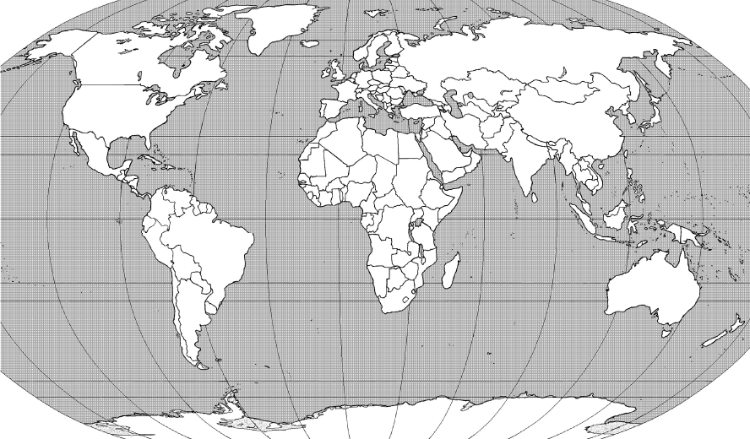
19
17
32
33
34
28
31
30
26
29
27
24
25
23
1
20
9
16
7
8
18
15
13
14
10
12
11
2
5
4
3
22
21
35
6

Name______________________________

Second Semester Final Exam Map Review
On the map on the following page locate and identify with the correct number
Oceans | Seas and Waterways | Countries/Regions | Countries/Regions
_____ Pacific Ocean  _____Atlantic Ocean  _____Indian Ocean | _____Suez Canal  _____Persian Gulf  _____Panama Canal | _____China  _____Japan  _____South Korea  _____Australia  _____Philippines  _____Manchuria  _____Afghanistan  _____Iran  _____Israel  _____Greece  _____France  _____England  _____Haiti  _____Poland | _____Iraq  _____Egypt  _____Turkey  _____South Africa  _____Nicaragua  _____Chile  _____Vietnam  _____Italy  _____Germany  _____Russia  _____U.S.A.  _____Mexico  _____Cuba  _____Columbia
EXTRA MAP FOR PRACTICE- USE MAP WITH NUMBERS TO COMPLETE ASSIGNMENT
