BIOLOGY EOC REVIEW PRACTICE TEST
Note: These are questions from EOC exams from Tennessee, Virginia, North Carolina, New York, and Texas.
1.Which process occurs in the chloroplasts of cells?
(A)cellular respiration (B) photosynthesis (C) reproduction (D) protein synthesis
2. Which discovery was essential to the concept that all life forms have cells as basic units?
(A) Cells are dependent on energy and nutrients from external sources.
(B) New cells are produced from the division of existing cells.
(C) Some substances in organisms exist outside of cells.
(D) Water is the chemical solvent involved in many cell processes.
3. Cells from which of the following organisms would be expected to contain cell walls?
(A) paramecium (B) sponge (C) oak tree (D) cricket
4. Which organelle has the most control over a cell’s function?
(A) cell membrane (B) ribosomes (C) nucleus (D) vacuole
5. Some organelles have their own DNA that is distinct from the cell’s nuclear DNA. This is true of which
organelle?
- cell wall (B) mitochondrion (C) plasma membrane (D) vacuole
6. A cell has a that results in the loss of its ability to regulate the passage of water, food, and wastes
into and out of the cell. In which of the following cell structures is this defect most likely to be
located?
- ribosomes (B) chloroplasts (C) cell membrane (D) endoplasmic reticulum
7. A student observed different types of cells under a microscope. Four of the cells he observed are
shown below.
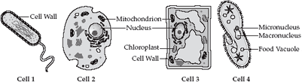
Which of the structures in Cell 3 releases energy for use in cell processes?
- nucleus (B) cell wall (C) chloroplast (D) mitochondrion
8. Cell 4 above has many hair-like structures that it uses for movement. What are these structures
called?
- cilia (B) flagella (C) vacuoles (D) pseudopodia

9. Study the animal cell below.
In animal cells, the endoplasmic reticulum serves as a channel for the transport of materials through the cell. The outer surface of the endoplasmic reticulum may be smooth or rough. Which cell structures cause the outer surface of the Rough Endoplasmic Reticulum to appear rough and allow it to make proteins?
- the ribosomes (B) the transport proteins (C) the mitochondria (D) the Golgi bodies
10. Which two structures are not present in animal cells?
(A) vacuole & nucleus (B) cell wall & chloroplasts (C) Golgi apparatus/bodies & mitchondria
(D) Smooth and Rough endoplasmic reticula & cytoplasm
11. The diagram below shows a cell.
The cell shown by the diagram is most likely
(A) an animal cell due to the presence of a cell membrane (plasma membrane)
(B) an animal cell due to the presence of a mitochondrion
(C) a plant cell due to the presence of a cell wall
(D) a plant cell due to the presence of a mitochondrion
12. What is the name of structure 4? See Chart below.
(A) vacuole (B) nucleus (C) ribosome (D) cell wall
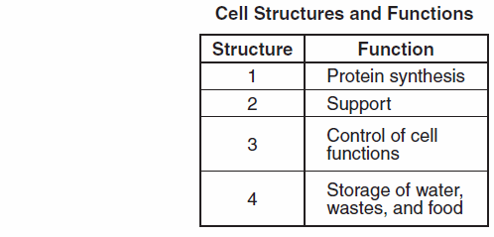
13. Review the cell below. The arrow identifies the organelle responsible for modifying lipids and proteins. What is the name of this organelle?
(A) lysosome (B) Golgi apparatus (C) mitochondrion (D) smooth endoplasmic reticulum
14. What is the main function of ribosomes?
(A) storage of water (B) synthesis of energy (C) replication of DNA (D) synthesis of proteins
15. Which of the following organelles is present in both prokaryotes and eukaryotes?
(A) nucleus (B) ribosome (C) endoplasmic reticulum (D) Golgi body
16. The main difference between prokaryotic and eukaryotic cells is that
(A) eukaryotic cells have a smaller nucleus
(B) eukaryotic cells have a more advanced cell organization
(C) prokaryotic cells are always much larger
(D) prokaryotic cells do not have a plasma (cell) membrane
17. Which characteristic of prokaryotic organisms makes them different from eukaryotes?
(A) Prokaryotic cells do not have membrane-bond organelles. (B) Prokaryotes are made of cells.
(C) Prokaryotes have DNA. (D) Prokaryotes do not have chromosomes.
18. What is the most accurate description of a eukaryotic cell?
(A) moves using cilia (B) contains a nucleus
(C) produces food by photosynthesis (D) reproduces only by mitosis

19. Which statement correctly identifies the cells?
(A) Cell 1 is prokaryotic; cell 2 is eukaryotic. (B) Cell 1 is eukaryotic; cell 2 is prokaryotic.
(C) Both cells are prokaryotic. (D) Both cells are eukaryotic.

20. Which of the following structures demonstrates the highest level of organization in organisms?
(A) nerve cell (B) muscle tissue (C) small intestine (D) endoplasmic reticulum
21. The eye is considered an organ because it
(A) is made up of different tissues working together (B) requires light energy to function correctly
(C) contains a fluid-filled central cavity (D) is almost completely surrounded by bone

22. The diagram below shows an animal cell in a beaker containing a solution of sugar and water. The
cell membrane is permeable only to water.
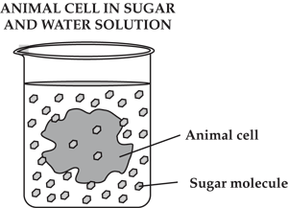
Which statement describes the relationship between the animal cell and the contents of the beaker?
(A) There is a higher concentration of water inside the cell than outside the cell.
(B) There is a higher concentration of sugar inside the cell than outside the cell.
(C) There is an equal concentration of water inside the cell as outside the cell.
(D) There is an equal concentration of sugar inside the cell as outside the cell.
23. What will most likely occur when a cell is placed into a saline solution that has a higher salt concentration than inside the cell?
(A) Water molecules will move into the cell. (B) Salt molecules will move out of the cell.
(C) Salt molecules will move until the salt concentration is the same inside and outside the cell
(D) Water molecules will move until the salt concentration is the same inside and outside the cell.
24. Which diagram represents active transport?
25. In active transport, carrier proteins
(A) move substances across the cell membrane without the use of ATP (energy)
(B) move from low concentration to high concentration by diffusion
(C) move small molecules through the cell membrane by osmosis
(D) move substances from a low concentration to high concentration through the use of ATP
26. The plasma membrane of a cell is selectively permeable or semi-permeable, which means it
(A) controls all cellular activities (B) is responsible for asexual reproduction
(C) allows some materials to pass (D) has a carbohydrate foundation
27. The channels in cell membranes that help substances to move in and out of cells during ACTIVE
transport are made of
- protein (B) chlorophyll (C) cytoplasm (D) carbohydrates
28.
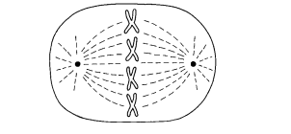
Which phase of mitosis would be seen next?
- 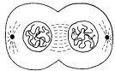 (B) 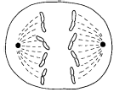(C) 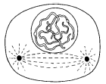 (D) 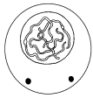

29. Mitosis is most important for an elephant’s
(A) vision (B) respiration (C) growth (D) metabolism.
30. A daughter cell that resulted from a mitotic division has 24 chromosomes. How many chromosomes
did the parent cell have?
- 5 (B) 12 (C) 2 4 (D) 48
31. What structure in plant cells is formed during cytokinesis that allows the cell to separate into two
new daughter cells?
- cell plate (B) spindle fibers (C) cleavage furrow (D) nuclear membrane
32. In cancer cells, mutations in the DNA cause the cells to reproduce uncontrollably, forming a tumor.
Cancer directly affects which cellular process?
- fertilization (B) mitosis (C) osmosis (D) conjugation
33. What is the function of enzymes in biological systems?
(A) Enzymes bond with substrates to create the new reaction products.
(B) Enzymes act as catalysts to drive chemical reactions forward.
(C) Enzymes act as substrates when the necessary proteins are unavailable.
(D) Enzymes act as products to create new chemical reactions.
34. What is the correct sequence for plant mitosis?
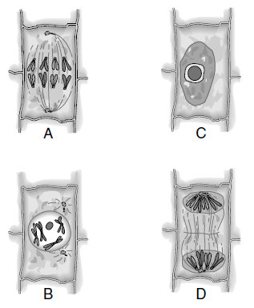
- B, A, D, C (B) C, B, A, D (C) D, C, B, A (D) A, B, D, C
35. Enzymes are classified as which of the following biological organic compounds?
(A) carbohydrates (B) lipids (C) nucleic acids (D) proteins
36. Individuals who lack lactase are unable to break down the sugar lactose. Which term best describes
lactase?
- enzyme (B) fatty acid (C) lipid (D) starch
37. Enzymes can promote chemical reactions in living tissues. For example, the breakdown of hydrogen
peroxide into harmless water and oxygen is accomplished by the chemical catalase. Which molecule
represents the substrate in this reaction?
- catalase (B) hydrogen peroxide (C) oxygen (D) water
38. The process of photosynthesis ultimately converts light energy into
(A) mechanical energy (B) chemical energy (C) nuclear energy (D) electrical energy
39. Algae and multicellular plants are autotrophs because they
(A) decompose dead organisms (B) capture sunlight to produce sugars
(C) absorb nutrients from soil (D) require oxygen for metabolic processes
40. A plant cell is shown below.
Which of these organelles uses light energy to produce sugar?
(A) chloroplast (B) vacuole (C) nucleus (D) mitochondrion
41. The energy required for photosynthesis is provided by
(A) proteins (B) sunlight (C) chlorophyll (D) carbohydrates
42. The diagram below shows the relationship between photosynthesis and respiration.

What are the products of photosynthesis?
(A) energy and oxygen (B) glucose and oxygen
(C) carbon dioxide and water (D) glucose and carbon dioxide

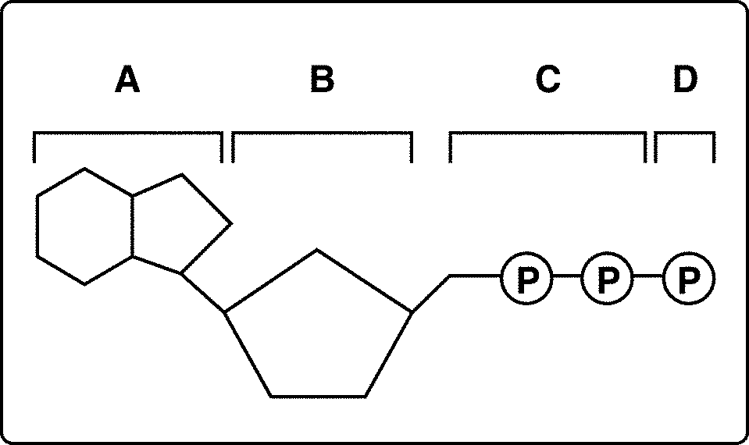
Figure 1-1
43. Look at Figure 1-1. All of the following are parts of an ADP molecule EXCEPT
a. structure A. b. structure B. c. structure C. d. structure D.

44. Which structures shown in Figure 1-1 make up an ATP molecule?
a. A and B b. A, B, and C c. A, B, C, and D d. C and D

45. What cellular activity requires ATP?
A. Osmosis B. Endocytosis C. Facilitated Diffusion D. Diffusion

46. How many calories does 1 gram of protein yield?
A. 1 B. 3 C. 2 D. 4

47. Which of the following is a primary function of carbohydrates?
A. storage of energy B. acceleration of chemical reactions
C. transmission of genetic material D.transport of molecules across membranes

48. A molecule with a structure composed primarily of amino acids would be classified in which of the following groups?
A. Carbohydrate B. Protein C. Nucleic Acid D. Lipid

49. The enzyme lactase will break down the sugar lactose into which of the following components?
A. Amino Acids B. Nucleic Acids C. Monosaccharides D. Fats

50. How much Energy is passed from one trophic level to the next in this pyramid?
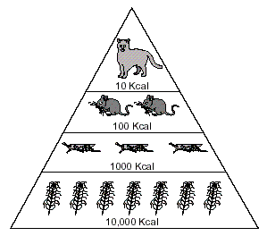
- 1% B. 10% C. 90% D. 100%

51. See diagram 2 below.
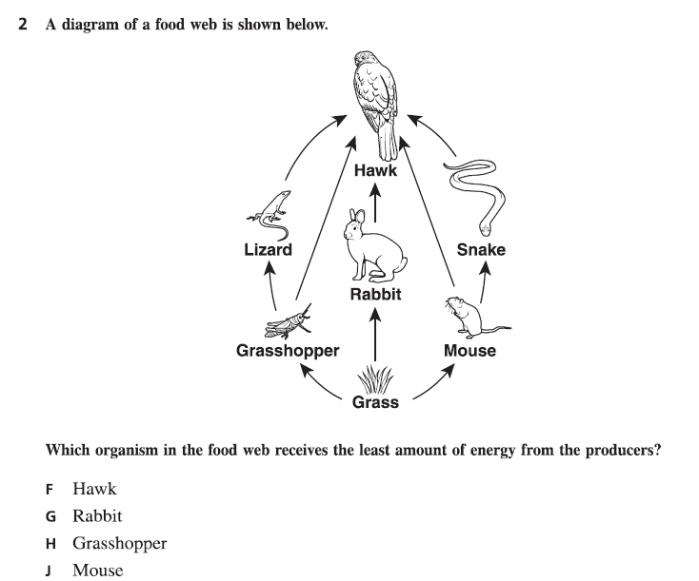

52. Which is the correct hierarchy of life from simple to complex
A. cell-->tissue-->organ-->organ system-->organism
B. cell-->organ -->tissue->organ system-->organism
C. DNA-->cell-->organ-->organ system-->organism
D. organism-->organ system-->organ-->tissue-->cell

53. Photosynthesis uses sunlight to convert water and carbon dioxide into
A. Oxygen only B. ATP and oxygen C. Glucose only D. Oxygen and Glucose

54. What are the monomers for proteins?
A. Monosaccharides B. Glycerol and Fatty Acids C. Amino Acids D. Nucleotides

55. Which terms most accurately describes the difference in ATP production between aerobic respiration and anaerobic respiration?
(A) Aerobic respiration produces more ATP than anaerobic respiration.
(B) Anaerobic respiration produces more ATP than aerobic respiration.
(C) Only anaerobic respiration produces measurable amounts of ATP.
(D) Anaerobic and aerobic respiration produce the same amount of ATP.

56. Which statement best distinguishes aerobic from anaerobic respiration?
(A) Only aerobic respiration involves fermentation.
(B) Only anaerobic respiration occurs in the mitochondria.
(C) Only aerobic respiration requires oxygen.
(D) Only anaerobic respiration produces carbon dioxide.

57. The diagram below shows some of the stages in cellular respiration. Which of the following gives the stages in the correct order?
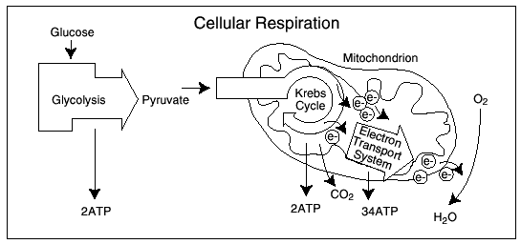
(A) Electron transport system, Krebs cycle, glycolysis
(B) Glycolysis, electron transport system, Krebs cycle
(C) Krebs cycle, glycolysis, electron transport system
(D) Glycolysis, Krebs cycle, electron transport system

58. Which cell organelle requires oxygen to carry out cellular respiration?
(A) ribosomes (B) nuclei (C) mitochondrion (D) membranes

59. The processes of photosynthesis and respiration can be thought of as a cycle because
(A) they both have the same purpose.
(B) one is used only by plants and the other is used only by animals.
(C) the products of one are used as the raw materials of the other.
(D) both give off oxygen to be used by animals.

60. The energy in the food produced by autotrophs or taken into the bodies of heterotrophs must be
changed into a form that cells can use. The energy-transferring molecule used by cells is
- ATP (B) RNA (C) DNA (D) CO₂

61. As respiration begins, glucose is broken down into pyruvic acid and two molecules of ATP are formed. What will happen next in yeast cells if no oxygen is available?
(A) Krebs cycle (B) photosynthesis (C) alcoholic fermentation (D) lactic acid fermentation

62. Which process produces two ATP molecules for every glucose molecule it breaks down, occurs in the cell’s cytoplasm, and produces NADH and pyruvate (pyruvic acid)?
(A) glycolysis (B) photosynthesis (C) the citric acid cycle (D) the electron transport chain

63. All of the following are organic molecules EXCEPT
(A) protein (B) lipid (C) carbohydrate (D) salt
64. Which organism in the food web below receives the least amount of energy from the producer?
(A) hawk (B) rabbit (C) grasshopper (D) mouse
Figure 2-1
65. Decomposers and detritivores are necessary in an ecosystem because they
(A) produce food for plants by the process of photosynthesis.
(B) provide energy for plants by the process of decay.
(C) can rapidly reproduce and evolve.
(D) make inorganic materials available to plants.
66. Which level of the food web listed above (Figure 2-1) has the greatest amount of biomass?
(A) hawk (B) bird (C) grasshopper (D) grass

67. A forest fire destroys the majority of the trees in a state park. Which effect will this most likely have
on secondary consumers in that ecosystem?
- The amount of available energy will increase because there will be fewer predators in the
forest.
(B) The amount of available energy will increase because there will be less competition from
predators.
(C) The amount of available energy will decrease because fewer primary consumers will survive
the lack of vegetation.
(D) The amount of available energy will remain constant because secondary consumers are not
reliant on primary consumers.

68. An insecticide is a chemical that kills insects. Most insects are killed the first time they are exposed
to an insecticide. However, some insects carry a gene that enables them to survive their first
exposure to an insecticide. When these surviving insects reproduce, this gene may be inherited by
their offspring. The number of insecticide-resistant insects usually increases over time because
increasing numbers of offspring with this gene are able to survive and reproduce.
Which process enables increasing numbers of insects to survive their initial exposure to an
insecticide?
- cloning (B) mutation (C) natural selection (D) genetic engineering

69. All of the following are main principles of evolution EXCEPT
(A) Individuals with beneficial traits are more likely to survive and reproduce.
(B) Every population has a variety of traits in the individuals.
(C) As the environment changes, new traits can appear and are passed on to offspring.
(D) A population that has undesirable traits will always survive.

70. Natural selection has often been summarized by what phrase?
(A) survival of the fittest (B) just do it (C) if it works, it must be true (D) if it’s complex,
it’s new
71. A man treated his home with a pesticide that kills roaches. The first application of the pesticide
killed 92% of the roaches. Two months later he applied the pesticide to his home again, but the
second application killed only 65% of the roaches. What would best explain the decrease in the
effectiveness of the pesticide?
(A) The pesticide is effective only against mature roaches.
(B) Once roaches learned how to fight the pesticide, they taught others.
(C) The surviving roaches were naturally resistant to the pesticide, and that resistance was
inherited by their offspring.
(D) The pesticide caused some of the roaches’ digestive systems to mutate and metabolize the
pesticide.
72. Compared to sexual reproduction, asexual reproduction results in a
(A) greater variation in offspring (B) larger number of identical cells
(C) longer life span of a cell (D) fewer number of cells dividing

73. A particular species of shark normally reproduces sexually. In captivity, it was found that a female
could also reproduce asexually. One negative result from asexual reproduction is
(A) increased gene recombinations (B) increased number of males produced
(C) decreased number of eggs laid (D) decreased variation within the species

74. Biological evolution can be summarized as the change in
(A) allele frequency of a population over time
(B) chromosome frequency of a population over time
(C) allele frequency of a population in one generation
(D) chromosome frequency of a population in one generation

75. Which is the best evidence of an evolutionary relationship between two organisms?
(A) similarity in behavior (B) similarity in DNA (C) similarity in habitat (D) similarity in niche

76. How would comparing the skeletons of a whale and an alligator provide support for evolution?
(A) It provides information about the organisms’ habitats.
(B) It shows possible common ancestry between organisms.
(C) It provides information to determine the organisms’ ages.
(D) It shows possible chromosome similarities between organisms.

77. Which of the following biological classification groups has the MOST organisms?
(A) phylum (B) order (C) kingdom (D) class

78. All of the following kingdoms include eukaryotic organisms EXCEPT
(A) Plantae (B) Protista (C) Animalia (D) Archaebacteria

79. A phylogenetic tree is represented below.
Which statement about phylogenetic trees is most accurate?
- All phylogenetic trees show that life began with autotrophic organisms that soon evolved into
heterotrophic organisms.
- Two organisms on the same branch of a phylogenetic tree are more closely related to each
other than to those on distant branches.
(C) All the organisms shown at the ends of phylogenetic tree branch tips are alive today.
(D) Phylogenetic trees show that evolution is a short-term process.

80. The chart below shows the classification of four different organisms.
According to the classification chart, which two organisms are most closely related?
- Organisms 1 and 3 (B) Organisms 1 and 4 (C) Organisms 2 and 3 (D) Organisms 2 and 4

81. According to the phylogenetic below, which organism is most closely related to Organism V?
- Q (B) U (C) W (D) X

82. What is the term for a feature that allows an organism to survive better in its environment?
A. Variation B. Adaptation C. Homologous structure D. Vestigial structure

83. The hind leg bones shown in the whale in Figure 10.2 are examples of
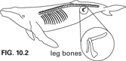

A. homologous structures. B. analogous structures. C. fossil structures. D. vestigial structures.

84. External sources, such as radiation and chemicals, can cause mutations in genes or entire chromosomes. For a mutation to be passed on offspring it must occur in the
A. Brain cell B. Muscle Cell C. Sex Cell D. Bone cell

85. A population of squirrels that contains a wide range of phenotypes has a
A. large amount of genetic variation.
B. high allele frequency for most alleles.
C. poor chance of surviving habitat change.
D. decreased chance of frequent gene flow.

86. A river has cut a deep canyon that has separated a population of rodents into two groups. This
separation is an example of what type of isolation?
- temporal B. behavioral C. geographic D. founder

85. The wings of robins and the wings of dragonflies are examples of
A. divergent adaptation. B. convergent evolution. C. adaptive radiation. D. punctuated equilibrium.

87. The structures listed below are examples of

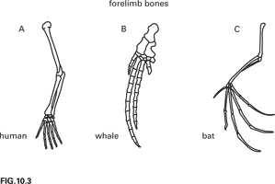

A. homologous structures. B. vestigial structures. C. analogous structures. D. All of these

88. ______________ proposed that evolution occurs through natural selection.
A. Gregor Mendel B. Thomas Malthus C. Charles Darwin D. Aldo Leopold

89. A symbiotic relationship in which one organism benefits while one organism is harmed is known as
(A) parasitism (B) antagonism (C) commensalism (D) mutualism
90. Mycorrhiza is a symbiotic relationship between plant roots and fungi. The fungi grow around the
plant roots and increase the surface area for the absorption of water and nutrients by the plant. The
plant roots, in turn, provide nutrients for the fungi. What type of symbiotic relationship is
this?
- commensalism (B) competition (C) parasitism (D) mutualism.
91. Which of these interactions is a form of parasitism?
(A) the remora riding on a shark’s back (B) the beaver chopping down a tree
(C) a tick feeding on the flesh of a dog (D) the lion hunting the zebra
92. Which of the following is an abiotic factor in a meadow ecosystem?
(A) trees (B) grasses (C) flowers (D) water
93. The diagram below represents the various stages of ecological succession in South Carolina.
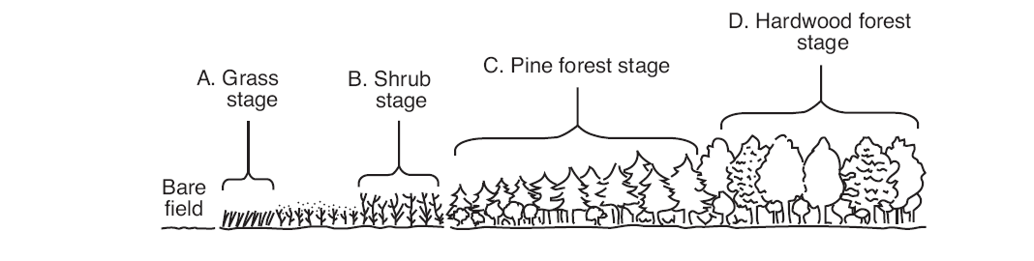
If the ecosystem is not altered, which stage would be the most stable?
- grass (B) shrub (C) pine forest (D) hardwood forest
94. During the process of primary succession, which of the following is the first to happen?
(A) development of a more complex ecosystem (B) reestablishment of trees and animals
(C) development of lichen (D) buildup of usable soil
95. After a volcanic eruption has covered an area with lava, which of the following is the most likely
order of succession in the repopulation of the area?
(A) lichens grasses shrubs trees (B) mosses grasses lichens trees
(C) grasses trees mosses lichens (D) shrubs grasses trees lichens
96. How is atmospheric nitrogen made available to plants and animals?
(A) Nitrogen is converted into nitrates by soil bacteria.
(B) Nitrogen is converted into nitrates as groundwater is filtered.
(C) Nitrogen is breathed in along with oxygen and discarded as nitrate waste.
(D) Nitrogen is released rapidly by the weathering of rocks and absorbed by vegetation.
97. In an ecosystem, elements such as nitrogen and carbon move between living things and the
environment. The conversions of these elements are part of
- biogeochemical cycles (B) ecological succession (C) energy pyramids (D) symbiosis
98. The theory of global warming suggests that a trend toward warmer temperatures on Earth will
cause glaciers to melt. Which result is a major consequence of glacial melting?
(A) flooding of coastal regions (B) destruction of fossil records
(C) increased saltiness of the ocean (D) an increase in atmospheric carbon dioxide
99. What is the largest “sink” for the absorption of carbon dioxide?
(A) soil (B) ions (C) oceans (D) plants
100. Which situation would result in the greatest increase in the human population?
(A) decreased birth rate and increased death rate
(B) increased infant mortality and decreased death rate
(C) decreased death rate and increased birth rate
(D) increased birth rate and increased infant mortality
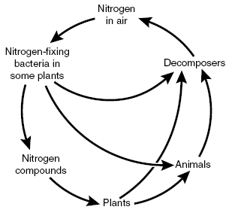
101. The diagram above shows a simplified nitrogen cycle. Which process is responsible for returning
nitrogen to the air?
(A) nitrification (B) decomposition (C) denitrification (D) assimilation
102. Recent climate data suggests a global warming trend. The most likely cause could be an increase
in which gas?
- oxygen (B) carbon dioxide (C) nitrogen (D) hydrogen sulfide
103. Wetlands are very specialized ecosystems. Of the following causes of wetland loss, which do
people have the least control over?
- overgrazing (B) droughts (C) discharge of pollutants (D) draining and filling
104. The pH of the water in several lakes in Norway and Sweden has decreased to below 5.0, resulting
in the decline of several fish populations. The decrease in the pH is due to which of the following?
(A) a greater rate of ozone depletion (B) an increase in acidic precipitation
(C) an increase in environmental temperatures (D) a rise in atmospheric carbon dioxide levels
105. Humans have had a tremendous impact on the environment. What has caused an increase in the
amount of acid rain?
(A) use of chlorofluorocarbons (B) use of pesticides
(C) coal burning power plants (D) nuclear power plants

106. The soil on a farm can very quickly become depleted of the minerals essential to plants because
harvesting of crops can interfere with the
(A) reproductive cycles of animals (B) recycling of inorganic compounds
(C) flow of energy (D) transport of groundwater
107. Lipids and carbohydrates are important for living organisms because they both
A. Form cell walls B. Store energy C. Provide insulation D. Contain Nitrogen
108. Some unicellular organisms have the ability to move. Which cellular structures are associated with
movement?
- Ribosomes B. Chloroplasts C. Lysosomes D. Cilia

109.
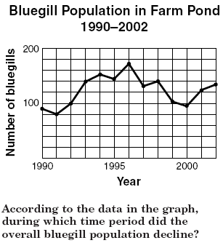
- 1996-1999 B. 1993-1996 C. 1990-1993 D. 1999-2002

110. A biology class of 24 students decides to measure the height of each student and then calculate the average height for the class. Which of these is a possible source of error in this activity?
A. The number of males and females in the class. B. The difference in ages of the students.
C. The accuracy of making and recording measurements. D. The total number of students.

111. The energy in the food produced by autotrophs or taken into the bodies of heterotrophs must be changed into a form that cells can use. The energy-transferring molecule used by cells is
A. ATP B. DNA C. RNA D. CO₂

112.
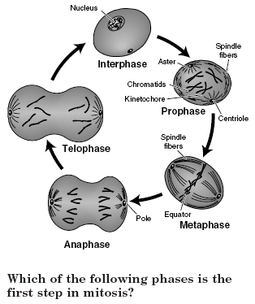

A. Metaphase B. Prophase C. Anaphase D. Telophase

113. Which of these graphs shows the most stable population?
(A) 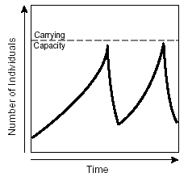 (B) 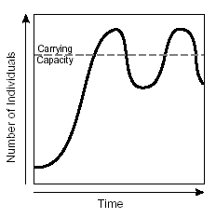
(C) 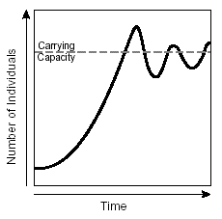 (D) 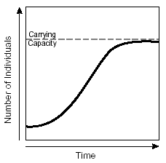

114. A company that produces Brand X flea shampoo claims to have the most effective shampoo for killing fleas. Which sets of data supports the Brand X claim?

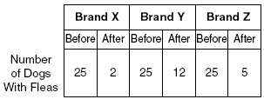

- 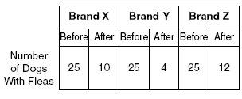

- 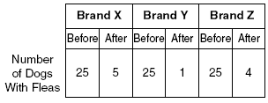

115. When there is a lower concentration of water outside of a plant cell rather than inside a plant cell, the plant will tend to
A. increase its rate of photosynthesis. B. grow toward the sun
C. gain water and become rigid D. Lose water and wilt.

116. Amino acids are linked together via peptide bonds to form proteins. What organelle does this process occur?
A. Nucleus B. Chloroplast C. Ribosome D. Mitochondrion

117.
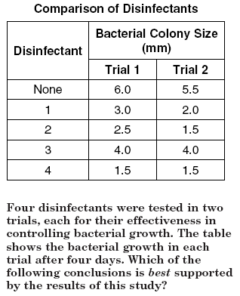

- Strong concentrations of disinfectants can be harmful.
- Some disinfectants are more effective than others.
- Disinfectants can’t be used to control bacterial infections.
- Disinfectants kill most bacteria on contact.

118. In the experiment listed above, what would be the independent variable?
A. Bacterial colony size B. Type of disinfectant C. Color of bacteria

119. A segment of a DNA strand has the following bases: TACGAT
What is the complementary strand of DNA?
- UAGCAU (B) TAGCAT (C) ATGCTA (D) AUGCUA

120. Which molecule resembles the shape of a twisted ladder?
(A) DNA (B) sugar (C) ATP (D) lipid

121. Which three substances are found in one DNA molecule?
(A) cytosine – ribose – guanine (B) phosphate – ribose – cytosine
(C) thymine – deoxyribose – adenine (D) phosphate – deoxyribose – thymine
122. Which statement best describes a chromosome?
(A) It is a gene that has thousands of different forms.
(B) It has genetic information contained in DNA.
(C) It is a reproductive cell that influences more than one trait.
(D) It contains hundreds of genetically identical DNA molecules.
123. 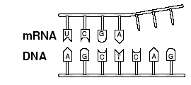
Which of these will complete the mRNA strand (shown above) matched to DNA?
- UAC (B) AUG (C) CAG (D) GUC
124. A portion of an mRNA molecule is shown below.
The diagram represents which process?
- translation (B) transcription (C) replication (D) fragmentation
125. Which of these is most responsible for carrying coded information from the nucleus?
(A) DNA (B) the ribosome (C) mRNA (D) ATP
126. Which of the following carries amino acids to the site of protein synthesis?
(A) mRNA (B) rRNA (C) tRNA (D) nRNA
127. Which is a correct example of the base-pairing rule within the Watson-Crick double-helix model of DNA?
(A) guanine-adenine (B) adenine-thymine (C) thymine-guanine (D) cytosine-thymine
128. The jimsonweed Datura stramonium, normally has 12 chromosomes in the body cells. How many
chromosomes will an egg cell of the weed have?
- 24 (B) 18 (C) 6 (D) 12
129. What process produces male and female reproductive cells in plants?
(A) mitosis (B) meiosis (C) replication (D) fertilization

130. Part of the process of protein synthesis is shown below. The different structures in this process are numbered 1 through 5.
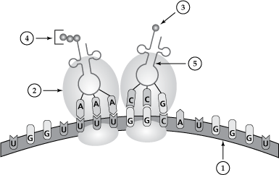
(A) Structure 2 in the diagram represents
(A) ribosome (B) mitochondrion (C) protein (D) chloroplast
(B) The process shown in the diagram occurs in the
(A) nucleus (B) cytoplasm (C) vacuole (D) chromosome.
(C) Structure 1 is produced in what part of the cell?
(A) vacuole (B) cytoplasm (C) mitochondrion (D) nucleus
131. Which step that occurs in meiosis increases genetic variation in multicellular organisms?
(A) formation of tetrads (B) crossing over of nonsister chromatids
(C) disappearance of the nuclear membrane (D) moving of centrioles to opposite ends of the cell
132. In squash plants, yellow fruit (Y) is dominant to white fruit (y). If two plants heterozygous for
yellow fruit are crossed, what are the possible genotypes of the offspring?
- YY and yy only (B) Yy only (C) YY, Yy, and yy (D) YY and yy only
133. In humans, the allele for having a hairline with a widow’s peak (H) is dominant to having a straight
hairline (h).
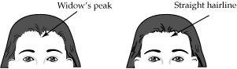
A woman that is homozygous dominant for having a widow’s peak and a man that is heterozygous
for having a widow’s peak have a child. What is the probability that their child will have a widow’s
peak?
- 0% (B) 25% (C) 75% (D) 100%

134. In guinea pigs, the allele for black fur (B) is dominant. The allele for brown fur (b) is recessive. Two
guinea pigs were crossed as shown in the Punnett square below. Numbers 1, 2, 3, and 4 represent
the types of offspring produced from the cross.
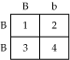
(A) What is the probability that an offspring from this cross would have brown fur?
(A) 0% (B) 25% (C) 50% (D) 75%
135. Using the information from question 134 determine which of these describes the phenotypes of
the parent guinea pigs?
(A) Both parents have black fur. (B) Both parents have brown fur.
(C) One parent has black fur and the other has brown fur.
(D) One parent has a mixture of black and brown fur, and the other has black fur.
136. A litter of guinea pigs can vary in color. Some are solid white and some are brown and white, while
others are black and white. The color and pattern of each guinea pig are distinct from those of its
parents and siblings. What process is responsible for the differences seen in each guinea pig?
- meiosis (B) mitosis (C) replication (D) translation
137. A woman with attached earlobes has a child with a man who has unattached earlobes. This couple
has three children, and all of them have unattached earlobes. The trait for attached earlobes is
most likely
- dominant (B) recessive (C) codominant (D) incompletely dominant
138. Two organisms, each with genotype AaBb, are crossed. The expected phenotype ratio
is expected to be
- 4:4:4:4 (B) 7:6:2:1 (C) 8:4:2:2 (D) 9:3:3:1
139. Which of these is an example of a heterozygous genotype?
(A) Rr (B) RR (C) wrinkled (D) round
140. According to the laws of genetics as determined by Gregor Mendel, the allele that expresses itself
in the phenotype of an organism is called the
(A) mutated allele (B) inherited allele (C) recessive allele (D) dominant allele
141. Most sex-linked, recessive traits – including hemophilia and color blindness – appear in males. This
phenomenon is best explained by which statement?
(A) Males have an X chromosome with dominant genes.
(B) Most of the genes on the X and Y chromosomes of males are recessive.
(C) In males, the recessive sex-linked genes appear only on the Y chromosome.
(D) In males, the Y chromosome lacks the genes needed to mask the recessive genes on the X
chromosome.

142. In a certain set of lab mice, black hair (B) is dominant to white hair (b), and coarse hair (C) is
dominant to fine hair (c). The Punnett square below shows a cross between a heterozygous black,
fine-haired mouse and a white heterozygous, course-haired mouse.
What is the probability this cross will produce black, coarse-haired offspring?
- 2/16 (B) 4/16 (C) 8/16 (D) 10/16
143. A couple has five children, all with blood type A. The mother’s blood type is O, and the father’s
blood type is A. Based on this information, which describes the most probable genotype of the
father?
- diploid (B) haploid (C) heterozygous (D) homozygous
144. Some flowers show incomplete dominance. If RR = red and R’R’ = white, which phenotypic ratio
would be expected in the offspring of two pink flowers?
(A) 1 red : 2 pink : 1 white (B) 0 red : 4 pink : 0 white
(C) 3 red : 0 pink : 1 white (D) 4 red : 0 pink : 0 white
145.
What type of trait is shown in the pedigree?
- sex-linked recessive (B) sex-linked dominant (C) autosomal recessive (D) autosomal dominant

146. Which of the following is an example of codominance in genetic traits?
(A) A tall pea plant and a short pea plant produce tall pea plants.
(B) An orange cat and a black cat produce an orange and black kitten.
(C) A blue-eyed man and a brown-eyed woman produce a blue-eyed child.
(D) A color-blind woman and a man with normal vision produce a color-blind son.
147. Red blood cells are classified as type A or type B, based on their surface antigens. Type O blood
does not contain any antigens. The chart below shows the possible phenotypes of each blood type.
Which mechanism explains how both A and B antigens produce type AB blood?
(A) complete dominance (B) polygenic inheritance (C) codominance (D) incomplete dominance
148. Human may have type O, A, B, or AB blood. This blood type is a trait that is determined by
(A) a double crossover on the X chromosome (B) multiple alleles
(C) genes on the Y chromosome only (D) three homologous chromosomes

149. In people, the trait for colorblindness ( X^{b}) is a recessive sex linked trait and normal vision (X^{B}) is dominant.
(A) A woman who is colorblind (X^{b}X^{b}) can expect
(A) 100% of her female offspring to be colorblind
(B) 100% of her male offspring to be colorblind
(C) 50% of her female offspring to be colorblind
(D) 50% of her male offspring to be colorblind
(B) If a female who is heterozygous for colorblindness has children with a man who has normal vision,
what percent of their male children would be expected to be color blind?
- 0% (B) 25% (C) 50% (D) 100%

150.
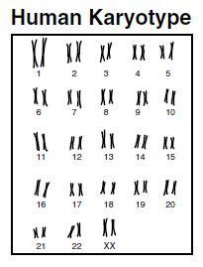
What information is revealed in the karyotype shown?
- the age (B) gene dominance (C) the sex (D) trisomy

151. An iodine solution is placed on the cut side of a potato. Within seconds, a blue-black color appears.
What is most likely occurring?
A. a positive test for proteins B. a positive test for starches
C. a negative test for proteins D. a negative test for starches

152. A person with swollen gums rinses his mouth with warm salt water, and the swelling decreases. Which has occurred?
A. The swollen gums have absorbed the saltwater solution.
B. The saltwater solution lowers the temperature of the water in the gums.
C. The salt in the solution has moved against the concentration gradient.
D. The water in the gums has moved from a high to a low concentration of water.

153. RNA and DNA are which type of organic compound?
A. Nucleic Acid B. Carbohydrate C. Lipid D. Protein

154. Which is an example of osmosis?
A. potassium ions moving in and out of an animal cell
B. carbon dioxide moving into the leaf cells of a plant
C. oxygen moving into the bloodstream from the lungs
D. water moving into the root cells of a plant

155. This diagram shows an enzyme-substrate complex. Which is represented by Structure X?
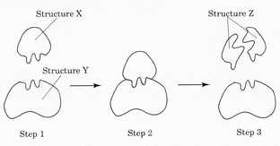
- substrate B. product C. enzyme D. complex
156. Two different species of bacteria are examined. Scientists find that Species X always produces CO₂ and H₂O during cellular respiration. Species Y always produces ethyl alcohol and CO₂. Which conclusion can be made from these observations?
A. Only Species Y is aerobic. B. Only Species Y is anaerobic. C. Both Species X and Y are aerobic. D. Both Species X and Y are anaerobic.

157. Which is the most likely function of a group of cells that contains a high number of chloroplasts?
A. respiration B. transpiration C. fermentation D. photosynthesis

158. What will most likely happen if an appropriate enzyme is added to a chemical reaction?
A. The reaction rate will increase. B. The equilibrium of the reaction will be maintained.
C. The reaction rate will decrease. D. The reaction will stop.

159. In humans, glucose is kept in balance in the bloodstream by insulin. Which concept does this best illustrate?
A. adaptation B. homeostasis C. metabolism D. organization

160. A sugar, a phosphate group, and a nitrogen base form the building blocks of which organic compound?
A. carbohydrates B. lipids C. nucleic acids D. proteins

161. In which way are photosynthesis and cellular respiration different?
A. Cellular respiration stores ATP, while photosynthesis releases ATP.
B. Cellular respiration produces oxygen, while photosynthesis uses oxygen.
C. Photosynthesis releases energy, while cellular respiration stores energy.
D. Photosynthesis uses carbon dioxide, while cellular respiration produces carbon dioxide.

162. This diagram represents a cell. Which organelle is the site where amino acids are synthesized into proteins?
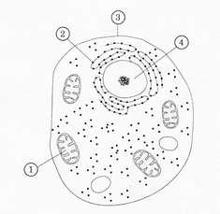
- 1
- 2
- 3
- 4

