HEREDITY STUDY GUIDE

Compare DNA and RNA in terms of structure, nucleotides, and base pairs.

Nucleic acids are organic molecules that serve as the blueprint for proteins and, through the action of proteins, for all cellular activity.
- There are two types of nucleic acids.
  - Deoxyribonucleic acid (DNA)
  - Ribonucleic acid (RNA)
- Both DNA and RNA are composed of small units called nucleotides. The nucleotides that compose nucleic acids have three parts:
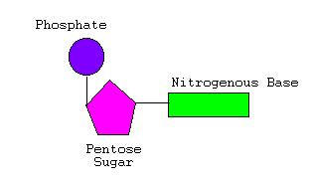
  - A nitrogenous base
    - Cytosine (C)
    - Guanine (G)
    - Adenine (A)
    - Thymine (T) (DNA only)
    - Uracil (U) (RNA only)
  - A simple (pentose) sugar
    - Deoxyribose (DNA only)
    - Ribose (RNA only)
  - A phosphate group

The basic structure of the two molecules is different.
- DNA consists of two single chains which spiral around an imaginary axis to form a double helix with nitrogenous bases from each strand of DNA chemically bonded through the axis of the helix.
  - When the nitrogenous bases of two strands of DNA chemically bond through the center of the helix, each base can bond to only one type of base. Bases that bond are called complementary bases.
    - Guanine (G) will only bond with Cytosine (C).
    - Thymine (T) will only bond with Adenine (A).
- RNA consists of a single chain of nucleotides with nitrogenous bases exposed along the side.
  - When the nitrogenous bases of RNA chemically bond to a strand of DNA, each RNA base can bond with only one type of DNA base. Bases that bond are called complementary bases.
    - Guanine (G) will only bond with Cytosine (C).
Uracil (U) will only bond with Adenine (A). Comparison of the structure of the two types of nucleic acid.

 | DNA | RNA
Type of base composing nucleotides | Cytosine (C)  Adenine (A)  Guanine (G)  Thymine(T) | Cytosine(C)  Adenine (A)  Guanine (G)  Uracil (U)
Type of sugar composing nucleotides | deoxyribose | ribose
Molecule structure and shape | Double helix | Single chain

In addition to compare, students are required to be able to:
- recognize the chemical names of the DNA and RNA molecules;
- identify the parts of a nucleotide;
- recognize the names of the 5 bases and the two sugars that compose the nucleotides that make up all nucleic acids;
- interpret an illustration of a nucleotide;
- interpret an illustration of a DNA or an RNA molecule.

2
Summarize the relationship among DNA, genes, and chromosomes.

DNA, genes, and chromosomes compose the molecular basis of heredity.
- A chromosome is a structure in the nucleus of a cell consisting essentially of one long thread of DNA that is tightly coiled.
- DNA, composed of nucleotides, provides the blueprint for the synthesis of proteins by the arrangement of nitrogenous bases.
  - The code for a particular amino acid (the base unit of proteins) is determined by a sequence of three base pairs on the DNA molecule.
- A gene is a specific location on a chromosome, consisting of a segment of DNA, that codes for a particular protein.
  - The particular proteins coded by the DNA on the genes determine the characteristics of an organism.
  - Each chromosome consists of hundreds of genes determining the many proteins for an individual organism.

Explain how DNA functions as the code of life and the blueprint for proteins.

DNA, which comprises the organism’s chromosomes, is considered the “code of life” (genetic code) because it contains the code for each protein that the organism needs.
  - The specificity of proteins is determined by the order of the nitrogenous bases found in DNA In order to construct the specific proteins needed for each specific purpose, cells must have a blueprint that reveals the correct order of amino acids for each protein found in the organism (thousands of proteins).
  - A gene is a segment of DNA that codes for one particular protein.
- Each cell in an organism’s body contains a complete set of chromosomes.
  - The number of chromosomes varies with the type of organism. For example, humans have 23 pairs of chromosomes; dogs have 39 pairs; potatoes have 24 pairs.
  - One pair of chromosomes in an organism determines the sex (male, female) of the organism; these are known as sex chromosomes. All other chromosomes are known as autosomal chromosomes, or autosomes.
  - Cells (except for sex cells) contain one pair of each type of chromosome.
    - Each pair consists of two chromosomes that have genes for the same proteins.
    - One chromosome in each pair was inherited from the male parent and the other from the female parent. In this way traits of parents are passed to offspring.
    - For example, human cells have 46 chromosomes (23 pairs).
- Each chromosome consists of thousands of genes. This is because there are so many unique proteins that each organism needs to produce in order to live and survive.
  - Organisms that are closely related may have genes that code for the same proteins that make the organisms similar. For example, all maple trees have many of the same genes.
  - Each individual organism has unique characteristics and those unique characteristics arise because of the differences in the proteins that the organism produces.
  - Organisms that are not closely related share fewer genes than organisms that are more closely related. For example, red maple trees share more genes with oak trees than with earthworms.

DNA can function as the code of life for protein synthesis or the process of DNA replication, which ensures that every new cell has identical DNA.
- DNA replication is carried out by a series of enzymes. The first enzyme unzips the two strands of DNA that compose the double helix, separating paired bases.
- Each base that is exposed can only bond to its complementary base.
  - Adenine (A) can only bond to thymine (T)
  - Cytosine (C) can only bond to guanine (G)
- Each of the separated strands serves as a template for the attachment of complementary bases, forming a new strand, identical to the one from which it was “unzipped”.
- The result is two identical DNA molecules.

Summarize the basic processes involved in protein synthesis (including transcription and translation).

When a particular protein is needed, the cell must make the protein through the process of protein synthesis. DNA molecules (which contain the code) do not leave the nucleus of the cell, but protein synthesis must occur in the ribosomes which are located outside of the nucleus in the cytoplasm. Therefore, the code must be carried from the nucleus to the cytoplasm.

3

Transcription
Transcription is the process by which a portion of the molecule of DNA is copied into a complementary strand of RNA. Through the process of transcription, the DNA code is transferred out of the nucleus to the ribosomes.

- Through a series of chemical signals, the gene for a specific protein is turned on. An enzyme attaches to the exact location on the DNA molecule where the gene is found, causing the two strands of DNA to separate at that location.
Complementary RNA nucleotide bases bond to the bases on one of the separated DNA strands.
DNA nucleotide bases exposed on the separated strand | RNA nucleotide  which bonds
Adenine (A) | Uracil (U)
Thymine (T) | Adenine (A)
Cytosine (C) | Guanine (G)
Guanine (G) | Cytosine (C)

- Nucleotides of RNA bond together, forming a single-stranded molecule of RNA that peels away from the DNA strand and the two DNA strands rejoin. This is called messenger RNA (mRNA).
- The messenger RNA (mRNA) is formed complementary to one strand of DNA.
- The mRNA strand leaves the nucleus and goes through the nuclear membrane into the cytoplasm of the cell.

Translation
Translation is the process of interpreting the genetic message and building the protein and begins when the mRNA attaches to a ribosome, which contains proteins and ribosomal RNA (rRNA), in the cytoplasm.
- The function of ribosomes is to assemble proteins according to the code that the mRNA brings from the DNA.
- Each three-base nucleotide sequence on the mRNA is called a codon. Each codon specifies a particular amino acid that will be placed in the chain to build the protein molecule.
- For example, if the DNA sequence was GAC, then the RNA sequence becomes CUG and the amino acid that is coded is leucine.
- The sequence of mRNA nucleotides determines the order of the amino acids in the protein chain which, in turn, distinguishes one protein from another in structure and function.
- Another type of RNA, transfer RNA (tRNA), is vital in assembling amino acids into the correct sequence for the required protein by transferring amino acids to the ribosomes when needed. There are twenty different types of tRNA molecules, one for each amino acid.
  - At one end of each tRNA is an anticodon site, which has the 3-nucleotide bases complementary to the codon of mRNA.
  - The other end of the tRNA molecule has a specific amino acid attached determined by the anticodon.
- The translation process takes place as follows:
  - The tRNA with its attached amino acid pairs to the codon of the mRNA attached to a ribosome.
  - When a second tRNA with its specific amino acid pairs to the next codon in sequence, the attached amino acid breaks from the first tRNA and attaches to the amino acid of the second tRNA.
  - The ribosome forms a peptide bond between the amino acids, and an amino acid chain begins to form.
  - The empty tRNA moves off and picks up another matching amino acid from the cytoplasm in the cell.

This sequence is repeated until the ribosome reaches a stop codon on the mRNA, which signals the end of protein synthesis.

Summarize the characteristics of the phases of meiosis I and II.

The process of meiosis and its importance to sexual reproduction just as mitosis is to asexual reproduction . In order for the offspring produced from sexual reproduction to have cells that are diploid (containing two sets of chromosomes, one set from each parent), the egg and sperm cells must be haploid (contain only one of each type of chromosome). The division resulting in a reduction in chromosome number is called meiosis.
Meiosis occurs in two steps:
- Meiosis I, in which the chromosome pairs replicate, results in two haploid daughter cells with duplicated chromosomes different from the sets in the original diploid cell.
- Meiosis II, in which the haploid daughter cells from Meiosis I divide, results in four haploid daughter cells called gametes, or sex cells (eggs and sperm), with undoubled chromosomes.

4

Meiosis I
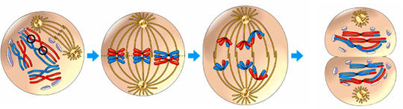

A B C D
prophase I metaphase I anaphase I telophase I

Meiosis I begins with interphase, like in mitosis, in which cells: (1) increase in size, (2) produce RNA, (3) synthesize proteins, and (4) replicate DNA
- Prophase I (as in figure “A” above)
  - The nuclear membrane breaks down; centrioles separate from each other and take up positions on the opposite sides of the nucleus and begin to produce spindle fibers.
  - Chromosomes pair up and become visible as a cluster of four chromatids called a tetrad.
    - A homologous chromosome pair consists of two chromosomes containing the same type of genes.
      - the paternal chromosome in the pair contributed by the organism’s male parent
      - the maternal chromosome in the pair contributed by the organism’s female parent
    - Each chromosome consists of two sister chromatids attached at a point called the centromere.
    - Because the homologous chromosome pairs are in close proximity, an exchange of chromosome genetic material between pairs often occurs in a process called “Crossing over.”
- Metaphase I (as in figure “B” above)
  - The chromosomes are attached to the spindle fiber at the centromere and are pulled into the mid-line (or equator) of the cell in pairs.
- Anaphase I (as in figure “C” above)
  - The chromosome pairs separate, one chromosome to each side of the cell.
    - Each daughter cell will receive only one chromosome from each homologous chromosome pair.
    - Sister chromatids remain attached to each other.
- Telophase I & Cytokinesis (as in figure “D” above)
  - Chromosomes gather at the poles, nuclear membrane may form, and the cytoplasm divides.
  - Cytokinesis that occurs at the end of telophase I is the division of the cytoplasm into two individual daughter cells.
- Each of the two daughter cells from meiosis I contains only one chromosome (consisting of two sister chromatids) from each parental pair. Each daughter cell from meiosis I proceeds to undergo meiosis II.

Meiosis II
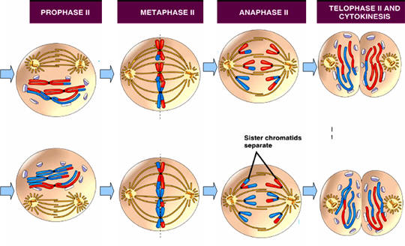

(E) (F) (G) (H)
5

- Prophase II (as in figure “E” above)
  - Spindle fibers form in each of the daughter cells from meiosis I and attaches to the centromeres of the sister chromatids
  - The chromosomes progress towards the midline of each cell.
- The nuclear membrane breaks down. Metaphase II (as in figure “F” above)
  - Chromosomes, made up of two sister chromatids, line up across the center of the cell.
  - Spindle fibers from opposite poles of the cell attach to one of each pair of chromatids.
- Anaphase II (as in figure “G” above)
  - The chromosomes separate so that one chromatid from each chromosome goes to each pole.
- Telophase II & Cytokinesis (as in figure “H” above)
  - Nuclear member forms around each set of chromosomes.
  - The resulting daughter cells are haploid, containing one single chromosome from each pair of chromatids, either from the maternal or paternal contributor.

Predict inherited traits by using the principles of Mendelian genetics (including segregation, independent assortment, and
dominance).

Genetics is the study of patterns of inheritance and variations in organisms. Genes control each trait of a living thing by controlling the formation of an organism’s proteins.
- Since in all cells (except gametes) chromosomes are diploid (exist as a pair of chromosomes), each cell contains two genes for each trait, one on the maternal chromosome and one on the paternal chromosome.
- The two genes may be of the same form or they may be of different forms.
  - These forms produce the different characteristics of each trait. For example, a gene for plant height might occur in a tall form and a short form.
  - The different forms of a gene are called alleles.
  - The two alleles are segregated during the process of gamete formation (meiosis II).

Law (Principle) of Dominance
The law (principle) of dominance states that some alleles are dominant whereas others are recessive.
- An organism with a dominant allele for a particular trait will always have that trait expressed (seen) in the organism.
- An organism with a recessive allele for a particular trait will only have that trait expressed when the dominant allele is not present.

Since organisms received one gene for a chromosome pair from each parent, organisms can be heterozygous or homozygous for each trait.
- When an organism has two identical alleles for a particular trait that organism is said to be homozygous for that trait.
  - The paternal chromosome and the maternal chromosome have the same form of the gene; they are either both dominant or both recessive.
- When an organism has two different alleles for a particular trait that organism is said to be heterozygous for that trait.
  - The paternal chromosome and the maternal chromosome have different forms of the gene; one is dominant and one is recessive.

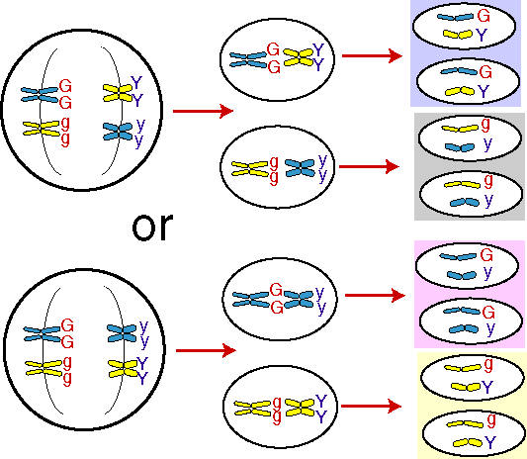
The genotype (genetic makeup) of an organism reveals the type of alleles that an organism has inherited for a particular trait. The genotype for a particular trait is usually represented by a letter, the capital letter representing the dominant gene and the lower-case letter representing the recessive gene.
- TT represents a homozygous dominant genotype.
- tt represents a homozygous recessive genotype.
- Tt represents a heterozygous genotype.
The phenotype (physical characteristics) of an organism is a description of the way that a trait is expressed in the organism.
- Organisms with genotypes of TT or Tt would have a phenotype of tall.
- Organisms with a genotype of tt would have a phenotype of short.

Law (Principle) of Segregation
The law (principle) of segregation explains how alleles are separated during meiosis.
- Each gamete receives one of the two alleles that the parent carries for each trait. Each gamete has the same chance of receiving either one of the alleles for each trait.
- During fertilization (when sperm and egg unite), each parent organism donates one copy of each gene to the offspring.

6
Law (Principle) of Independent Assortment
The law (principle) of independent assortment states that the segregation of the alleles of one trait does not affect the segregation of the alleles of another trait.
- Genes on separate chromosomes separate independently during meiosis.
- This law holds true for all genes unless the genes are linked. In this case, the genes that do not independently segregate during gamete formation, usually because they are in close proximity on the same chromosome.

The principles of Mendelian genetics can be used to predict the inherited traits of offspring. A Punnett square can be used to predict the probable genetic combinations in the offspring that result from different parental allele combinations that are independently assorted.
- A monohybrid cross examines the inheritance of one trait. The cross could be homozygous-homozygous, heterozygous-heterozygous, or heterozygous-homozygous.
 | T | t
T | TT | Tt
t | Tt | tt
- The Punnett square example represents the probable outcome of two heterozygous parents with the trait for height: T = dominant tall, t = recessive short (Tt x Tt). The parents are the F₁ generation; the resulting offspring possibilities are the F₂ generation.
The square shows the following genotypes are possible:
  - there is a 1:4 ratio (25%) that an offspring will carry two dominant alleles.
  - there is a 1:4 ratio (25%) that an offspring will carry two recessive alleles.
there is a 2:4 or 1:2 ratio (50%) that an offspring will carry one dominant allele and one recessive allele.
The square also shows the following phenotypes are possible:
  - there is a 3:4 ratio (75%) that an offspring will express the tall trait.
- There is a 1:4 ratio (25%) that an offspring will express the short trait. A dihybrid cross examines the inheritance of two different traits.
- The following Punnett square example represents the probable outcome of two traits of homozygous parents with the traits for shape and color: R = dominant round, r = recessive wrinkled; Y = dominant for yellow, y = recessive green (rryy x RRYY). The parents are the F₁ generation; the resulting offspring possibilities are the F₂ generation.

 | ry | ry | ry | ry
RY | RrYy | RrYy | RrYy | RrYy
RY | RrYy | RrYy | RrYy | RrYy
RY | RrYy | RrYy | RrYy | RrYy
RY | RrYy | RrYy | RrYy | RrYy

  - All of the offspring for this generation would predictably have the same genotype, heterozygous for both traits (RrYy).
  - All of the offspring for this generation would predictably have the same phenotype, round and yellow (16/16 will be round and yellow).

Summarize the chromosome theory of inheritance and relate that theory to Gregor Mendel’s principles of genetics.

The current chromosome theory of inheritance is a basic principle in biology that states genes are located on chromosomes and that the behavior of chromosomes during meiosis accounts for inheritance patterns, which closely parallels predicted Mendelian patterns. The principles of Mendelian genetics (segregation, independent assortment, and dominance) support the chromosome theory of inheritance . Due to advances in technology since Mendel, inheritance patterns and genetic variations that could not be explained by Mendelian genetics are now understood using the chromosome theory of inheritance. The following are new developments since Mendel’s principles of genetics:

Gene Linkage and Crossing-over
- Gene linkage simply means that genes that are located on the same chromosome will be inherited together. These genes travel together during gamete formation.

7
  - This is an exception to the Mendelian principle of independent assortment because linked genes do not segregate independently.
- Crossing-over is a process in which alleles in close proximity to each other on homologous chromosomes are exchanged. This results in new combinations of alleles.
  - When chromosomes pair up during meiosis I, sometimes sections of the two chromosomes become crossed. The two crossed sections break off and usually reattach.
  - When the genes are rearranged, new combinations of alleles are formed.
Crossing-over explains how linked genes can be separated resulting in greater genetic diversity that could not be explained by Mendel’s principles of genetics.

Incomplete Dominance and Codominance
- Incomplete dominance is a condition in which one allele is not completely dominant over another. The phenotype expressed is somewhere between the two possible parent phenotypes.
- Codominance occurs when both alleles for a gene are expressed completely. The phenotype expressed shows evidence of both alleles being present.
- These conditions go beyond Mendel’s principle of dominance.

Multiple Alleles and Polygenic Traits
- Multiple alleles can exist for a particular trait even though only two alleles are inherited. For example, three alleles exist for blood type (A, B, and O), which result in four different blood groups.
- Polygenic traits are traits that are controlled by two or more genes. These traits often show a great variety of phenotypes, e.g. skin color.
- Mendel’s principles of genetics did not explain that many traits are controlled by more than one gene.

Sex-Linked Traits
- Sex-linked traits are the result of genes that are carried on either the X or the Y chromosome.
- This is an exception to the Mendel’s principle of independent assortment, which does not explain sex-linked traits.
- In organisms that undergo sexual reproduction, one pair of chromosomes (the sex chromosomes) determines the sex of the organism.
  - The pair of sex chromosomes in females consists of two X chromosomes, each carrying the same genes; the pair of sex chromosomes in males consists of one X chromosome and one Y chromosome.
 | X | Y
X | XX | XY
X | XX | XY
  - During meiosis I, when chromosome pairs separate, each gamete from the female parent receives an X chromosome, but the gametes from the male parent can either receive an X chromosome or a Y chromosome.
- A Punnett square for the cross shows that there is an equal chance of offspring being male (XY) or female (XX).
- In humans, the Y chromosome carries very few genes; the X chromosome contains a number of genes that affect many traits. Genes on sex chromosomes are called sex-linked genes. Sex-linked genes are expressed differently from an autosomal gene.
  - If a gene is linked on the X chromosome (X-linked),
    - Female offspring will inherit the gene as they do all other chromosomes (X from the father and X from the mother). The principles of dominance will apply.
    - Male offspring will inherit the gene on their X chromosome, but not on the Y chromosome.
    - Since males have one X chromosome, they express the allele whether it is dominant or recessive; there is no second allele to mask the effects of the other allele.
  - For example, the trait for color blindness is located on the X chromosome:
 | X^{C} | Y
X^{C} | X^{C} X^{C} | X^{C}Y
X^{c} | X^{c} X^{C} | X^{c} Y
    - X chromosomes carrying a gene for normal vision can be coded X^{C}
    - X chromosomes carrying a gene for color-blindness can be coded X^{c}
    - Y chromosomes that all lack this gene can be coded Y
    - Only offspring that have the X^{C} gene will have normal vision.
  - Hemophilia is also a sex-linked trait.
  - In rare cases, a female can express the sex-linked, recessive trait.
Pedigree
A pedigree is a chart constructed to show an inheritance pattern (trait, disease, disorder) within a family through multiple generations. Through the use of a pedigree chart and key, the genotype and phenotype of the family members and the genetic characteristics (dominant/recessive, sex-linked) of the trait can be tracked.

8

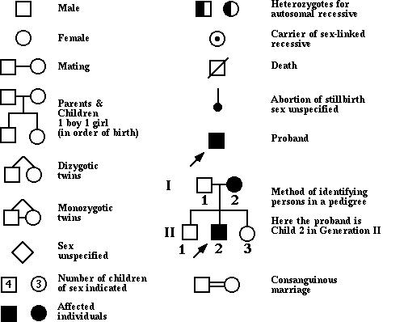
An example of a pedigree key:

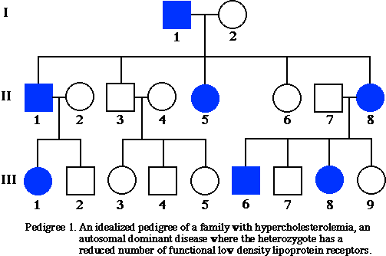
Pedigree Example I:

(Family with a dominant autosomal genetic trait)

The gene for this particular genetic trait does not occur on the sex chromosomes; it occurs on an autosomal chromosome because both males and females have the trait. This information can be inferred from two facts:
- Because the father has the trait, if the trait were sex-linked (on the father’s X chromosome), then all females would have the trait. However, because some females do not have the trait, it is not a sex-linked trait.
- Individual III-7 who is a male did not inherit the trait from his mother, who has the trait. He received his only X chromosome from his mother.
- This particular gene is a dominant gene because
  - each of the people who have the trait has only one parent who has the trait.
  - if only one parent has the trait and the trait is not sex-linked, then the individuals who have the trait must be heterozygous for the gene.
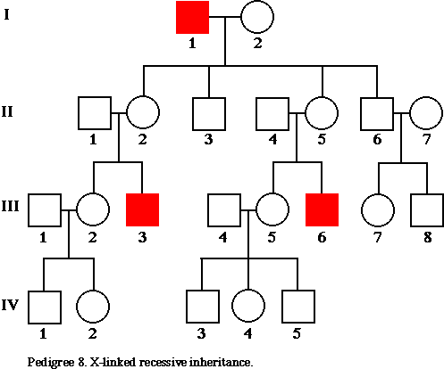
Pedigree Example II
(Family with a recessive sex-linked genetic trait)

The gene for this particular trait is sex-linked and recessive.

This information can be inferred because only males have the trait.
- This is common in X-linked, recessive traits because females who receive the gene for the trait on the X chromosome from their fathers also receive an X chromosome from their mothers which hides the expression of the trait.
- The trait skips a generation.
  - In generation II, all of the offspring receive an X chromosome from their mother.
    - Because the males only receive the X chromosome from their mother, they do not receive the gene carrying the trait.
    - Because the females receive an X chromosome from their mother and father, they are heterozygous and do not express the recessive trait, but they are carriers.
9
  - In generation III, the offspring of all of the females from generation II have a 50/50 chance of passing a trait-carrying gene to their children.
    - If the males receive the trait-carrying gene, they will express the trait.
    - If the females receive the trait-carrying gene, they will again be carriers.

Compare the consequences of mutations in body cells with those in gametes.

A mutation is the alteration of an organism’s DNA. Mutations can range from a change in one base pair to the insertion or deletion of large segments of DNA. Mutations can result from a malfunction during the process of meiosis or from exposure to a physical or a chemical agent, a mutagen.

Most mutations are automatically repaired by the organism’s enzymes and therefore have no effect. However, when the mutation is not repaired, the resulting altered chromosome or gene structure is then passed to all subsequent daughter cells of the mutant cell, which may have adverse or beneficial effects on the cell, the organism, and future generations.
- If the mutant cell is a body cell (somatic cell), the daughter cells can be affected by the altered DNA, but the mutation will not be passed to the offspring of the organism.
  - Body cell mutations can contribute to the aging process or the development of many types of cancer.
- If the mutant cell is a gamete (sex cell), the altered DNA will be transmitted to the embryo and may be passed to subsequent generations. Gamete cell mutations can result in genetic disorders.
  - If the mutation affects a single gene, it is known as a gene mutation.
    - For example, the genetic basis of sickle-cell disease is the mutation of a single base pair in the gene that codes for one of the proteins of hemoglobin.
    - Other examples of genetic disorders are Tay-Sachs disease, Huntington’s disease, cystic fibrosis, or albinism.
  - If the mutation affects a group of genes or an entire chromosome, it is known as a chromosomal mutation.
    - Nondisjunction results in an abnormal number of chromosomes, usually occurring during meiosis.
      - Examples of abnormalities in humans due to nondisjunction of sex chromosomes are Klinefelter’s syndrome (male) and Turner’s syndrome (female).
      - Examples of abnormalities in humans due to nondisjunction of autosomal chromosomes include Down syndrome.

In some cases mutations are beneficial to organisms. Beneficial mutations are changes that may be useful to organisms in different or changing environments. These mutations result in phenotypes that are favored by natural selection and increase in a population.

Exemplify ways that introduce new genetic characteristics into an organism or a population by applying the principles of modern genetics.

The knowledge of genes and chromosomes enables the manipulation of the genotypes and phenotypes of organisms rather than allowing them to be left to natural processes.

Genetic Engineering
Genetic engineering is the process of replacing specific genes in an organism in order to ensure that the organism expresses a desired trait. Genetic engineering is accomplished by taking specific genes from one organism and placing them into another organism.
- Genetic engineering can only occur when scientists know exactly where particular genes for particular traits occur on specific chromosomes.
  - A gene map shows the relative location of each known gene on a chromosome.
  - Genome refers to all the genetic material in an organism. The Human Genome Project that mapped the DNA sequence of human genes is useful in identifying genes for specific traits.
- In cloning, an identical copy of a gene or an entire organism is produced. This may occur naturally or may be engineered. Cloning brings benefits such as organ transplants or saving endangered species, but it may also result in an organism with genetic disorders or health problems.
- In gene therapy, scientists insert a normal gene into an absent or abnormal gene. Once inserted the normal gene begins to produce the correct protein or enzyme, eliminating the cause of the disorder. However, gene therapy has had limited success because the host often rejects the injected genetic material.
- Stem cells are undifferentiated cells that have the potential to become specialized in structure or function. Although primarily found in embryos, they are also found all over the adult human body (for example bone marrow) but may be harder to isolate. Therapy using stem cells can replace tissue that is deficient due to disease or damage.
- Results of genetic engineering may include:
  - The development of plants that manufacture natural insecticides, are higher in protein, or spoil more slowly.
10

  - The development of animals that are bigger, are faster growing, or are resistant to disease.
  - The development of bacteria that produce hormones such as human insulin or human growth hormone.
  - In humans, it is theoretically possible to transplant copies of normal genes into the cells of people suffering from genetically carried diseases such a Tay-Sachs disease, cystic fibrosis, and sickle-cell anemia.

Selective Breeding
Selective breeding is the method of artificially selecting and breeding only organisms with a desired trait to produce the next generation. Almost all domesticated animals and most crop plants are the result of selective breeding.
- The process works because in order for the parents to show strong expression for the trait, they must carry at least one gene for the trait.
  - Once the breeder has successfully produced offspring with the desired set of characteristics, inbreeding (crossing individuals who are closely related) continues.
  - Over several generations, the gene for the trait will become more and more prevalent in the offspring.
  - The drawback to this method is that recessive gene defects often show up more frequently after several generations of inbreeding.
- Hybridization, which is another form of selective breeding, is the choosing and breeding organisms that show strong expression for two different traits in order to produce offspring that express both traits. This occurs often between two different (but similar) species. The offspring are often hardier than either of the parents.

RFM 9/10

