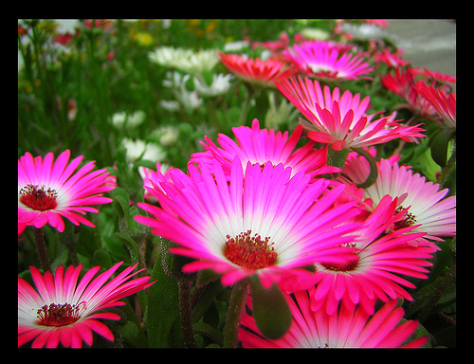
TROYER TALK
April 5, 2012
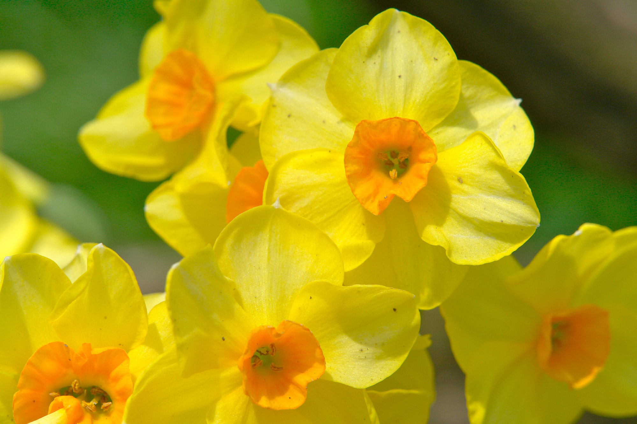

Religion-
This week, we finished our unit on the New Testament. We covered several stories, miracles, and life events of Jesus from his birth through his resurrection. The student Bibles turned out very nicely. We hope you enjoy them! We made stained glass crosses and watercolor Easter eggs. After spring break, we will start talking about the sacrament of Baptism and our church officials. Please begin talking to your child about his/her baptism and about Saint Bridget Church, the priests, our Bishop, and our Pope. We would like for every student to bring in a picture from his/her baptism and one with his/her godparents if at all possible. Please make sure that the pictures are able to be cut and glued onto posters that we will be making. We don’t want to use your originals!
Writing/Language Arts-
This week, we have been reviewing the alphabet, and we have been working with the digraphs sh, ch, th, and wh, beginning and ending sounds, and sight word identification. The students have been writing sticker stories as well as responding to journal topics relevant to religion, math, and science. During language arts stations, we have worked at the listening center, made CVC words and pictures, sorted digraph pictures, and completed “Write the Room” activities for the beginning vowel sounds a, e, i, o, and u. After spring break, we will be focusing on middle short vowel sounds, spelling CVC words, digraphs sh, ch, th, and wh, sight word identification, and story writing. We will also begin talking about consonant blends. We will be focusing on correct letter formation. Please review and practice handwriting with your child at home. Make sure to refer to the Zaner Bloser writing method when working with your child. It is very important that the children learn how to write their letters from the top down instead of bottom up.
Reading-
This week, we read The Thing That Went Thump! We also read The Tale of Peter Rabbit. We have been discussing the beginning, middle, and end of stories. We will be starting to discuss the different characters, setting, problem, and solutions in stories that we listen to and read as a group. We encourage our students to continue to read each night with an adult for 15 to 20 minutes and to review his/her sight words on a regular basis. We do not have new sight words this week. After spring break, our new words for the week of April 16th-20th are this, then, & where. Please begin to help your child begin to learn how to spell his/her sight words that he/she can successfully read. When you read with your child at night, please encourage him/her to point out and read sight words, attempt to sound out CVC words (i.e. cat, dog, hug), and answer comprehension questions about the story (characters, setting, main idea, etc.). Please work on identifying the cover of the book, the title, the author, and the illustrator as well. Please help your child remember to return his/her reading log at the end of each month. Thank you!
Math-
This week, we finished our unit on measurement. We primarily focused on using an inch ruler for standard measurement. We discussed why measurement is important in our daily lives. We learned about non-standard and standard units of measurement. We worked with estimation, volume, weight, and capacity of containers. Next week, we will begin our unit on number sense and addition. In this unit, we will learn about different ways to add numbers to 10, use pictures to create addition stories, use stickers and concrete items to practice adding, and use dice to roll, count, and add numbers to determine sums.
Science & Social Studies-
We started our new unit on the sun, the moon, the stars, and the Earth. We will be discussing why they are important and talking about their characteristics. The students will be making different mobiles for the sun, the stars, and the moon. The students have already created globes for the Earth in social studies. In social studies, we will conclude our unit on community helpers and how they help us in our lives.
Star of the Week: Riley W.
Favorite Colors: pink, purple, & blue
Favorite Book: The Library
Favorite Activity: painting
Favorite Food: pizza
Favorite Place to Visit: Mimi’s house
My Talents: running & jumping
I am special because: My family loves me.
When I grow up, I want to be a: nurse.
My Birthday is: Jan. 12th
Important Dates To Remember:
- April 6th-16th -Spring Break/No School
- April 20th- Ecology Spirit Day (“Earth Day” colors) ($1.00)
- April 24th- Kindergarten Mothers’ Visit @ 8:00 a.m.
- April 27th- Progress Reports
- April 28th- Bull Dog Blast @ 9:00 a.m.
Supply Needs and Requests
KB is in need of Clorox wipes, extra glue sticks, stickers, and individual pencil sharpeners. In order to finish out the school year, it is a good idea for the “Easter Bunny” to bring your child a new box of crayons, a new box of markers, extra glue sticks, and stickers to share with the class. The Clorox wipes could be the “Easter Bunny’s” gift to us! As always your generosity is awesome, and we greatly appreciate any “gifts” of supplies that may come our way after spring break.
Important Information for Report Cards
Report cards were sent home via email on March 23, 2012. In addition, your child’s report card insert and assessment packet came home in his/her folder. The report card insert is for your records. Please keep the insert info. at home to refer to when working with your child. The assessment packet must be signed and returned to school. Progress reports will be coming out shortly after we return from spring break. Therefore, we would love to have all assessment packets back prior to progress report week. Thank you!
HAPPY EASTER!
Have a great and relaxing spring break.
We will see you all back on April 17th.
Star of the Week: Kendyl W.
Favorite Colors: purple & blue
Favorite Book: Love Ruby Valentines
Favorite Activities: playing soccer & drawing
Favorite Food: brownies
Favorite Places to Visit: Disney World & Bush Gardens
My Talent: hula hoop
I am special because: My family loves me.
When I grow up, I want to be a: singer.
My Birthday is: Oct. 11th

