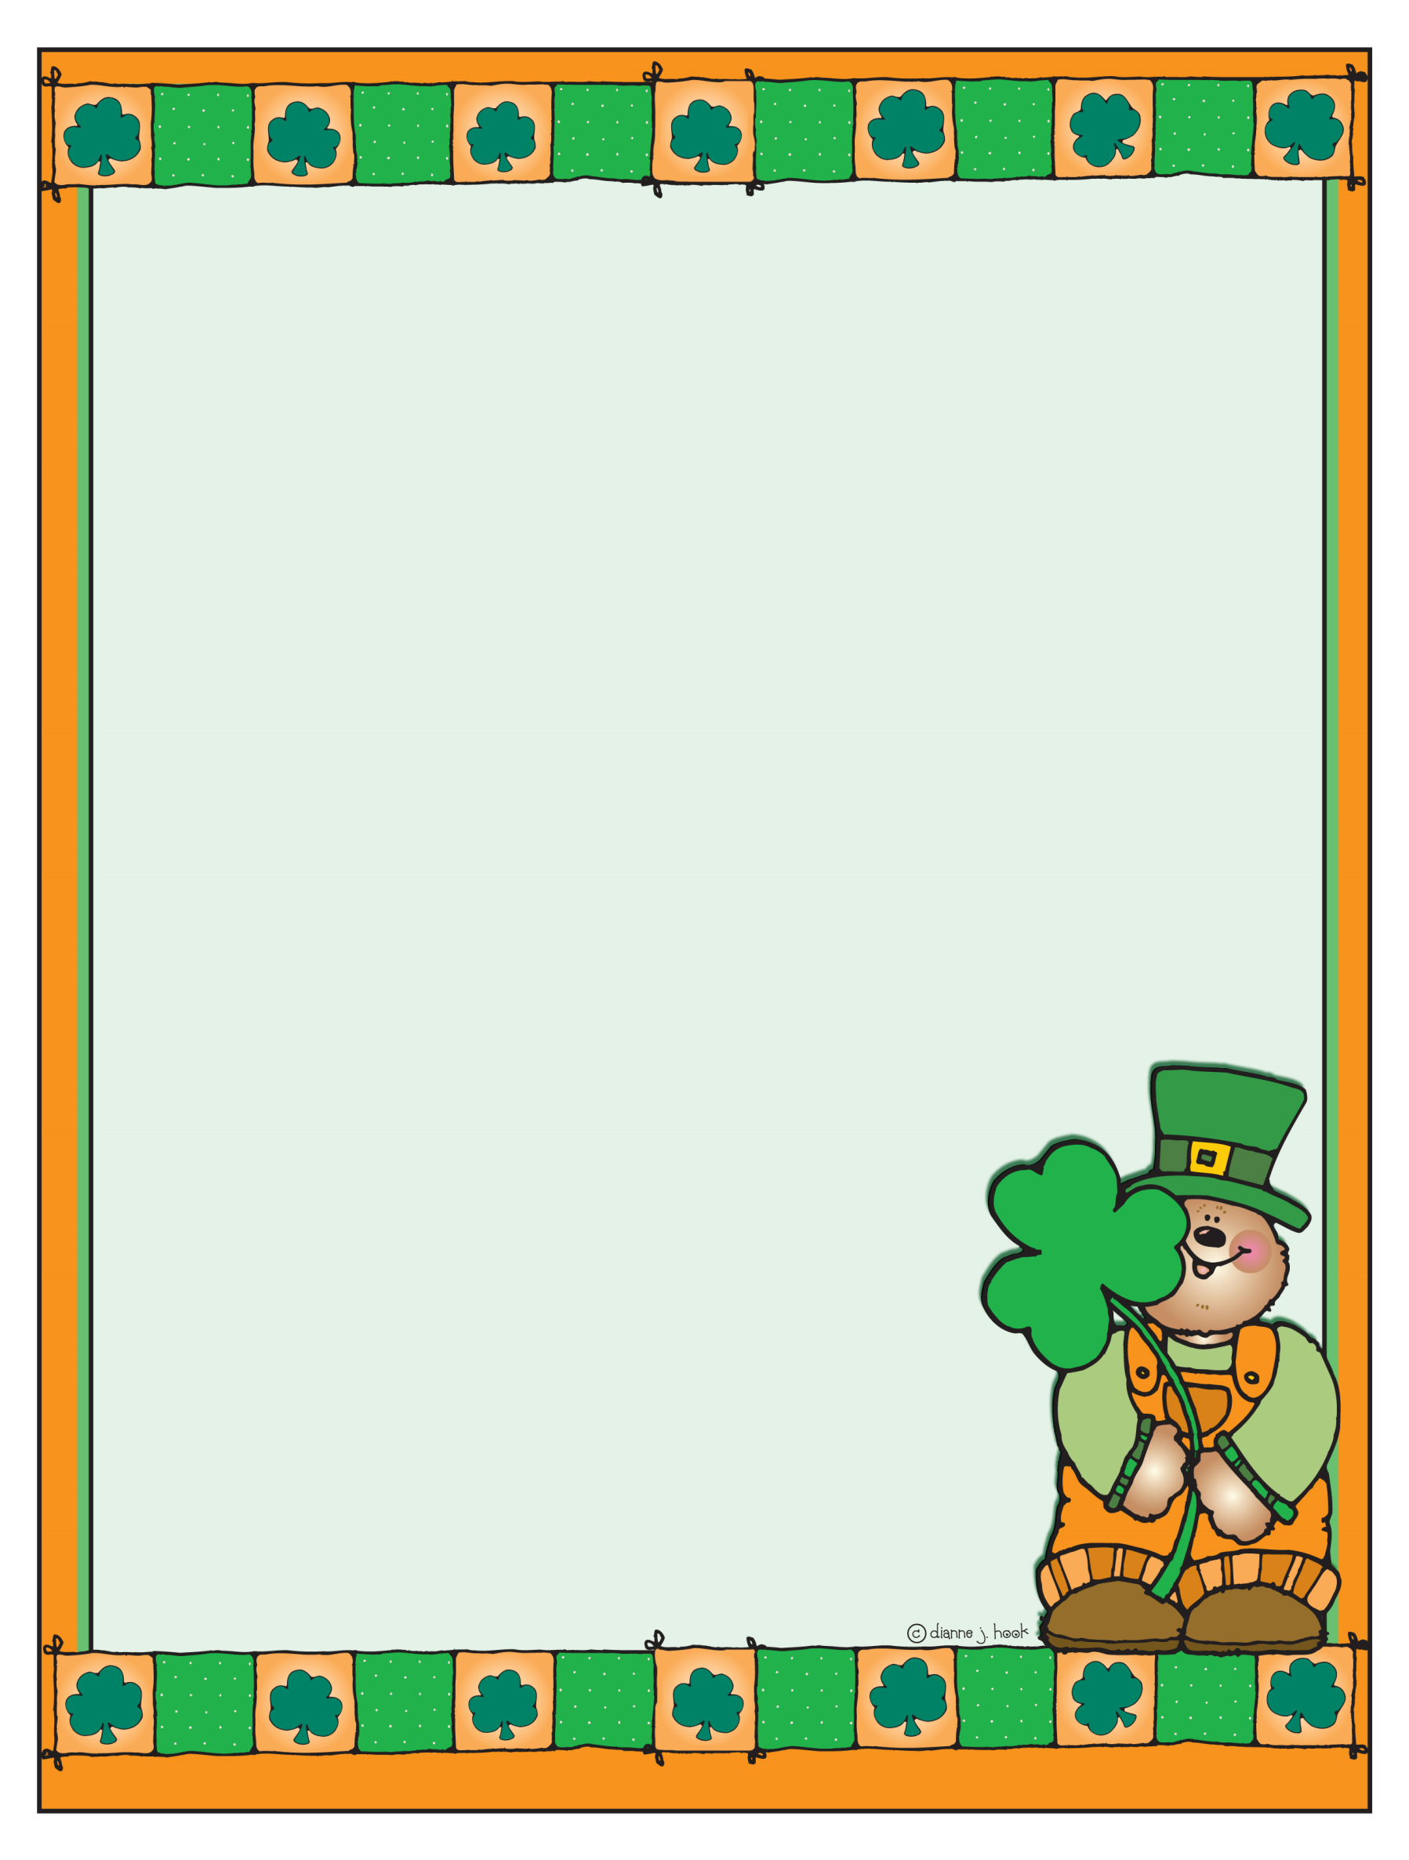
KB Requests for Supplies

We are currently in need of stickers. The children love completing the sticker story station, and we are quickly running out of stickers. We request that each child bring in one or two packs of stickers to share with the class. Please keep in mind that the children write stories using the pictures on the stickers, so be creative in your sticker selections.

We are also out of large glue sticks. Please send in two large glue sticks with your child to keep in his/her cubby when he/she runs out. Extras are ALWAYS welcomed and appreciated. We appreciate your generosity, and we thank you in advance for your donations.

Please check with your child to see if he/she needs new crayons, markers, or a glue bottle. If so, please send them in as soon as possible.

Our pencil sharpener is currently not working. Please send in a handheld pencil sharpener with a case to collect the pencil shavings. The children are currently borrowing classroom sharpeners. Thank you!

Upcoming Events & Reminders:
*Report cards will be sent home via email on March 23, 2012. You will also receive a third nine weeks report card assessment packet as well as a report card insert. Please keep the report card insert for your records. Please review the assessment packet, make copies if you wish, and return it to school no later than March 30, 2012. All the information in the packet must be returned. Thank you!

*On April 4, 2012, we will be having our kindergarten Easter egg hunt. KB is scheduled for 10:00 a.m. In order to prepare for the hunt, we will make bags in the classroom for your child to collect his/her eggs. Please send in two dozen filled Easter eggs by March 30th. You can fill the eggs with wrapped candy, coins, stickers, tattoos, small party favors, etc. Please avoid all candy that contains peanut butter. Also, please tape the eggs shut so that they do not come open before the hunt. Thank you!

Important Dates:
March 23rd- Report Cards
March 26th- Stations of the Cross III @ 2:00 p.m. (Church)
April 2nd- Class Group Picture Day (REGULAR UNIFORMS PLEASE…NO P.E. UNIFORMS!)
April 4th- Kindergarten Easter Egg Hunt (KB @ 10:00 a.m.)
April 5th- Holy Thursday Prayer Service @ 11:00 a.m./Noon Dismissal/No Afterschool
April 6th-April 13th- Spring Break (No School)
April 16th- Classes Resume

