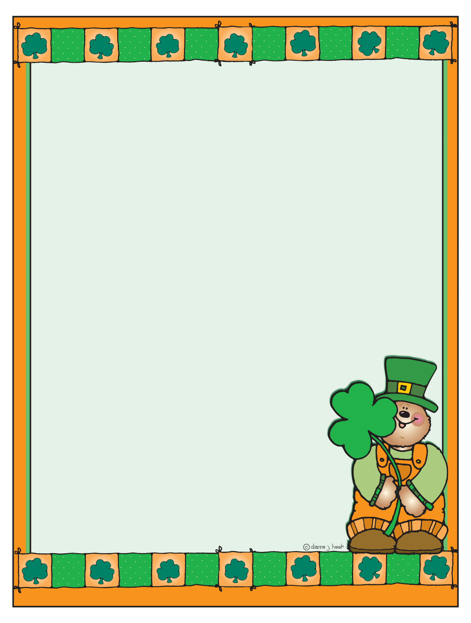
Upcoming Events & Reminders:
*Monthly envelopes were sent home on Friday, March 2, 2012. Please review all of the materials, sign the comment sheet, and return ALL of the materials on Monday, March 5, 2012. Please email me if you have any questions or concerns about your child’s monthly work. As always, I welcome your comments, and I am here to work with all of you.

*On Friday, March 2nd a packet for Grandparents’ Mass was sent home. The packet contains a note to explain Grandparents’ Mass and your child’s assignment to make invitations and grandparent faces for the hallway display. Please adhere to the dates indicated on the information pages. Please make sure to have your child make all of his or her grandparent faces even if they are unable to attend the mass. If your child’s grandparents are deceased or unable to attend, please encourage your child to make face for important adults in his or her life. Also, please try to make arrangements for these special adults to attend the mass on Friday, March 16, 2012.
KB Requests
*Continue to practice sight words with your child on a nightly basis. An updated list was sent home on Wed., Feb. 29th. If you find that your child is mastering the list very easily, begin to help him/her learn how to spell them. If you find that your child is having a difficult time, review only a handful of words each night to make sure that you do not overwhelm your child. Always remember to start with words that your child knows to build self-confidence.

*Continue to focus on proper letter and number formation using the Zaner Bloser handwriting method. We work very hard in kindergarten to teach it, and it is helpful for you to reinforce our efforts at home. It is very important that your child be forming the letters and numbers correctly because it is a skill that continues throughout elementary school. If you need another reference guide, please let me know, and I will get one to you very soon!

*Please return your child’s February reading log if you haven’t done so already. Also, please return your child’s progress report packet along with your child’s third nine weeks signed progress report. It is almost time for report cards. I would like to have everything back before I send home new assessments. Thank you!

Important Dates:
March 13th- Stations of the Cross II @ 2:00 p.m.
March 15th- Green & White Spirit Day ($1.00)/Reading, Writing, & Listening @ 1:45 p.m.
March 16th- Grandparents’ Mass (K-1)/Noon Dismissal

