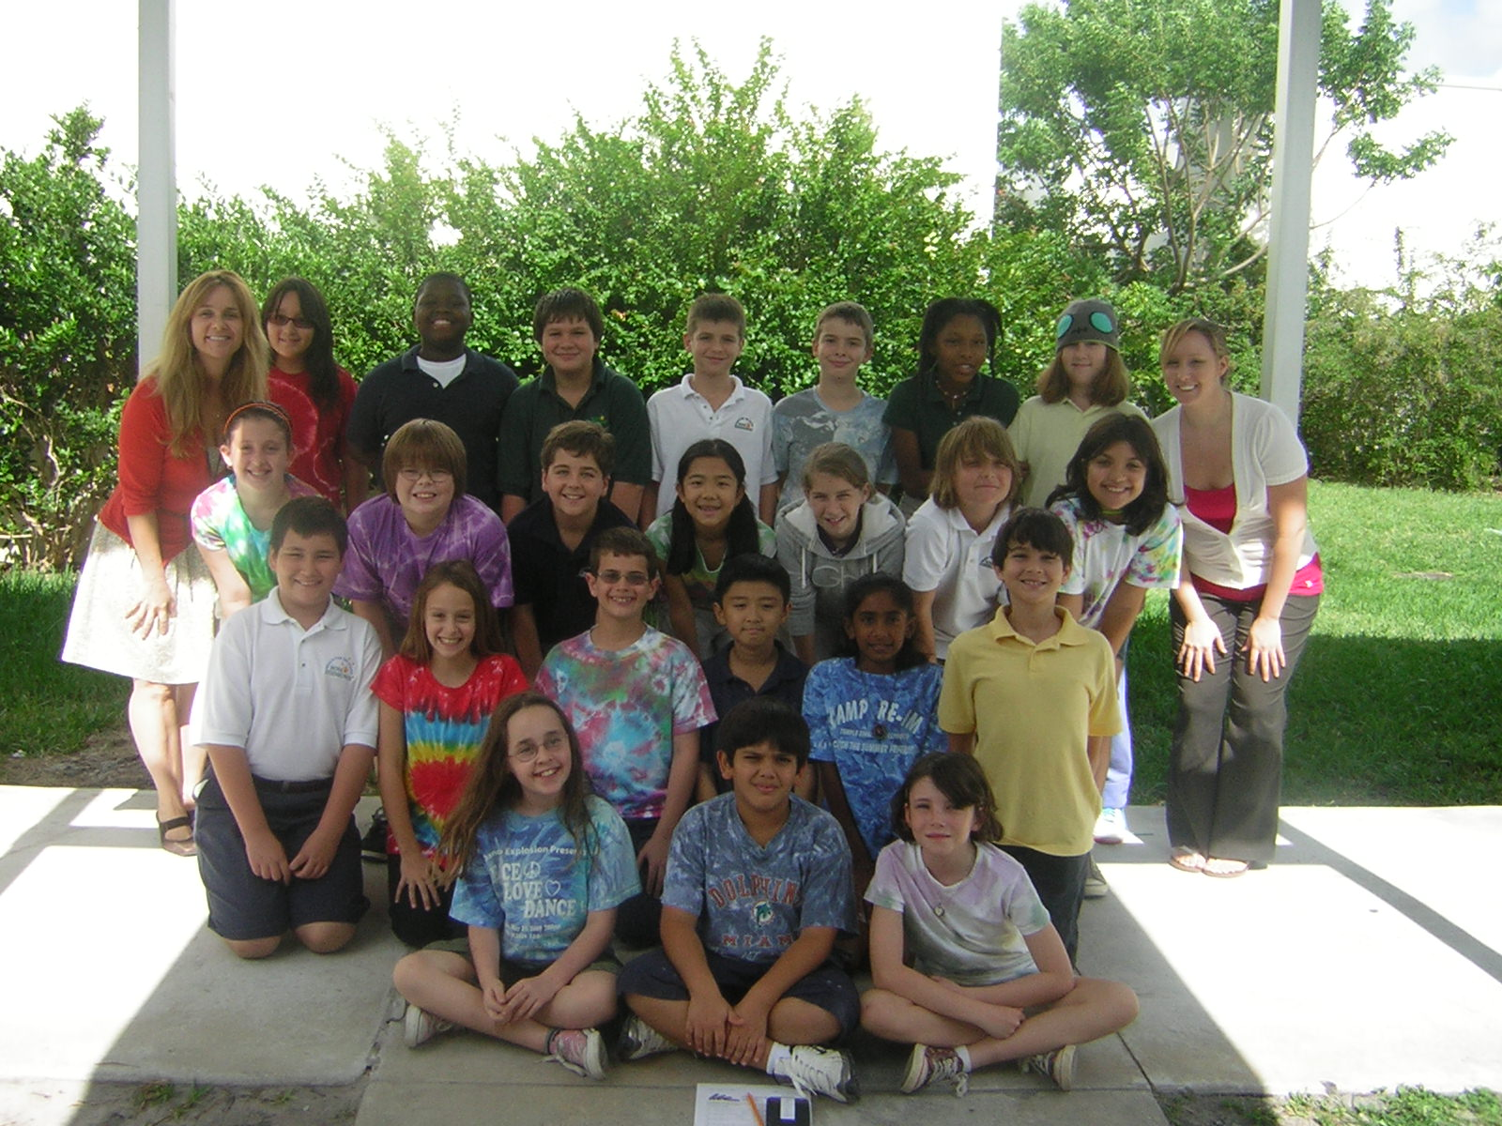
Submission Essay to Oriental Trading

Yippy ki aye, its time for the carnival today! Hello Oriental Trading Company! Our annual carnival is coming soon and our theme this year is international awareness to encourage tolerance and understanding of customs, beliefs, and opinions of different cultures. It is the International Olympics Carnival. Everyone always has a great time at our carnivals, and this year will be no different, except for the possibility of it being the best carnival to date with your generous gift card. Preparing for this spectacular event is hard work and comes with a huge price tag. Our international theme will also help us learn more about geography through our weekly game of “Where in the World is This Teacher.” Each week, a teacher gives us clues about where he/she went on their vacation. Each class gets to submit their answers for a prize certificate at the end of each week. We can make this year’s carnival event and our school wide game even more successful with your help.
As I browse through your catalogue I envision a carnival with sombreros, Asian straw hats, Flamenco pom pom hats, and your beautiful Mandarin hats. Flags of all nations are waving in the breeze while children bounce around inflatable globes. Our carnival can have booths with games pertaining to the international cultures of countries. Teachers could assign students different countries to research. The students could then use poster boards to decorate and use for our different booths. With the gift card, we would have the ability to create beautiful posters accessorized from top to bottom. Booths would be fully supplied with games that we can make. We could use materials to create “passports” to each country’s booth and get it stamped when children visit and complete different projects. Projects that are made possible because of the supplies we purchase from Oriental Trading. Some game ideas include Mancala from Africa that could be made with colorful beads and egg cartons. Cuarenta is a card game originating from Ecuador that we could make. We could have a country trivia game about Mexico and right answers could win a swing at the Piñata. We could have musical chairs using music from other countries. There can be a DJ and we could have Hawaiian dance contests. We need many volunteers for this big event. What better way than to advertise with flyers. And what would an International Olympics Carnival be without fun prizes and spectacular snacks from Oriental Trading. Our carnival needs to have fantastic prizes and be very decorative. Who wants a dull, boring carnival? No one! There are endless possibilities to decorate, play and learn. Oriental Trading carries all the necessities for the most fantastic carnival ever. At the carnival, my friends at school and I will be enjoying ourselves so much, that we won’t even realize we are learning. A great carnival means happier students, which promotes a better learning environment, and that means everything to our school.
If Nova Eisenhower receives the $5000 dollar gift card, it would help make our carnival more popular and exciting so that more people will come, have fun and spend money. This would benefit our school and help make all of us better students. Money earned from the carnival could be used to buy necessities for our school. We could use the money to buy class supplies for people who cannot afford them. We could buy colored ink for our computers in the computer lab. We could purchase more equipment for our physical education specials, ensuring that we exercise and stay healthy. Our librarian was cut because there was not enough money to keep our school librarian. She would show us where the best books were in the library and bought books that she knew the students would love to read. With the money earned from the carnival, we could buy more books for our library.
If the school had money left over from the gift card used for the carnival, we would use it very wisely. Our school has cafeteria parties every month for classes who have good behavior during lunchtime. We could purchase games and prizes for these cafeteria parties. We could purchase fun prizes like friendship bracelets, key chains, pencils, erasers, chocolate, mints, and lollipops. And don’t worry, I didn’t forget about all the educational items you sell. Especially those international goodies like flags, maps and globes. There is also a Math Superstars program at our school. When students complete and achieve success on these difficult math problems, they win prizes. Accelerated Reader is another program at our school. When students read and pass comprehension tests based on the book read, points are earned. Students who achieve classroom goals receive more prizes and attend parties. As you can tell, students are rewarded for their hard work and dedication to learning at Nova Eisenhower. After all, hard work should be rewarded, just like it is in real life.
Our school would be honored if we won the $5000 dollar gift card. Our International Olympic Carnival will be our major fundraiser for our school. Oriental Trading Company can help make this a tremendous success. Learning about different cultures shows us how we are all alike and how we are all different. We need to embrace our differences and learn from each other to make our world a better place, a more accepting and loving place to live. Every person that leaves our carnival will have learned something new. There will be more awareness, tolerance, respect and understanding of different countries, cultures and their customs. This is a major, educational event that will help our school raise money. These are all of the reasons why our school should benefit from this wonderful opportunity you have provided to us.

