What is Dating Violence?
Dating violence is a pattern of abusive behaviors used to exert power and control over a dating partner.
Types
- Physical Abuse: Any intentional use of physical force with the intent to cause fear or injury, like hitting, shoving, biting, strangling, kicking or using a weapon.
- Verbal or Emotional Abuse: Non-physical behaviors such as threats, insults, constant monitoring, humiliation, intimidation, isolation or stalking.
- Sexual Abuse: Any action that impacts a person’s ability to control their sexual activity or the circumstances in which sexual activity occurs, including rape, coercion or restricting access to birth control.
- Digital Abuse: Use of technologies and/or social media networking to intimidate, harass or threaten a current or ex-dating partner. This could include demanding passwords, checking cell phones, cyber bullying, sexting, excessive or threatening texts or stalking on Facebook or other social media.
Statistics
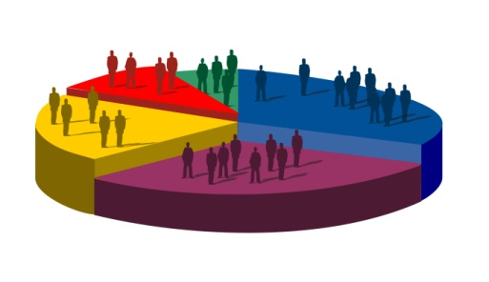
*1 in 3 teens and young adults experience some form of dating abuse
*One quarter of high school girls have been victims of physical or sexual abuse
*Violent behavior typically begins between the ages of 12 and 18
*¼ of high school girls have been victims of physical or sexual abuse.
*81% of parents believe teen dating violence is not an issue or admit they don’t
know if it’s an issue.

Dating Rights
I have the right to refuse a date without feeling guilty.
I have the right to say no to physical closeness.
I have the right to say, “I want to know you better before I become involved.”
I have the right to say, “I don’t want to be in this relationship any longer.”
I have the right to an equal relationship with everyone I date.
I have the right not to be abused physically, sexually or emotionally.

Healthy Relationship Wheel
