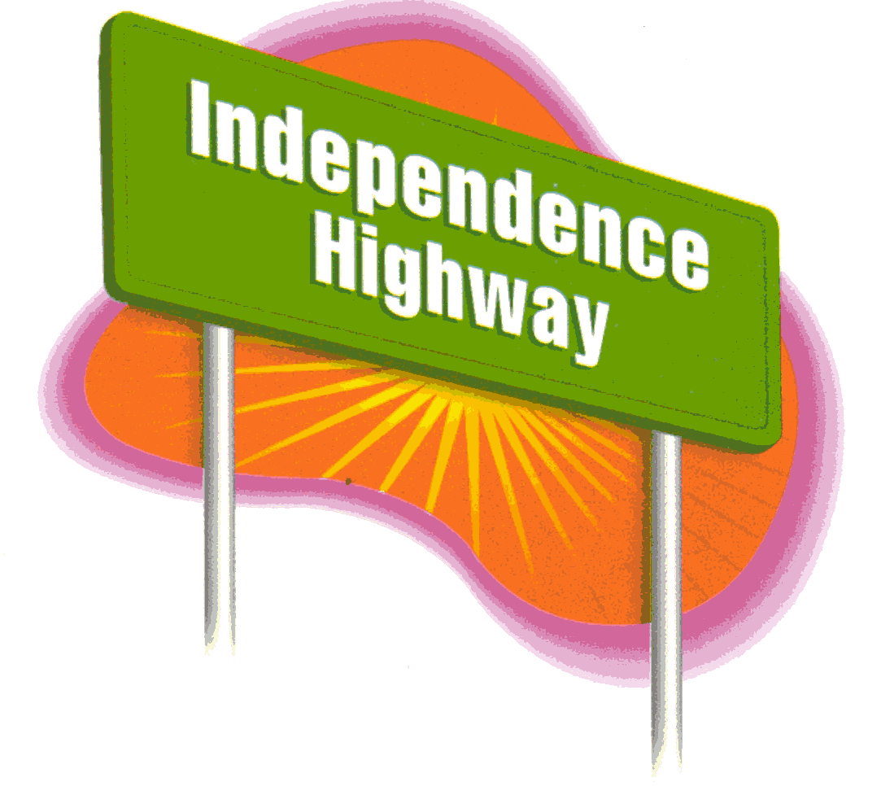®
Male____Female____Age_____School__________________Period____Presenter____________
Post Test (Confidential)
Please check the box either with Yes, Kind of, or No for each question.

- I can explain how STIs are passed.

No Kind of Yes

- I can explain the losses of becoming pregnant as an adolescent.

No Kind of Yes

- I can identify how media influences adolescents.

No Kind of Yes

- I can explain the negative impact alcohol and drugs have on adolescents.

No Kind of Yes

- I can come up with useable comeback lines to uncomfortable or dangerous situations.

No Kind of Yes

- I can explain the differences between love and infatuation.

No Kind of Yes

- I can recognize abusive behavior in a relationship.

No Kind of Yes

- It is possible to choose abstinence even if a person has been sexually active in the past.

Agree Disagree

- I think abstinence is the only 100% protection from STIs and pregnancy.

Agree Disagree

10. What are three things that you learned from this program?
1.
2.
3.

11. What should the presenter have talked about that she/he didn’t?

**Please provide feedback on the back of this sheet. We’d love to hear what you think about our program!**

