Pickleball

Paddles: paddles are made of plywood. The head of the paddle is 8” wide. Most paddles have a short cord attached to the butt of the handle for safety purposes and should be wrapped around your wrist during play.

Balls: plastic “whiffleball” type.

Courts: Official court is 20’ x 44’. Singles and doubles are played on the same size court.
(see diagram). The non-volley zone is 7’ officially. You will notice we modified that in class so we could use pre-existing lines on the floor.

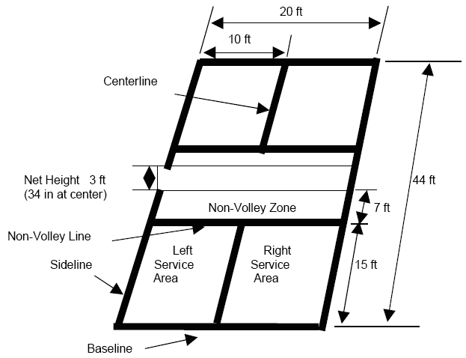

Vocabulary:
Ace- A serve the receiver can not get to and that scores a point for the server.
Backcourt- The area around the baseline.
Crosscourt shot- Hitting the ball over the net into the diagonal court.
Doubles- A game played between two teams of two.
Down the line- Ball that travels low over the net and parallel to the sideline.
Drive- A ball hit after the bounce so it will travel to the back of the opponents court.
Drop shot- A ball hit softly so that it just clears the net and lands very close to the net in the
non-volley zone.
Error: A point lost because of poor play…your mistake, not your opponent’s.
Face- Hitting surface of the paddle.
Foot Fault- When the server fails to keep one foot behind the line.
Forehand- A stroke played on the paddle side of the body.
Game- Completed when one side has won 11 points and is ahead by at least 2 points.
Let- Point that must be replayed.
Let Serve- A serve that hits the top of the net but otherwise is legal. Must be re-served.
Lob- A high arching shot that lands near the opponents’ baseline.
Non-volley zone- The area 7’ on either side of the net; players may not step into this zone and
play the ball until it has bounced; also may not step into on the follow through until the
ball is down. This area must also be cleared on the serve for the serve to be legal.
Odd court- The opposite court that you started in.
Smash- A hard, over hand stroke that is hit in a sharp downward angle.
Rally- Continuous play after a serve.
Serve- The underhand stroke use to put the ball in play at the beginning of each point. Must
be contacted below the waist with the paddle head down.
Singles- A game played between two players.
“Spin the paddle” done at the beginning of the game to determine who chooses: Serve,
receive or side of court. Winner gets choice, non-winner gets remaining choice. We
usually play ROCK PAPER SCISSORS in class.
Volley- A ball hit before it bounces.

Basic Rules:
Player must keep one foot behind the backline when serving. The serve must be underhand. The paddle must pass below the waist. The server must hit the ball in the air on the serve—they are not allowed to bounce it then hit it across the net. The serve must be diagonal and must clear the non-volley zone. Only the person in the diagonal court can receive the ball. Servers are only allowed one attempt at serving unless a legal “let” has been called.

NOTE: At the start of the game, the first serving team is allowed only one fault before giving up the serve to their opponent. After that, both member of each team will serve until two team faults have been committed before turning the ball over to the opponent.

RIGHT SIDE ALWAYS SERVES FIRST!

DOUBLE BOUNCE RULE: Each team must play their first shot off the bounce. That means the receiving team must let the serve bounce before returning it and the serving team must let the return bounce before hitting it back. After that, all balls can be volleyed or returned off the bounce. (watch out for the non-volley zone!)

ONLY THE SERVING TEAM CAN SCORE A POINT! Game is played to 11 points, must win by two. Server and partner switch courts after each point. Do not switch if serving team’s play results in a fault. A ball that lands on the line is GOOD.
COMMON FAULTS (mistakes):
􀂾 Hitting the ball out of bounds
􀂾 Serving to the wrong court
􀂾 Hitting ball before it bounces when you are in the non volley zone.
􀂾 Not following the “double bounce rule”.
􀂾 Wrong person returning the serve.
􀂾 Serve not clearing the non-volley zone.

If you have the opportunity to play singles, the same rules apply, however, each player serves from the RIGHT when score is EVEN and from the LEFT when score is ODD.

