Northwest CASA Services
- Advocacy- 24 hour Hotline- 888-802-8890, telephone crisis intervention and in- person advocacy at the hospital emergency rooms, police departments, and court proceedings.
- Counseling- Available to all sexual violence survivors, their families, and significant others.


STATISTICS
93% of people 18 years old or younger know their attacker.
17.7 million American women have been victims of attempted or completed rape.
2.78 million Men in the U.S. have been victims of sexual assault or rape.
There is an average of 207,754 victims (age 12 or older) of rape and sexual assault each year.
43% of rapes occur between 6:00pm and midnight.

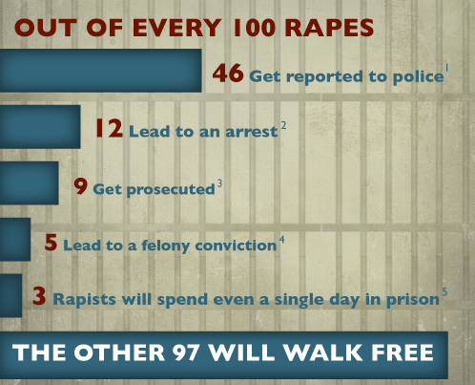

Myths / Facts
Myth: Women provoke sexual assault by their appearance. Sexual attractiveness is a primary reason why a rapist selects a victim.
Fact: Rapists do not select their victims by their appearance. They select victims who are vulnerable and accessible. Victims of sexual assault range in age groups from infants to the elderly. Sexual attractiveness is not an issue.
Myth: Women often lie about rape or falsely accuse someone of rape.
Fact: Statistical studies indicate false reports make up two percent or less of the reported cases of sexual assault. Only one out of 10 rapes are actually reported. Rapes by someone the victim knows are the least likely to be reported.
Myth: Sexual assault is a topic that only concerns women, and men do not have to be concerned about sexual assault.
Fact: Men, both straight and gay, suffered 10 percent of the sexual assaults reported in the United States last year. In addition, men have wives, friends, sisters, mothers and daughters who may someday need assistance in coping with sexual assault. Rape is a concern for everyone.

What is Consent??

Freely given agreement to the act of sexual penetration or sexual conduct in question. Lack of verbal or physical resistance or submission by the victim resulting from the use of force or threat of force by the accused shall not constitute consent. The manner of dress of the victim at the time of the offense shall not constitute consent. (IL Statute 720 ILCS 5/11-1.70)

Ways people may be saying “No”

"NO" means NO.

"Not Now" means NO.

"Maybe Later" means NO.

"I Have A Boy/Girlfriend" means NO.

"No Thanks" means NO.

"You're Not My Type" means NO.

"*#^+ Off!" means NO.

"I'd Rather Be Alone Right Now" means NO.

"Don't Touch Me" means NO.

"I Really Like You But ..." means NO.

"Let's Just Go To Sleep" means NO.

"I'm Not Sure" means NO.

"You've/I've Been Drinking" means NO.

SILENCE means NO.

"__________ " means NO.

If You or Someone You Know is Sexually Assaulted
- Do NOT shower or bathe Call a crisis hotline
- Go to the hospital/seek medical attention Talk with someone you trust
- Call the police

What to Say to a Survivor of Sexual Assault
  - I’m glad you’re alive You did the best you could
  - It’s not your fault I believe you
  - I’m sorry it happened

