​Pre-Teaching Assignment
SECTION 1: Team handball originated in Europe in the late 1920s. It was used mainly by three
different countries as an alternative to playing soccer, The Czech called it hazena, the Danish called it handbold, and the German called it Torball. The International Handball Federation (IHF) consists of 136 member nations and currently has about 12 million registered players. A men's handball competition was included on the Olympic calendar at the Munich Games in 1972 and there was a women's competition in the 1976 Games in Montreal. Handball is currently the secondly most popular sport in the world, behind soccer.

SECTION 2:
​Objective of the game: The objective of team handball is to score the most points by throwing the handball into the opponent’s goal. It involves a combination between throwing, dribbling, and running with possession of the ball. The teams are divided up evenly into two teams. Regulation rules are seven on each team. The winner is determined by the most goals scored against their opponent in the allotted time.

​How a winner is determined: The team with the most points at the end of two, 30 minute periods is the winner. Ties go to shoot outs.

​Rules:
- Players are divided up into even teams.
-One handball is used in a game of team handball.
-One team will start off with the ball at their goal line. -
-Passing, from hand to hand, dribbling and carrying the ball are all allowed.
-Contact with the ball to a foot, such as a kick, will result in the opposing team to
have automatic possession of the ball where the kick occurs.
-After receiving the ball, players can only hold the ball for three seconds before
passing, dribbling, or shooting.
-After receiving the ball, players can take up to three steps without dribbling. If
players dribble, they may take an additional three steps.
-Players that stop dribbling have three seconds to pass or shoot. They may take three additional steps during this time.
-A player is offered unlimited dribbles, but must only take three steps during this time.
-No players other than the defending goalkeeper are allowed within the goal line (within 6 meters of the goal). Goalkeepers are allowed outside this line. Therefore shots must be taken from outside the 6 meter semi-circle. A violation of this will result in a turn over to the other team.
-Goalkeepers are the only ones allowed to use their feet to kick the ball, only in defense of an opponent shooting at them.
-If the ball touches the floor during a pass, the ball immediately goes to the other team.
-The ball is in continuous play. ß After a team scores, the ball is given to the opposing team.

​Diagram of playing field with measurements: 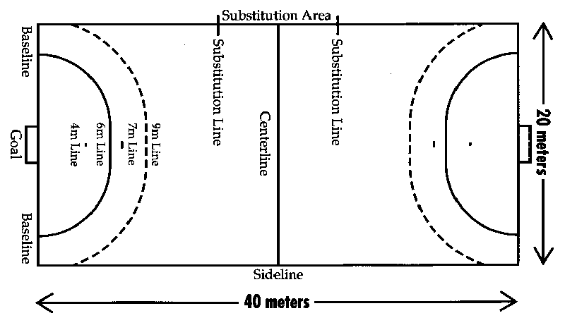
​Equipment needed:
Ball: The ball, with a leather casing, ranges in circumference from 58 to 60 centimeters for men and 54 to 56 for women. It weighs 425 to 475 grams for men, 325 to 400 for women.
Court: The court for handball is 40 meters long and 20 meters wide. A center line across it divides it into two equal courts, with a goal area at each end. The goal area is D-shaped, arcing from the corners to a straight line six meters in front of the goal. The arcing sides similarly create a six-meter distance from the nearest part of the goal at all points.
Goals: We will be using two soccer goals. The goals will be placed at opposite ends of the gym.
Pennies: The pennies will be given out to one team so that there is no confusion to who is on what team.
Cones: Cones will be used for drills, the specific number will be stated with the drill.

​Number of players on a team: There are seven players on each team (one goalkeeper and six field players). A maximum of 12 players may dress and participate in a game for each team. Substitutes may enter the game at any time through own substitution area as long as the player they are replacing has left the court. For our game, however, we will just divide the class in half evenly depending on how many we have that day.

​Guidelines for the Official -where he/she stands, moves & what he/she is responsible for:
-Team handball requires two officials (one is sometime allowed for special cases).
-The referees position themselves such that the team players are confined between
them. They stand diagonally aligned so that each can observe one side line. Depending on their positions one is called field referee and the other goal referee. These positions automatically switch on ball turnover. They physically exchange their positions approximately every 10 minutes (long exchange) and change sides every 5 minutes (short exchange).
-The IHF defines 18 hand signals for quick visual communication with players and officials. The signal for warning or disqualification can be accompanied by a yellow or red card. The referees also use whistle blows to indicate infractions or restart the play.
-The officials are accompanied by a timekeeper and a scorekeeper.

Section 3
Day 1:
Son and Charlie will take attendance while Yoon, Frank, and Ms. Wilson go set up the videos.
(A guide to passing in Handball, USA team Handball introductory Video, How to jump and shoot in handball, and Team handball intro)
Four short videos will be shown, to go over rules and throwing techniques.
Then we will go down to the gym and start the drills.
Drill 1: Passing
Physical Setup: This drill will be to teach the class how to pass the ball properly. The teachers will demonstrate all of the passing techniques to the class then allow time for the class to practice the throws in between. We will teach the students all of the types of throws: Over-head, hip, jump, side and bounce. We will also briefly go over how to recieve the ball when it is passed to you.
Organization: The class will be divided up into partners, they may choose thier own partners with some restrictions if necessary. They will line up facing each other on the basket ball court roughly ten to fifteen feet apart facing east and west.
Equipment needed: The equipment needed will be one handball per pair of students (roughly 10-12 balls). The balls will be passed out after the first demonstration by the teachers. Then throughout the drill we will have the students place the balls on the floor so that they dont have any distractions when the teachers are demonstrating the throws. Once the drill and the need for the balls is done we will have the students put their balls back into the equipment room.
Objective: The objective of this drill is to teach the class all of the throwing techniques so that they know how to use them in the game. Giving the students all of the skills they need will not limit the game to only one or two techniques that they students know. The students can now choose thier favorite pass and use that one, and they wont be throwing to other students who dont know how to recieve it. Also teaching them all the skills in one day saves time for more gameplay later on.

Day 2:
Yoon will Take attendance while Charlie, Frank and Son go set up the goals and cones for the relay and shooting drill.
Drill 2 Dribbling
Physical setup: The cones will be pre set up by Charlie, Frank and Son. The goals will be out of the way for the relay on opposite ends of the court. Cones will be lined up in five different rows, one for each team. Each person must dribble the ball in and out of the cones to reach their team mates on the other end of the cones. The ball must be dribbled contiunously and may not be touched by both hands, only one at a time. Once a student has finished the relay he/she must sit down so we can determine the winner.
Organization: The class will have been pre-divided into five groups by the teachers. Then we will asssign people to be on one end of the relay and other people to be on the other end of the drill, so that they can pass to each other continuoulsy once they are done with their part of the dribbling relay.
Equipment needed: Cones for the relay, which will have been already set up by Charlie, Frank and Son. One ball per group (5 balls). The balls will be distributed by the teachers once the students know what they are doing. Then once the drill is finished the teachers will collect the balls and cones then move on to the next drill.
Objective: The objective of this drill is to teach the students proper technique for dribbling the ball, so that they may use it effectivley in the game. This will also demonstrate another throw, the "Handoff" They will be handing the ball ot eachother at the end of the relay.
Drill 3: Defensive Positions
Physical setup: The teachers will divide the students into groups that have already been made to save time. Then the teachers will explain the field positions and the defensive positions of the game, go over a few more rules and then simulate a game scenario.
Organization: The students will be put into pre-determined groups set by the teachers. These will be the same groups as those that will be used in the actual games the next day.
Equipment needed: A goal, which will have been put out by Charlie, Frank and Son before the period starts. One handball and one set of pennies. The teachers will determine which team gets the pennies before the drill starts.
Objective: The objective of this drill is to simulate an actual in game scenario. This will give the students a feel for how they should set up the next day for thier games.
Drill 4: Goalie training and shooting
Physical setup: The goals will have already been set up by Charlie, Frank and Son before the period has started. Then the teachers will demonstrate the shooting techniques that the students will be using. Once the students have watched the demonstaration they will be divided into two groups and shoot on goals with a goalkeeper in the net. The teachers will be acting goalkeepers, one teacher will be in the net and the other will be critiquing the students on thier form. The students will be working on shooting standing still, dribble shot, then finally jump shot.
Organization: The students will be asked to choose partners then one othe then will gon to one side of the court and one on the other side. Then two leaders will be assigned to each group and they will stay with them, one being the keeper and the other critiquing the students. The two groups will be shooting on two different goals so they dont interfere with each other.
Equipment needed: This drill requires two goals, one for each group on either side of the gym. 4 handballs per groups in oder to move them as fast as possibly through the drill. Then we will need cones to mark up the distances for the lines that they cannot cross while they are shooting.
Objective: The objective of this drill is to teach the students how to shoot the ball into the net and hopefully score. They will also be able to see how a keeper works while he or she is in the net. This will give them a good idea of where to shoot the ball in the net (Upper corners, lower corners, left side, right side).

​DAY 3:
​How will teams be determined: The 2 teams will be chosen by the leaders before class according to gender and ability.
​How many playing areas are needed: 1 playing field will be needed. It will be set up according to the diagram show above.
​Equipment needed: 2 goals and 1 handball. Depending on the placement of the gym lines, we may need cones to establish boundaries. If that is needed then we will need to use cones to mark up the distances of the court.
​When is the game over: We will play the entire period until we have to stop so we have enough time to clean up and critique. The team with the most points at the end of the playing time will be the winner.
How many games will they play: 1 game will be played involving the entire class.

Section 4: Charlie, Frank, Yoon, and Son will be expected to work equally and demonstrate their knowledge of the game successfully. On a day to day basis everyone's role will be different, sometimes people will be demonstrating, other times they will be taking attendance and setting up for the period. Everyone is expected to critique the students and help them to understand the gist of the game. After our unit is finished, we expect the students to be capable of playing and understanding Team Handball well enough to teach it in the Leaders P.E. class next year.

