Team Handball Pre-Teaching Assignment
Section 1:
Team Handball originated in Europe in the late 1920s. At this time, it was most popular to the Czech, Danish, and German, and was usually a substitute to playing soccer. The International Handball Federation (IHF) currently consists of 136 member nations and 12 million registered players. This sport has been growing in popularity since its creation and has become the second most popular sport in the whole world, behind soccer.
Section 2:
Objective
- The objective of team handball is to score the most points by throwing the handball into the opponent’s goal.
- It involves a combination between throwing, dribbling, and running with possession of the ball.
- The teams are divided up evenly into two teams. (If not even use Ms.Wilson as a player or have a sub) Regulation rules are seven on each team.
- The winner is determined by the highest number of goals scored against their opponent in the allotted time.

Rules
- Players are divided up into even teams.
- One handball is used in a game of team handball.
- One team will start off with the ball at their goal line.
- Passing, from hand to hand, dribbling and carrying the ball are all allowed.
- Contact with the ball to a foot, such as a kick, will result in the opposing team to have automatic possession of the ball where the kick occurs.
- After receiving the ball, players can only hold the ball for three seconds before passing, dribbling, or shooting.
- After receiving the ball, players can take up to three steps without dribbling. If players dribble, they may take an additional three steps.
- Players that stop dribbling have three seconds to pass or shoot. They may take three additional steps during this time.
- A player is offered unlimited dribbles, but must only take three steps during this time.
- No players other than the defending goalkeeper are allowed within the goal line (within 6 meters of the goal). Goalkeepers are allowed outside this line. Therefore shots must be taken from outside the 6 meter semi-circle. A violation of this will result in a turn over to the other team.
- Goalkeepers are the only ones allowed to use their feet to kick the ball, only in defense of an opponent shooting at them.
- If the ball touches the floor during a pass, the ball immediately goes to the other team.
- The ball is in continuous play.
- After a team scores, the ball is given to the opposing team.

Diagram of Field Positions with Measurements
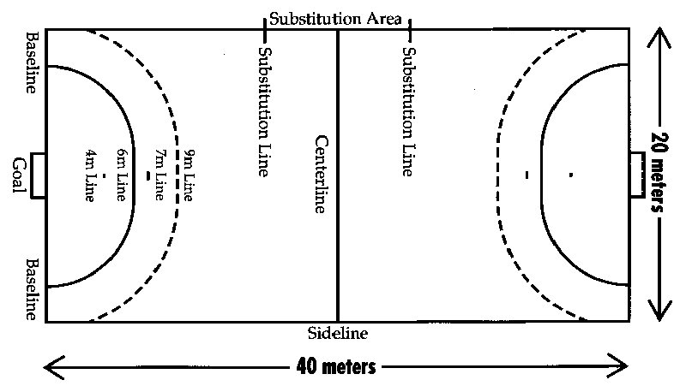
Equipment:
- A few handballs (preferably enough so that there is one handball for every two students), two goals, cones for drills, gym shoes, uniform, no jewelry

- The ball used has a leather casing, 58 to 60 centimeters in circumference for men and 54 to 56 for women. It weighs 425 to 475 grams for men, 325 to 400 for women.

- The court for handball is 40 meters in length and 20 meters width. A center line across
divides it into two equal courts, with a goal area at each end. The goal area is D-shaped,
arcing from the corners to a straight line six meters in front of the goal. The arced sides
create a six-meter distance from the nearest part of the goal at all points.

- We will be using two soccer goals. The goals will be placed at opposite ends of the gym.

- Pennies will be given out to one team so that there is no confusion to who is on what team.
- Projector, video, projector screen

Number of players on a team:
  - Two evenly divided teams. Each team has one goalie.
  - Substitutes may enter the game at any time through own substitution area as long as the player they are replacing has left the court.

Guidelines for the officials of the game
- Team handball requires two officials (one is allowed for special cases).
- The referees position themselves such that the team players are confined between them. They stand diagonally aligned so that each can observe one side line. Depending on their positions one is called field referee and the other goal referee. These positions automatically switch on ball turnover. They physically exchange their positions approximately every 10 minutes (long exchange) and change sides every 5 minutes (short exchange).
- The IHF defines 18 hand signals for quick visual communication with players and officials. The signal for warning or disqualification can be accompanied by a yellow or red card.. The referees also use whistle blows to indicate infractions or restart the play.
- The officials are accompanied by a timekeeper and a scorekeeper.

SECTION 3: The Lesson Plan (25 points total)
Day 1: Throwing and Catching
· Students will dress; Eliana will take attendance while Karina sets up for the videos.
· A short informational (from section 1) will be given to introduce Team Handball.
· A few short videos will be shown to introduce the sport.

· We will go down to the gym and start with a quick warm up consisting of butt kicks, high knees, skipping for height and skipping for speed.
Drill 1: Throwing and Catching Overhead pass
a.) Setup: No setup is necessary besides the equipment needed.
b.) Organization for drill: We will pass out the handballs after partners are selected and we have demonstrated the first pass. Students will practice passing the balls back and forth with their chosen partners using the demonstrated pass. Once the drill is over and we move onto the next form of passing, students will be asked to place the ball on the ground to grab their attention, save time, and to refrain from recollecting the balls every time. We will repeat this with overhead passes, jump passes, side passes. We will also show the proper technique for catching the ball with two hands, using soft arms to bring it into your body so the ball doesn’t just bounce off your hands.
c.) Equipment needed: One handball for each pair of students.
d.) Objective: The objective of this drill is to show the students how to pass the ball properly and learn different ways of passing to make the game more exciting.

Drill 2: Throwing and Catching Jump Pass

b.) Students will practice passing the balls back and forth with their chosen partners using the demonstrated Jump Pass. Once the drill is over and we move onto the next form of passing, students will be asked to place the ball on the ground to grab their attention, save time, and to refrain from recollecting the balls every time.
c.) Equipment needed: One handball for each pair of students.
d.) Objective: The objective of this drill is to show the students how to pass the ball properly and learn different ways of passing to make the game more exciting.

Drill 3: Throwing and Catching Side Pass
a.)Setup: No setup is necessary besides the equipment needed.
b.) Students will practice passing the balls back and forth with their chosen partners using the demonstrated Side Pass. Once the drill is over we will start clean up and have each set of partners turn in their handball.
c.) Equipment needed: One handball for each pair of students.
d.) Objective: The objective of this drill is to show the students how to pass the ball properly and learn different ways of passing to make the game more exciting.

Day 2: Dribbling (Shortened Period)
Equipment: 1 handballs, 4 cones, 1 goal
    - Karina will take attendance and Eliana will take a few students upstairs to set up the gym.
    - Class will be started with a warm-up of heel-toes, but kicks, karaoke and skipping.
    - We will review all of the different passes from the day before and then start our first drill.
Drill 1: Dribbling to Goal
(a) Physical setup for each drill: 2 parallel lines with 3 cones in each spaced down the court until the arc.
(b) Organization: Students will separate evenly into the two lines. One line will be given the ball. The first student with the ball will run down the court dribbling the ball taking the 3 dribble rule into consideration. While they are moving down the court the first student in the opposite line will run down with them. Once the student has dribbled 3 times they will pass to the student in the other line, who will proceed to shoot the ball into the goal.
( c) Equipment: 6 cones, 1 handball, 1 goal
(d) Objective: To teach students how to dribble while running up and down the court, to review passing, and start learning shooting.

- If extra time allows we will start a short mini game to help students put the new skills that we have learned.
- Critique and Stretch

Day 3: Game
Equipment needed: One playing area, two goals, two handballs, pinnies, and cones.
    - Eliana will take attendance while Karina takes two students up to the gym to set up.
    - Predetermined teams will be separated and one will be given pennies.
    - We will go over the rules as review and play rock paper scissors to decide who gets the ball first.
Team 1: Team 2:
Dominique Rachel
Ksenia Kevin
Conner Wolfe
Sam Kristen
Michelle Wilson

  - If a player is absent one of the leaders will step in and take their place or teams will be adjusted.
  - We will play one game of two evenly divided halves and two minutes of halftime.
  - The end of the game will be determined by the leaders whistle of when time runs out.
  - Instructions to help clean up will be given at the end of the game, each student must help with the goals.
  - The end of the game will be followed by Stretch and Critique.

Section 4:
Our role during these 3 days will be to teach our class how to play handball in a fun and safe way. By the end of our teaching, our students should know the basics of handball and how to correctly play. Our students will be able to confidently teach their own students next year and be able to understand everything they have learned.

