Ultimate Frisbee Study Guide
In 1968, Joel Silver introduced his idea of Ultimate Frisbee to the Columbia High School student council in Maplewood New Jersey, USA. The next year, the first game was played between two groups of students. They used a Wham-O Master disc. In 1969, a team had been formed at the school and they played in a parking lot. The only lines that existed were the goal lines, usually marked by the telephone poles or piles of the players' coats. The first and second set of rules were written in 1970 by Joel Silver, Buzzy Hellring and Jon Hines. On Nov 7th, CHS played the first interscholastic game. They won over Millburn High School by a score of 43 to 10.
Objective of the game: score points by passing the disc into the opposing end zone, similar to American football.
Rules
The Field -- A rectangular shape with endzones at each end. A regulation field is 70 yards by 40 yards, with endzones 25 yards deep.
- Initiate Play -- Each point begins with both teams lining up on the front of their respective endzone line. The defense throws ("pulls") the disc to the offense. A regulation game has seven players per team.
- Scoring -- Each time the offense completes a pass in the defense's endzone, the offense scores a point. Play is initiated after each score.
- Movement of the Disc -- The disc may be advanced in any direction by completing a pass to a teammate. Players may not run with the disc. The person with the disc ("thrower") has ten seconds to throw the disc. The defender guarding the thrower ("marker") counts out the stall count.
- Change of possession -- When a pass in not completed (e.g. out of bounds, drop, block, interception), the defense immediately takes possession of the disc and becomes the offense.
- Substitutions -- Players not in the game may replace players in the game after a score and during an injury timeout.
- Non-contact -- No physical contact is allowed between players. Picks and screens are also prohibited. A foul occurs when contact is made.
- Fouls -- When a player initiates contact on another player a foul occurs. When a foul disrupts possession, the play resumes as if the possession was retained. If the player committing the foul disagrees with the foul call, the play is redone.
- Self-Refereeing -- Players are responsible for their own foul and line calls. Players resolve their own disputes.
- Spirit of the Game -- Ultimate stresses sportsmanship and fair play. Competitive play is encouraged, but never at the expense of respect between players, adherence to the rules, and the basic joy of play.
Diagram of playing field with measurements (5 points)
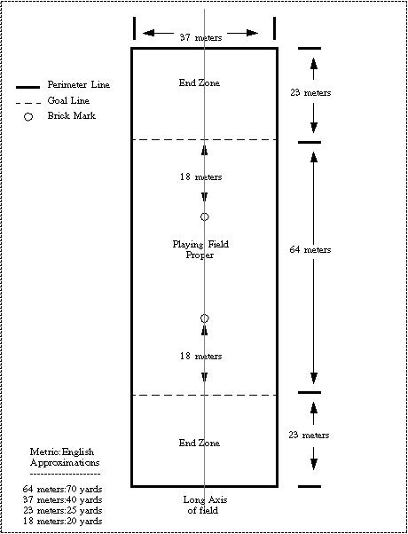

Number of players on a team: 7 (from each team) on the field at one time.

