Sam Hogan
Wolfe Riedel

PICKLE-BALL PRE-TEACHING ASSIGNMENT

SECTION 1:
History: The mini-tennis game called Pickle-ball was created during the summer of 1965 on Bainbridge Island - a short ferry ride from Seattle, WA. The original purpose of the game was to provide a sport for the entire family, according to co-inventors U.S. Congressman Joel Pritchard, William Bell, and Barney McCallum.

SECTION 2:
Objective of the game: The objective of the game is to score points by hitting the ball over the net in such a way that the other team is unable to legally return it.
How a winner is determined: The first team to score 11 points (and win by 2) is the winner.
The Rules
Serving:
- The serve must be hit underhand before it bounces and contacted below the waist.
- The server must start from the right hand court and alternate sides after each serve.
- The serve must go diagonal and land in the opponent’s correct service court (clearing the non-volley zone).
- A team keeps the serve by winning the point. One person serves until their team loses the serve. On their next service opportunity, players rotate.
- A ‘let’ occurs when a served ball hits the net but still lands in the correct box. (In the case of a let, the point is replayed).
- The server must keep one foot behind the baseline.
- If the serve hits the net and does not land in the correct box, is served out of bounds, is served into the wrong box, or is served illegally, the team loses the serve and the ball goes to the other team.

Game Play:
- Double Bounce Rule: Each team must play their first shot off a bounce. (The receiving team must let the served ball bounce before returning the ball to the serving team, and the serving team must let the ball bounce before returning the ball to the receiving team).
- After the first returned hit, the ball may be played on a bounce or on a fly (volley).
- The ball may not be hit before it bounces when it is in the non-volley zone or the player hitting it is in the non-volley zone. The player cannot enter the non-volley zone to volley the ball, nor in their follow-through.
- After the ball has bounced once and been played once on each side, both teams can either volley the ball in the air or play it off the bounce.
- Only one contact is allowed per side. The ball can only be contacted with the paddle.
- The serve switches teams when the receiving team wins the point. The player on the right hand court always starts play.
- All balls that hit the lines are considered in play.

Scoring:
- Only the serving team can get points.
- When the receiving team fails to legally return the ball, the serving team is awarded 1 point.
- The game is played to 11 points, but it must be won by 2 points.
- A match is won when a team wins 2 of 3 games.

Faults:
- Hitting the ball out of bounds
- Not clearing the net (on a serve this is a let and is replayed)
- Stepping into the non-volley zone and volleying the ball
- Failure to hit the ball after the ball bounces twice

Diagram of playing field with measurements:
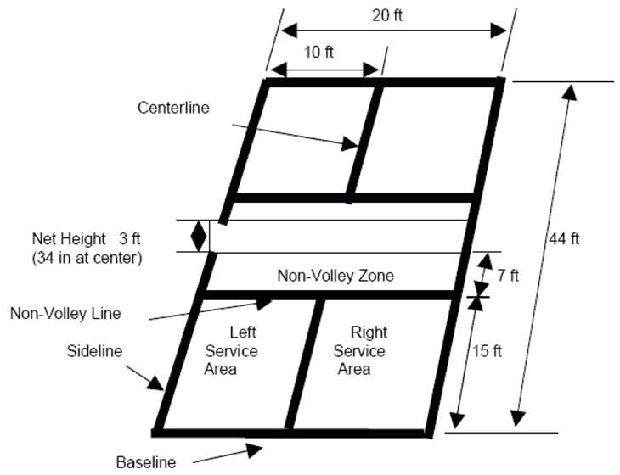
Equipment needed:
One paddle per player
One plastic whiffle ball per court
A net that is 36 inches high at each end, 34 inches high in the middle, and twenty feet long.
Number of players on a team: 1 person in a singles game and 2 people in a doubles game
Guidelines for the Official: where he/she stands, moves & what he/she is responsible for. Referee stands to the side of the net on the outside of the court the whole game. The ref is responsible for calling foot faults in the non-volley zone, service line faults, and keeping and calling the score.

SECTION 3: the lesson plan

Day 1:
Wolfe will take attendence while Sam goes upstairs into the gym and brings out the necessary equiptment (nets should already be set up). The class will begin with a warm up consisting of high knees, skipping, jogging, etc. Leaders will then introduce pickle-ball to the class. How it’s played along with general rules. Then proceed to drill one.

Drill 1:Forehand (with bounce, and without bounce)
Explain: First teach the correct way to hold the pickle ball racket. Then demonstrate how to do a forehand pass.
Right handed-Pivot forward (with left foot)
Pivot backward (with right foot)
Left handed-Pivot forward (with right foot)
Pivot backwards (with left foot)
Students legs should be shoulder-width apart (knees slightly bent) while facing the net with their paddle no higher than their belly button. To pass, bring paddle behind you (at a comfortable distance) shifting your weight onto your back foot, and then swing through hitting the pickleball perpendicular to the net (must be perpendicuar to the net off volley and off bounce). Paddle should not go above the waist.
Physical set up: Nets will be set up across the gym.
How the class will be organized for each drill: The class will be organized in pairs. One person from each group will line up on one side of the net and the rest of the students will line up on the opposite side facing their partner.
Equipment needed & dispersal: Nets will already be set up, and will not need to be taken down. Paddles and balls will be brought out, students will take paddles and pickleballs from cart, and will return them when finished with the drills.
Objective: To learn the proper mechanics of a forehand pass and how to perform one properly.
Drill 2:Backhand (with bounce, and without bounce)
Explain:
Right handed-Pivot forward (with right foot)
Pivot backward (with left foot)
Left handed-Pivot forward (with left foot)
Pivot backward (with right foot)
Specify that the front of the hand should be facing the net when doing a backhand pass. Students legs should be shoulder-width apart (knees slightly bent) while facing the net with their paddle no higher than their belly button. To pass, bring paddle behind you (at a comfortable distance) shifting your weight onto your back foot, and then swing through hitting the pickleball perpendicular to the net (must be perpendicuar to the net off volley and off bounce). Paddle should not go above the waist.
Physical set up: Nets will be set up across the gym.
How the class will be organized for each drill: The class will be organized in pairs. One person from each group will line up on one side of the net and the rest of the students will line up on the opposite side facing their partner.
Equipment needed & dispersal: Nets will already be set up, and will not need to be taken down. Paddles and balls will be brought out, students will take paddles and pickleballs from cart, and will return them when finished with the drills.
Objective: To learn the proper mechanics of a backhand pass and how to perform one properly.
Drill 3: Serving
Explain: Again students should be in an athletic position (as mentioned above) and will serve by tossing themselves the ball, using an underhand swing making contact with the ball below the waist. The server must start from the right hand court and alternate sides after each serve. The serve must go diagonal and land in the opponent’s correct service court (clearing the non-volley zone).
Physical set up: The physical set up will be the same as the two previous drills.
How the class will be organized for each drill: The class will be organized the same way as the two previous drills.
Equipment needed & dispersal: Equipment needed and dispersal/collection will be the same.
Objective: The objective will be to learn the basics of serving in pickleball. At the end of class students will help put the equipment away and the group will stretch and critique.

Day 2: Workout
1.)Sam will take attendance.
2.)Wolfe will start the group by doing warm-ups:
-jogging
-high knees
-butt kicks
-skipping
-karaoke
3.)After we will have them start doing squats with the med balls:
-15 squats
-15 stepping and lunging forward
-15 lunging side to side
-15 stepping backwards and lunging
4.) Take them over to the pulley weights
-10 each arm chest pull (arms to chest)
-10 right arm pulls (elbow to stomach and pull with wrist)
-10 left arm pulls (elbow to stomach and pull with wrist)
-10 over the head pulls
5.) Go over to jump ropes.
-30 sec. jumping normally
-30 sec jump on right foot
-30 sec jump on left foot
-30 sec criss cross jumping
-have a mini game see who can jump the most times in 45sec.
6.) Have them cool off with some stretches

Day 3:
Brief review from day 1 While Sam is taking attendance Wolfe will be setting up the paddles and pickle-balls. Sam will lead the class upstairs and they will do the same warm up as day one and after will review what the class learned the first day. The class will then learn two more drills and if there is time left they will play a mini game of pickle-ball.
Finish covering necessary skills EXPLAIN DOUBLE BOUNCE RULE. Each team must play their first shot off of the bounce. That is, the receiving team must let the serve bounce, and the serving team must let the return of serve bounce before playing it. After the two bounces have occurred, the ball can be volleyed or played off the bounce.
Drill 1: Smash Shot
Explain: First explain the non-volley zone (the seven feet of the net in which they cannot volley) then demonstrate a smash shot. Bring your racket behind your head with your elbow pointing slightly upward. Then snap your wrist when the ball reaches you and follow through down and to the side of your body.
Physical set up for each drill: The nets will be set up across the gym
How the class will be organized for each drill: The students will then find their partners and one partner will have a racket and one partner will have a pickle-ball. Their partner will throw them the ball and they will practice their smash shot and then they will rotate.
Equipment needed & dispersal: Equipment needed and dispersal/collection will be the same as day 1.
Objective of each drill: The objective will be to learn more techniques of pickleball, specifically the smash shot.
Drill 2: Lob Shot
Explain: Now demonstrate the lob shot. The objective of this shot is to hit the ball as far and deep as possible so the opposite team will have to move to the backline. The lob shot is then demonstrated like a smash shot with a snap of the wrist to make the ball go deep.
Physical set up for each drill: Same set up as the previous drill.
How the class will be organized for each drill: The students will get back in their pairs from before and begin this drill like the smash shot drill except using the lob shot, and the partner will then try to hit the ball back.
Equipment needed & dispersal: Equipment needed and dispersal/collection will be the same as day 1.
Objective of each drill: The objective will be to learn more techniques of pickleball, including the lob shot.

After the drills a mini game may (if there is enough time) begin.

Mini game: King of the court.
Wolfe & Sam will explain the game. We will use two courts that are set up. Everybody will have a paddle. There will be two games going on. Both courts will have a line of students on each side. The side by the glass door will be called the kings and they will serve first. They will serve to the other side and will play a game. If the kings win the volley they remain in their spots. If the opposing team beats them, they become the kings. The losing team steps off the court, goes to the back of the line, and is replaced with two new students. When the mini game is finished the equipment will then be away and the class will then stretch and critique.

Day 4: Workout
1.)Wolfe will take attendance
-Also have them do dynamic warm-up
2.) Sam & Wolfe will be leading yoga today
- ASK MS WILSON IF WE HAVE YOGA MATTS?
-if so everyone grabs a yoga matt and spreads out in the center of the workout room
3.)poses from http://www.yogajournal.com:
Pose 1: The Sukhasana
1. Cross your shins, widen your knees, and slip each foot beneath the opposite knee as you bend your knees and fold the legs in toward your torso.
2. Relax the feet so their outer edges rest comfortably on the floor and the inner arches settle just below the opposite shin. You'll know you have the basic leg fold of Sukhasana when you look down and see a triangle, its three sides formed by the two thighs and the crossed shins. Don't confuse this position with that of other classic seated postures in which the ankles are tucked in close to the sitting bones. In Sukhasana, there should be a comfortable gap between the feet and the pelvis.
3. As always, you should sit with your pelvis in a relatively neutral position. To find neutral, press your hands against the floor and lift your sitting bones slightly off the support. As you hang there for a few breaths, make your thigh bones heavy, then slowly lower your sit bones lightly back to the support. Try to balance your pubic bone and tail bone so they're equidistant from the floor.
4. Either stack your hands in your lap, palms up, or lay your hands on your knees, palms down. Lengthen your tail bone toward the floor, firm your shoulder blades against your back to you're your upper torso, but don't overarch your lower back and poke your lower front ribs forward.
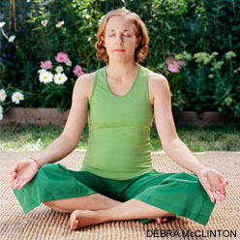
Pose 2: The Dolphin Pose
1. Come onto the floor on your hands and knees. Set your knees directly below your hips and your forearms on the floor with your shoulders directly above your wrists. Firmly press your palms together and your forearms into the floor.
2. Curl your toes under, then exhale and lift your knees away from the floor. At first keep the knees slightly bent and the heels lifted away from the floor. Lengthen your tailbone away from the back of your pelvis and press it lightly toward the pubis. Against this resistance, lift the sitting bones toward the ceiling, and from your inner ankles draw the inner legs up into the groins.
3. Continue to press the forearms actively into the floor. Firm your shoulder blades against your back, then widen them away from the spine and draw them toward the tailbone. Hold your head between the upper arms; don't let it hang or press heavily against the floor.
4. You can straighten your knees if you like, but if your upper back rounds it's best to keep them bent. Continue to lengthen your tailbone away from the pelvis and lift the top of your sternum away from the floor.
5. Stay between 30 seconds to one minute. Then release your knees to the floor with an exhale.
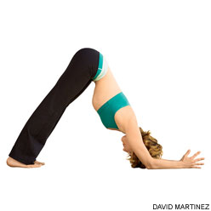
Pose 3: Extended Side Angle Pose
- On an exhalation, step or lightly jump your feet 3.5 to 4 feet apart. Raise your arms parallel to the floor and reach them actively out to the sides, shoulder blades wide, palms down. Turn your left foot in slightly to the right and your right foot out to the right 90 degrees. Align the right heel with the left heel. Firm your thighs and turn your right thigh outward, so that the center of the kneecap is in line with the center of the right ankle. Roll the left hip slightly forward, toward the right, but rotate your upper torso back to the left.
- Anchor the left (back) heel to the floor by lifting the inner left groin deep into the pelvis. Then exhale and bend your right knee over the right ankle, so that the shin is perpendicular to the floor. As you bend the knee aim the inner knee toward the little-toe side of the foot. If possible, bring the right thigh parallel to the floor.
- Firm your shoulder blades against the back ribs. Extend your left arm straight up toward the ceiling, then turn the left palm to face toward your head and with an inhalation reach the arm over the back of your left ear, palm facing the floor. Stretch from your left heel through your left fingertips, lengthening the entire left side of your body. Turn your head to look at the left arm. Release your right shoulder away from the ear. Try to create as much length along the right side of your torso as you do along the left.
- As you continue to ground your left heel to the floor, exhale and lay the right side of your torso down onto (or bring it as close as possible to) the top of the right thigh. Press your right fingertips (or palm) on the floor just outside of your right foot. Actively push the right knee back against the inner arm; counter this by burrowing your tail bone into the back of your pelvis, toward the pubis. The inside of your right thigh should be parallel with the long edge of your sticky mat.
- Stay for 30 seconds to 1 minute. Inhale to come up. Push both heels strongly into the floor and reach the left arm forcefully toward the ceiling to lighten the upward movement. Reverse the feet and repeat for the same length of time to the left. Then come up and return to Tadasana.

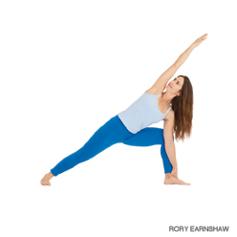
Pose 4: Extended Triangle Pose
- Stand in Tadasana. With an exhalation, step or lightly jump your feet 3 1/2 to 4 feet apart. Raise your arms parallel to the floor and reach them actively out to the sides, shoulder blades wide, palms down.
- Turn your left foot in slightly to the right and your right foot out to the right 90 degrees. Align the right heel with the left heel. Firm your thighs and turn your right thigh outward, so that the center of the right knee cap is in line with the center of the right ankle.
- Exhale and extend your torso to the right directly over the plane of the right leg, bending from the hip joint, not the waist. Anchor this movement by strengthening the left leg and pressing the outer heel firmly to the floor. Rotate the torso to the left, keeping the two sides equally long. Let the left hip come slightly forward and lengthen the tailbone toward the back heel.
- Rest your right hand on your shin, ankle, or the floor outside your right foot, whatever is possible without distorting the sides of the torso. Stretch your left arm toward the ceiling, in line with the tops of your shoulders. Keep your head in a neutral position or turn it to the left, eyes gazing softly at the left thumb.
- Stay in this pose for 30 seconds to 1 minute. Inhale to come up, strongly pressing the back heel into the floor and reaching the top arm toward the ceiling. Reverse the feet and repeat for the same length of time to the left.
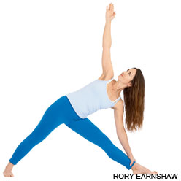
Pose 5: Child’s Pose
- Kneel on the floor. Touch your big toes together and sit on your heels, then separate your knees about as wide as your hips.
- Exhale and lay your torso down between your thighs. Broaden your sacrum across the back of your pelvis and narrow your hip points toward the navel, so that they nestle down onto the inner thighs. Lengthen your tailbone away from the back of the pelvis while you lift the base of your skull away from the back of your neck.
- Lay your hands on the floor alongside your torso, palms up, and release the fronts of your shoulders toward the floor. Feel how the weight of the front shoulders pulls the shoulder blades wide across your back.
- Balasana is a resting pose. Stay anywhere from 30 seconds to a few minutes.
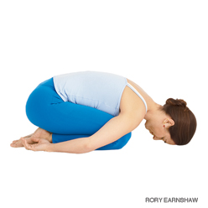
Pose 6: Downward Facing Dog
- Come onto the floor on your hands and knees. Set your knees directly below your hips and your hands slightly forward of your shoulders. Spread your palms, index fingers parallel or slightly turned out, and turn your toes under.
- Exhale and lift your knees away from the floor. At first keep the knees slightly bent and the heels lifted away from the floor. Lengthen your tailbone away from the back of your pelvis and press it lightly toward the pubis. Against this resistance, lift the sitting bones toward the ceiling, and from your inner ankles draw the inner legs up into the groins.
- Then with an exhalation, push your top thighs back and stretch your heels onto or down toward the floor. Straighten your knees but be sure not to lock them. Firm the outer thighs and roll the upper thighs inward slightly. Narrow the front of the pelvis.
- Firm the outer arms and press the bases of the index fingers actively into the floor. From these two points lift along your inner arms from the wrists to the tops of the shoulders. Firm your shoulder blades against your back, then widen them and draw them toward the tailbone. Keep the head between the upper arms; don't let it hang.
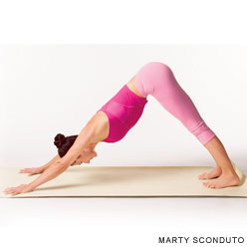
Pose 7: High Lunge
- Start in Adho Mukha Svanasana (Downward-Facing Dog). Exhale and step your right foot forward between your hands, aligning your knee over the heel. Keep your left leg strong and firm.
- Inhale and raise your torso to upright. At the same time, sweep your arms wide to the sides and raise them overhead, palms facing.
- Be careful not to overarch the lower back. Lengthen your tailbone toward the floor and reach back through your left heel. This will bring the shoulder blades deeper into the back and help support your chest. Look up toward your thumbs
- Be sure not to press the front ribs forward. Draw them down and into the torso. Lift the arms from the lower back ribs, reaching through your little fingers. Hold for 30 seconds to a minute.
- Then exhale, release the torso to the right thigh, sweep your hands back onto the floor, and, with another exhale, step your right foot back and return to Down Dog. Hold for a few breaths and repeat with the left foot forward for the same length of time.
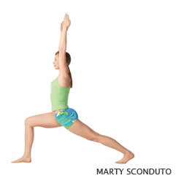’
Pose 8: Mind Meditation
- Get grounded and comfortable, and maintain your usual posture. If you're new to meditation, find a comfortable upright position, take a few deep breaths, and relax as much as you can.
- Think about yourself relaxing.
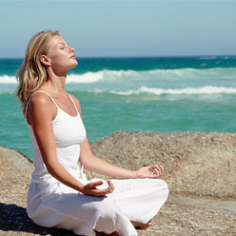

Day 5: April 12 2013:
- Sam will take attendance.
- Wolfe will take the class upstairs and have them set up the nets and cones for the courts. Also put together the scoreboard clock.
- Do a dynamic warm up:
-jogging
-high knees
-butt kicks
-skipping
-karaoke

- Review over the past days what we have been doing
- Have 2 courts set up
- Split the teams up:
-Michelle & Kristen
-Kevin & Rachel
-Connor &Eliena
-Karina & Dominique
-Kasenia & Sam
5.) Have the clock going for 2:00 minutes. Have the each pair keep track of their score. Wolfe will keep track of the clock and walk around to make sure they are playing the game correctly.
6.) The winner stays on the court and the loser moves to the right playing another team.
7.) After 25min have gone by we will switch teams:
-Kasenia &Connor
-Kevin & Dominique
-Karina & Rachel
-Michelle & Eliena
-Kristen & Wolfe
8.) keep the clock the same at 2:00min and losing team switching to the left. Sam will keep track of the clock and walk around to make sure they are playing the game correctly.

SECTION 4:
Explain what your role and your partner’s role will be during the lesson. Summarize what you will expect your students to know after the lesson.
As leaders of Pickle-ball, Our role is to clearly define the different strokes and mechanics of pickle-ball. We will assist the class to play using proper mechanics, and to better their playing skills while learning and enjoying the game. After the lesson we hope that the student learned how to play a game of pickle-ball, and have a blast while doing it.

