Kevin McMahon
Dominique LoVerde

Pre – Teaching Assignment
Speedball
SECTION 1:
Title of the Activity: Speedball

A wide variety of techniques are employed in speedball, including kicking and dribbling the ball with the feet as in soccer, catching and throwing the ball as in basketball, and punting and passing the ball as in football.

In as much as speedball combines the elements of basketball, soccer, and touch football, in general the soccer rules apply when the ball is on the ground, basketball rules apply to aerial or fly balls, and football rules usually apply in the forward passing of the ball and in scoring.

SECTION 2:
Objective of the Game:
The objective to the game of Speedball is for the team in possession of the ball to advance the ball down the field toward the opponent’s goal line or goal area and attempt to score. The opponents of the team in possession of the ball try to intercept and obtain possession of the ball in order to move it toward the opposite goal line or goal area in an attempt to score. The players are able to dribble the ball as in soccer, catch and throw the ball as in basketball, and pass, punt, and catch the ball as in football. In other words, the objective is to score as many points possible using these methods in the time given.

How a Winner is Determined:
In the game of Speedball, the winner is determined by the amount of points each team is able to score in time given. At the end of the game, whichever team has more points is the winner.

Rules:
Scoring- Points may be scored as follows:
Roll Ball- A roll ball is made when the player either kicks the ball in soccer style or rolls the ball with there hands into the end zone. While it is rolled, the ball must not bounce. A roll ball counts for 2 points.
Touchdown- A touchdown is made when an offensive player passes the ball to a teammate who catches it behind the opponent’s goal line. The teammate catching the ball is then required to touch the ball to the wall. A touchdown counts for 1 point.
- Game starts by having a jump ball in the center of the court
- The field players are allowed to move anywhere on the field of game play
- The field players are permitted to touch the ball with any part of their body at any time EXCEPT their arms/hands (see next rule for details) Field players may use their arms/hands as long as the last thing the ball touches is not the ground; one may not pick up the ball from the ground or catch it after it bounces off the ground.
- If a player does touch the ball with their arms illegally, then it is considered a handball penalty and will result in the ball being turned over to the other team's goalie
- If the player has the ball in his/her hands, they must make every effort to stop moving as fast as possible (if one keeps moving it is considered a travel and the ball will be turned over to the other team's goalie)
- Once a player has a ball in their possession, they can pass it off, attempt to score, or drop the ball in order to utilize other parts of the body to move the ball
- It is still illegal for goalies to travel when the ball is in their hands; however they can dribble the ball while moving

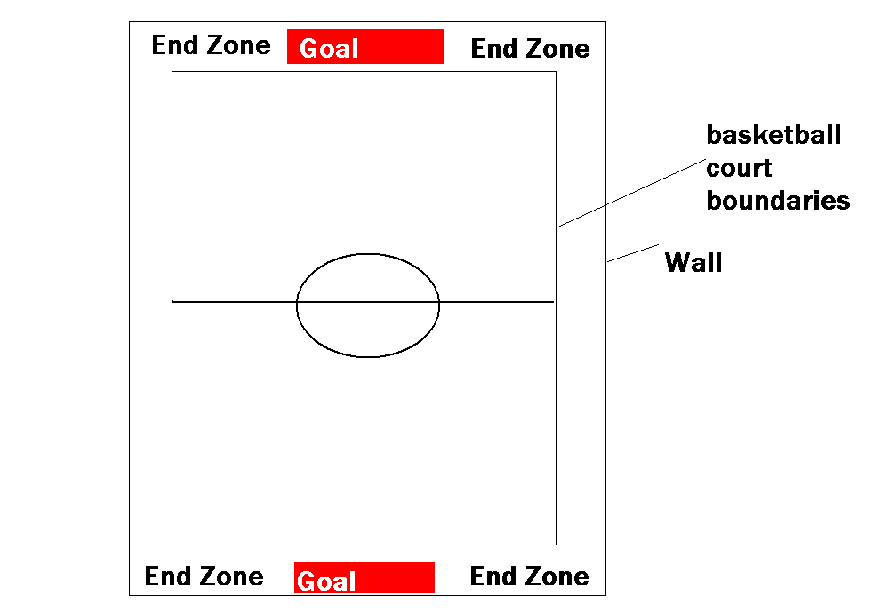
Diagram of Playing Field (with measurements):

Generally, the game of Speedball is played on a basketball court. Speedball can also be played on a soccer field. The size of the goal should be about 6 ft wide by 2.5 ft tall. However, different size goals can be used; the larger the goal, the faster the game generally goes. Hockey goals are also commonly used. A soccer ball or volleyball may be used for game play.

Equipment Needed:
- Soccer goals, or cones to mark the goal area
- Soccer balls - It is advisable to have enough balls on hand to enable small sided games totaling about six players.
- Pinnies, jerseys, or even flag belts can be used for identification purposes

Number of Players on a Team:
The game of Speedball requires two teams, each with 11 players on the field at a time. If there are not enough players for two 11-person teams, Speedball can be played with fewer people. Some speedball rules allow for more than one goaltender per team, while some allow teams to have only one goaltender. The remaining players on a team divide themselves into offensive and defensive positions as in soccer. The class will be divided into two equivalent teams depending on the number of students on game day.

Guidelines for the Official (where he / she stands, moves and what he / she is responsible for):

The officials will be officiating the game. They will be calling any penalties, including violations of the rules, and any type of foul. Additionally, the officials will be watching the clock for the time and will be keeping track of the score. One official will be located on either side of the playing field.

Rule Infractions:
There are three categories of rule infractions, which are: Violations, Personal Fouls and Technical Fouls.
Violations: Simple rule infractions are called violations and include:
    - Traveling with the ball
    - Touching a ground ball with the hands or arms (illegal use of hands)
    - Air dribbling more than once
    - Causing the ball to go out of bounds
    - Illegally lifting the ball
    - Interfering with a kick off, penalty kick or throw in

    - Violation Penalties: Penalty for a violation committed in the field of play outside the penalty area is that the opponents are awarded possession of the ball in an aerial position. If a violation is committed within their own penalty area one penalty kick is awarded, if missed, play continues.
    - Personal Fouls: Personal fouls are rule infractions that involve unnecessary roughness and include actions like pushing, holding, kicking, tripping, charging, slide tackling or blocking an opponent.

    - Personal Foul Penalty: Personal fouls committed in the field of play outside penalty areas are penalized one penalty kick. If a personal foul is committed within their own penalty area, the opponents are awarded two penalty kicks; if the second kick is missed, play continues.
    - Technical Fouls: The following infractions are considered technical fouls:
      - Illegal substitution
      - Unsportsmanlike conduct
      - Unnecessary delay of game

      - Technical Foul Penalty: A penalty kick is awarded for a technical foul committed outside the penalty area. Any member of the team may attempt the penalty kick. If committed in the penalty area two penalty kicks are awarded, if the second is missed, play continues.
SECTION 3: The lesson plan
Day 1:
Introduce your sport- Speedball is a game consisting of aspects from football, rugby, soccer, and basketball. In these drills the students will learn to properly pass, using the different techniques, and get a better understanding of the game.
Drill 1: Foot Passing/Stopping and Hand Passing
Physical set up- We will need exactly half the number of balls as the students that are present in class that day. This number will be determined as soon as attendance has been taken.
How the class will be organized- Dominique and Kevin will stand at a distance from the center of the basketball court to the sideline of the basketball court. The class will be told to stand on one side of the demonstration so they will be able to lead the drill. No one will have any equipment yet. When the drill is ready to begin the class will form lines facing each other from the sideline of the basketball court to the center of the basketball court.
Equipment needed & dispersal/collection of equipment- After the demonstration is over Kevin will tell the class to partner up. When each member of the class has found a partner then one of these partners will be told to grab a ball. The ball will always start with the partner on the sideline.
Objective of the Drill- The objective of this drill is for the students to understand how to kick the ball with the inside of their foot to a teammate. Therefore, each student will know how to pass when games begin.
Drill 2: Chest/Overhead Passing
Physical Set up- There is no need for any physical set up because the partners will remain where they are.
How the class will be organized- The class will remain with their same partner and watch Kevin and Dominique demonstrate the next drill. Also, Kevin and Dominique will make sure that everyone is watching the demonstration before they begin.
Equipment needed & dispersal/collection of equipment- The class will be told to place balls on the ground so there will be no distractions during the demonstration.
Objective- The objective of this drill is for students to go over the passing of a chest pass and the one handed pass. This will help students throw the ball through the air once games start.
Drill 3: Kick Up Pass
Physical Set up- There once again will be no physical set up needed because the students will remain where they are standing.
How the class will be organized- The class will be told to watch the demonstration and place all balls on the ground to make sure no one is distracted and everyone can hear the leaders.
Equipment needed and dispersal/collection- Each student will keep the ball they have used in past drills and remain with their same partner.
Objective- The students will learn how to do a kick up pass. They will learn how to do a kick up pass with one foot, two feet, off the wall, and to a teammate. This will enable them to transfer the ball from their feet to their hands during gameplay.
Drill 4: Shooting/Scoring
Physical Set up- A goal will have already been placed at the baseline on the end of the Boler gym closest to the Dean’s Office.
How the class will be organized- During the demonstration of the drill the class will be told to stand on the side of the demonstration in order to see the entire demonstration.
Equipment needed & dispersal/collection: After the demonstration the students will then be told to each grab a ball. During the demonstration any student with a ball will be told to place the ball on the ground in order to prevent distractions.
Objective- The students will be taught to roll the ball into the goal and against the wall in the end zone. Therefore the goal will be placed on the baseline closest to the Dean’s office so the students can practice both techniques. The students will be told the ball is not to bounce as it travels into the goal or against the wall.
Day 2:
Quick Review From Day One- The class will go over passing, shooting, and how to do a kick up pass
Finish Covering Necessary Skills- The class will go over jump stopping and how to pass the ball by punting it to one another.
Modified or Mini Game Play-
1st Game: Juggling
The leaders will explain to the class that this mini game’s objective is to keep the ball in the air for as long as possible by using any part of their body. The leaders will put people into groups of three based on skill to ensure each group has a fair chance in succeeding. Then the leaders will send each group off to a different section of the gym to give everyone a large amount of space to prevent collisions. The leaders will blow the whistle to begin and will tell the groups to keep track of how many touches they get in a row. If one group drops the ball the leaders will have them do a kick up pass to either themselves or another person in the group rather than just picking it up with their hands. The groups will try this game for about five minutes to get the hang of it. After five minutes the leaders will make this into a competition to see who can get the most consecutive juggles without letting the ball hit the ground.
2nd Game: Moving and Passing
Cones will be set up approximately arm’s length apart throughout the entire gym. These cones will be set up while the class is still juggling by one of the leaders. Five sets of cones will be set up. The class will be split up into partners by a leader. The objective is to pass the ball through the cones from one partner to the other and to then move to other sets of cones and pass through those cones. The partners will earn a point for completing a pass through the cones. If the ball hits a cone while going through the cones no points are awarded. The partners are not allowed to continually pass the ball between the same set of cones. To begin the game each set of partners will start at different locations throughout the gym. This game will last approximately 10 minutes.
3rd Game: Accuracy of Passes
The partners will remain together. They will be told to stand on the volleyball sidelines. While one leader tells each set of partners who they are with while the other partner will take the cones and place them on either side of the volleyball sidelines. Then the leaders will tell two teams to go next to one set of cones and stand on either side of the volleyball lines. The leaders will also ensure that each group will have two cones. After they are in position a leader will give each set of partners one ball. Then the leaders will tell one side of the gym that they are the shooters and the other side that they are the defenders. This is when the game will begin. The side that is the shooters will have six chances to hit the other cone down and the defenders will try to stop them. Each partner will receive three shots. After the shooters have taken six shots the roles will be switched from shooters to defenders. The teams that got to shoot first will always rotate to the right. This game will last for approximately 10 minutes.
Day 3: Game Day
How teams will be determined- The teams will be divided by Dominique and Kevin based on skill. This will be done before class starts.
How many playing areas are needed- the basketball court in the Boler/Cahill Gym is the only playing area needed because of the small number of students in class.
Equipment needed- One ball will be needed. The number of pinnies needed will be known as soon as attendance has been taken for the day. Goals will also be set up on each baseline. One leader will take attendance and the other leader will take a group of students upstairs to set up goals so no time is wasted.
When is the game over- The game will be over after the second game and the time for each game will be twelve minutes. After the game is over the goals will be put back and the class will stretch and critique.
How many games will be played- The games will be twelve minutes and two games will be played.
Teams
1st Game
Connor, Michelle, Karina, Ksenia, Kristen (Pinnies)
Elania, Rachel, Wolfe, Sam, Ms. Wilson
2nd Game
Michelle and Rachel will switch
Sam and Karina will switch
SECTION 4: Leaders’ Roles
As leaders it is our job to properly teach the students the basic rules and fundamental skills required to play the game of Speedball. We will be loud and will be on either side of the court moving with the game in order to make proper calls. After this lesson it is hoped that the students will understand the game of Speedball and learn new techniques along the way. Students should also be familiar with certain Speedball terms.
WORKOUTS:
All equipment needed for that day’s workout will be set up by Kevin while Dominique has the class going through the warm-up. Also, Kevin and Dominique will lead stretching and go over how to do each exercise prior to the students doing them.
First Workout:
Dynamic Warm-up (5 minutes)
Jump rope at 45 second intervals with 30 second breaks (4 sets)
Body squats with pipes at 45 second intervals with 30 second breaks (4 sets)
Class will be divided and one half will do cardio on the machines and the other half will do weight lifts
Weight lifts:
Bicep Curl
Curl and Press
Arm Extensions
Remaining time will be spent stretching with cords
Second Workout:
Dynamic Warm-up (5 minutes)
Cable Workout (10 minutes)
Cable Chops
Triceps Extension
Turn and Press
One section of the Iron Lion abdominal workout (5 minutes)
Static Stretching for the remainder of class time

