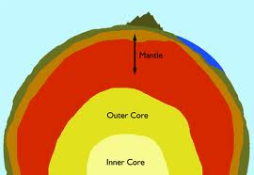
Inside Earth Study Guide

Earth’s Layers
Be able to identify, name and locate (correctly spelled)
each of the layers of Earth including:

  - Crust
  - Lithosphere
  - Upper mantle
  - Asthenosphere
  - Lower mantle
  - Outer core
  - Inner core

Knowledge of Earth’s Layers
a. seismic waves
b. pressure
c. basalt
d. granite
Which of the 3 main layers (Crust, Mantle & Core) is the thickest layer?
In general what happens to temperature (and pressure) as you travel from the crust
towards the core of the Earth?
Know why the inner core is solid, even though it’s the hottest layer.
The type of rock:
  - Oceanic Crust
  - Continental Crust
Which type of rock is more dense?
Heat Transfer
Be able to define:

- Heat transfer
- Radiation
- Conduction
- Convection
- Fluids

Be able to explain what the steps are that take place during convection currents (using key
terms- heating & cooling, less dense and more dense and rising and falling).
Know how heat naturally travels: hot vs. cold.
Be able to explain convection currents that take place inside earth (see convection notes).
Know which layer convection currents take place in.
Know where the heat source is to cause convection currents.

