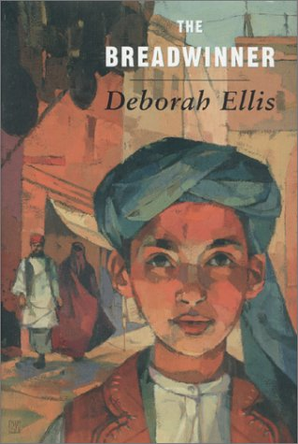
The title of the book I read is The Breadwinner. It is a work of fiction written by Deborah Ellis. I found it in hardcover format in the King County Library.
The Breadwinner takes place in Kabul, the capital of Afghanistan. The book takes place during the Taliban’s rule. The main character is a girl named Parvana. After her father is arrested, she has to cut her hair, get into boy’s clothes, and work in the marketplace in order to get money for her family. Girls aren’t allowed to work there, so she pretends to be male even though this is extremely dangerous. While she is working in the marketplace, she meets a friend from school named Shauzia, who also works in the market. They work together and sell cigarettes.
Parvana’s mother goes to Mazar-e-Shariff, which was not yet under the control of the Taliban. A few weeks later, Parvana’s father returns from prison where he has been unjustly incarcerated. A few weeks later, the Taliban conquer Mazar-e-Shariff and massacre the inhabitants. Since Parvana’s mother is still there, Parvana and her father go to Mazar-e-Shariff to find her mother. The story gives us intriguing insight into the of life a young girl who takes on tremendous responsibility in a horrific situation in a country of chaos. It is the story of a young girl who is forced to become a woman while desperately trying to save her family.
I liked The Breadwinner because is was accurate and it was well-written. The gripping story held my attention completely until I finished reading it. The characters appeared to be realistic and I learned much about life under the Taliban. I would recommend reading The Breadwinner to anyone who loves stories about how people grow in difficult circumstances, or would like to learn about life in Afghanistan under the Taliban.

