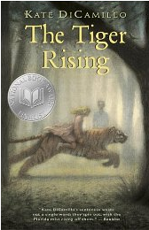
The Tiger Rising by Kate D. Camileo is a fictional story about a boy, although the book is really for all ages. The main character, Rob Horton, is an outcast at school, his mother has died, and he lives in a motel, in Florida, with his father. One day he stumbles upon a tiger locked in a cage in the forest behind his motel. He later befriends a girl named Sistine, who is in dire need of friendship, like himself, and the two are faced with many life problems throughout the story.

This is a story which strikes the very human conditions of freedom, loss, hope, and most importantly friendship. Dicamillo is on top of her game with a story which will ring true to everyone who reads it. While some of the incidents seemed bizarre to me, the responses of the characters rang true. Each scene was vividly portrayed and I felt as if I were drawn into this strange world with Rob and his friend. The imagery and beautiful language will hold the interest of readers of any age.

