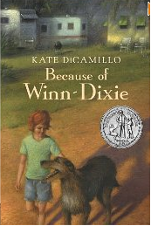
Because of Winn-Dixie, a big, ugly, happy dog, 10-year-old Opal learns 10 things about her long-gone mother from her preacher father. Because of Winn-Dixie, Opal makes new friends among the somewhat unusual residents of her new hometown, Naomi, Florida. Because of Winn-Dixie, Opal begins to find her place in the world and let go of some of the sadness left by her mother's abandonment seven years earlier.
With her newly adopted, goofy pooch at her side, Opal explores her bittersweet world and learns to listen to other people's lives. This warm and intriguing book has an unforgettable cast of characters, including a librarian who fought off a bear with a copy of War and Peace, an ex-con pet-store clerk who plays sweet music to his animal charges, and the neighborhood "witch," a nearly blind woman who sees with her heart. Opal brings her own unique and wonderful voice to a story of friendship, loneliness, and acceptance. Opal's down-home charm and dead-on honesty will touch your heart and draw you into her world.

