How to Use Noodlebib MLA Starter at RTC’s Library Website

- Open the Internet and go to http://www.rtc.edu/Library/.

- Click on Online Databases.

- Click on NoodleBib.

- Click on NoodleBib MLA Starter in the lower center of the page.

- Create a personal ID and password of your own choice, then fill in your initials and last 4 digits of your telephone number.

- Click on in the upper right corner.

- Give your project a name (Example: ESL report or Global Warming) and click on create project.

- Click on Bibliography and follow the directions.
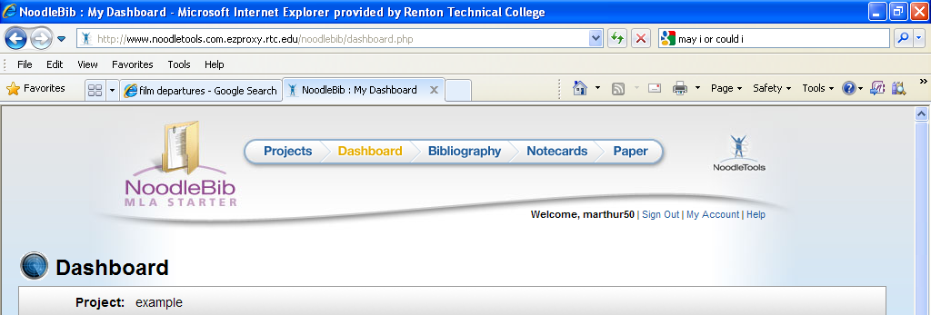

NoodleBib saves a copy of the information for you. Sign out.
The next time you sign in to NoodleBib, the project name will appear. Click to open.
When you want to print the bibliography page, click and then click Print/Export to Word. You can save the file to your computer and/or a USB drive.

