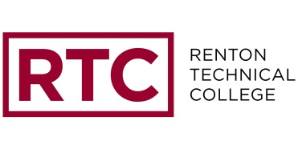
Renton Technical College Closure Information
2013-14

Listed below are several outlets to find out school closure information, in the event that Renton Technical College closes due to inclement weather or other emergencies.

1. Television - The following stations are recommended and should have information about Renton Technical College, scrolling on the bottom of the screen:

KOMO TV 4
KING TV 5
KIRO TV 7
KCPQ TV 13

2. Log on to www.schoolreport.org and search “Renton Tech” to view the College’s message there.

3. Check the RTC website, www.RTC.edu. Closure information will be listed under “News and Events” on the homepage.

4. Call the College at 425-235-2352 and press 9 for the latest operating schedule. Keep in mind that if many people are calling at the same time, the lines will be busy.

5. Social Media - Check the College’s social media outlets to find out about closures.
Facebook – www.facebook.com/rentontechnicalcollege
Twitter - www.twitter.com/rentontech

6. Radio stations - The following radio stations may voluntarily run closure information. We recommend that you have a radio station tuned into one of the following stations, but not to rely on receiving information solely from this source:

KBKS 106.1 FM KIXI 880 AM
KGRG 89.9 FM KGRG 1130 AM
KOMO 97.9 FM KOMO 1000 AM
KIRO 97.3 FM KFNQ 1090 AM
KMPS 94.1 FM KPLU 88.5 FM
KPLZ 101.5 FM KUOW 94.9 FM
KZOK 102.5 FM

6. RaveAlert - A message about any College closure will be sent out by the Director of Safety and Security, via the RaveAlert system. To sign up for RaveAlerts, visit: https://www.getrave.com/login/renton

Remember, YOUR power may be out or YOU may have 5” of snow, but not everyone will. You’re encouraged to form a buddy system with someone who does not live close to you, so you can check in with each other for updates.

