1) Find the area of the shaded region 2) Find the area of the shaded region.
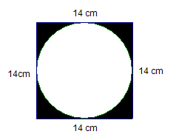
if the big diameter is 12 in, and the
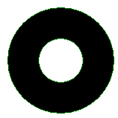
small diameter is 8 in.

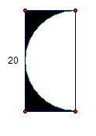
3) Find the area of the shaded region: 4) Find the area of the shaded region
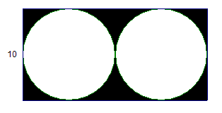

5) Find the area of the shaded region if the 6) Find the area of the shaded region
radius of the circle is 9 in,
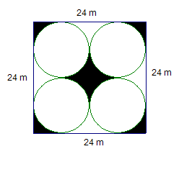
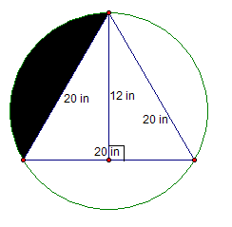

7) Find the area of the shaded region 8) Find the area of the shaded region
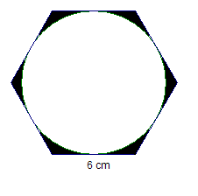
if the radius of the big circle is 12 cm.
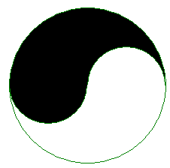

9) Find the area of the shaded region. 10) Triangle ABC is equilateral. The arc is part of a
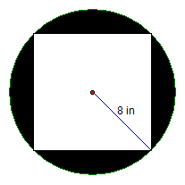
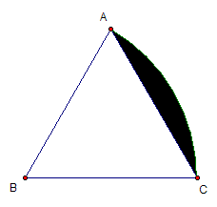
circle with center B and radius BA. What is the area of the shaded region?

6 cm

11) Find the area of the shaded area in this 12) This problem is wicked hard!!! If you don't want
figure in which each side of the right to do it, don't :-( If you want a challenge, give it a
triangle has a semicircle created using try. Find the area of the shaded region. I left some
the side as the diameter. This is one of those some points in there to get you started.
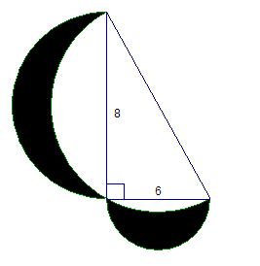
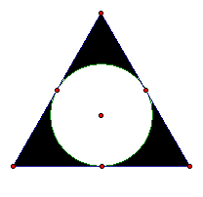
you have to look for the secret ones:-)

6 cm

