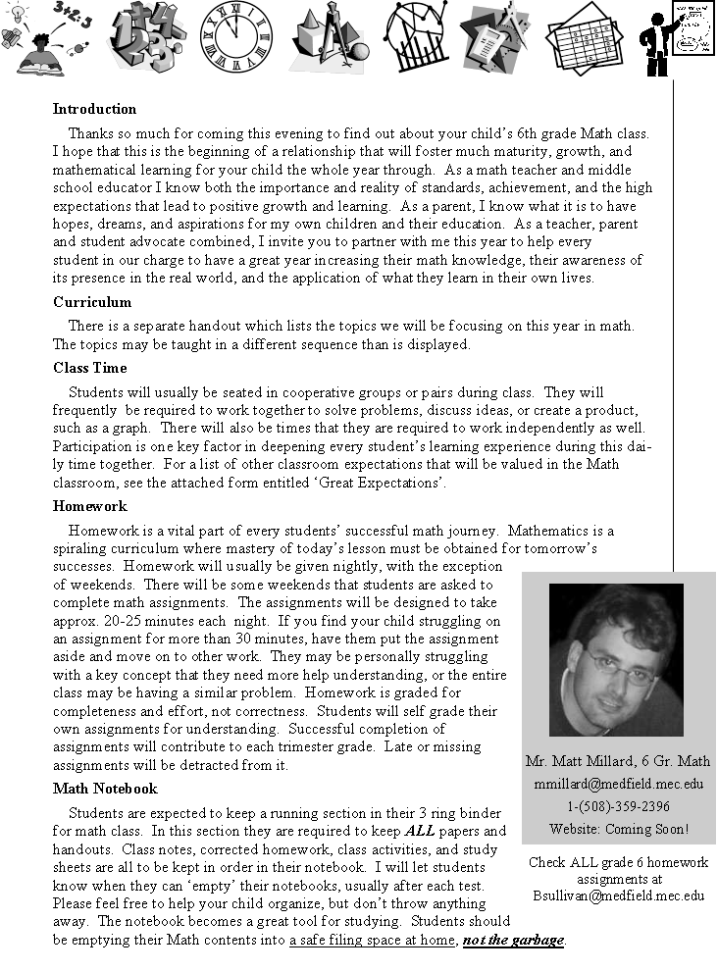

Class Binder

Every student is required to have a smaller math binder for the classroom. It should be a
1 to 1 1/2 inch binder. This binder will be kept in class. It will be used to keep track of
graded tests and quizzes, word problems, journal entries, and other selected work.

Tests, Quizzes, & Projects
Tests, Quizzes and Projects will be given throughout the year on material we have learned in class. In most cases students will be given one week’s advance notice of all tests and quizzes and a corresponding study guide. Projects will also be clearly announced and accompanied by a rubric. Feel free to check your child’s agenda or my website for these details and dates as they pop up throughout the year.

Grading
Final grades are determined by calculating the number of points received during the term against the total possible points for the term. The following is a list of assignments
and assessments that will contribute towards semester points with approximate point values:

Tests ≈ 50-100 points each
Quizzes ≈ 10-50 points each
Projects ≈ 10-50 points each
Problems of the Week ≈ 10-15 points each
Homework ≈ 1-2 points each

Bonus Points
There will be some opportunities for students to earn points for doing extra assignments, challenging problems, or bonus questions on quizzes. These points will be added as extra points at the end of a grading period.

Extra Help
I am available after school until 3 pm Tuesdays and Thursdays for extra help for anyone who
decides to stay after. Advance notice is not necessary for these sessions. If mornings are the best time for your child to get extra help then email me to discuss a morning that will work for both of us. Morning help sessions will start at 7 am and conclude at 7:30 am. You should
arrange a morning session at least one day in advance. If your child has self graded any homework assignment as a 2 or 1, then that is the first indication that they should spend some extra time with me after or before school. My desire is to see all students succeed, and offer as much encouragement and support as I possibly can with the time that I am given.

Contact me!
If you have any questions, feel free to call or contact me by email. The best way for me to be reached is by email which I check daily—several times. I will do my best to be a resource to you and your child as we travel on this mathematical adventure together. I look forward to helping any way that I can and having fun along the way!

Teaching, caring, serving,

Matt Millard
6th Grade Math, Blake Middle School

