Rental Units
Rental #1 | Rental #2
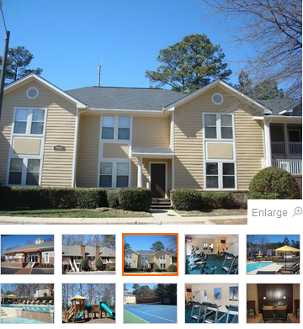 | 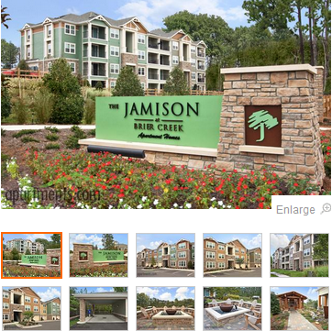
Six Forks Station  (855) 770-5970  8501 New Brunswick Lane Raleigh, NC 27615 | The Jamison at Brier Creek  (855) 337-8216  9920 Jamison Valley Dr. Raleigh, NC 27617
3 Bedroom $825 - $1040 a month  Deposit$400  2 baths  Square Footage of apt 1295 - 1430 | 3 Bedroom $1340 - $1365 a month  2 baths  Square footage of apt 1291
Pets Allowed  - Cats Allowed  - Small Dogs Allowed  - Large Dogs Allowed  Pet Restrictions  $200 deposit. $250 one-time fee. $10 monthly rent per pet. Two-pet maximum. 150-pound weight limit. No breed restrictions.  Pet Questions? Call Toll Free: (855) 770-5970 | Pets Allowed  - Cats Allowed  - Small Dogs Allowed  - Large Dogs Allowed
Amenities: Six Forks is a community offering a great residential environment. -- Two sparkling pools -- Resident's clubroom to rent for entertaining -- Exercise facility -- Spacious floor plans -- Two playgrounds -- Professional on-site management team -- Great location -- Great attention to detail -- Two-bedroom nightly guest suite | Conveniently nestled in beautiful Brier Creek, The Jamison at Brier Creek is situated only minutes from The Triangle area's best schools, shopping, restaurants, recreation and nightlife. Featuring elevated resort style amenities and urban accessibilities, The Jamison at Brier Creek embodies contemporary living with award-winning floor plans that meet your unique lifestyle needs. Work, rest or play, The Jamison has everything you seek in a Luxury Apartment Home community. The Jamison at Brier Creek. Inspired Apartment Living.
Lease Length  - 3 Months  - 6 Months  - 7 Months  - 9 Months  - 12 Months  - 13 Months | Lease Length  - 10 Months  - 11 Months  - 12 Months
I recommend Six Forks Station. It allows pets has three bedrooms and two baths. Plus they can lease it by semesters or quarters. They appear to be college students.

